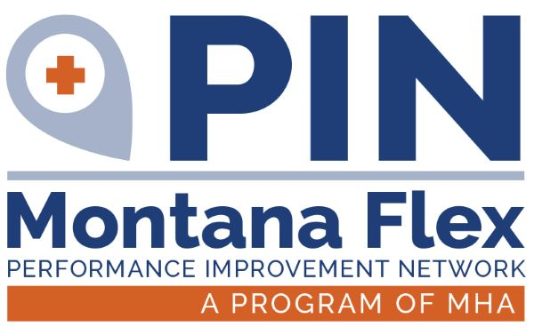
National quality improvement reporting has traditionally been difficult for Critical Access Hospitals (CAHs) due to the challenges that arise from attempting to measure improvement in “low-volume” settings, which often have limited resources. In fact, CAHs have been exempt from reporting programs at the national level for these very reasons. Recent work has shown that it is possible for CAHs to not only participate in national quality improvement reporting programs, but to excel in areas that are relevant to their rural locations and hospital size. One example of such success is small rural hospitals that participate in Hospital Consumer Assessment of Healthcare Providers and Systems (HCAHPS) assessments. These hospitals often outperform prospective payment system (PPS) hospitals on the same survey.
CRITICAL ACCESS HOSPITAL
QUALITY REPORTING OVERVIEW GUIDE
September | 2023
With the prospect of a health care system that pays for value of care over volume of care, it is vital for CAHs to demonstrate their ability to provide quality care by participating in federal public quality reporting. It is important to provide evidence-based care for every patient, 100 percent of the time. This can be achieved through monitoring, reporting and continuous quality improvement efforts.
About this Guide:
This guide explains the various quality reporting programs in which CAHs may participate. The programs are outlined via the areas the hospital covers (i.e., outpatient, inpatient, etc.) and the type of program the hospital is associated with (i.e., HCAHPS, Medicare Beneficiary Quality Improvement Project, etc.). Participation in these programs varies depending on the needs and desire for quality monitoring by the CAH.
Purpose of this Guide:
This guide was written by CAH Quality Improvement Directors for other CAH Quality Improvement Directors and staff. The purpose of this guide is to help Quality Improvement Directors structure and support quality improvement (QI) efforts as well as make informed decisions about the quality reporting for their facilities.

Contributing Authors: MACRA/MIPS Content Contributors: Prior Authors:
Susan Runyan Seema Rathor Namrata Dave (2016, 2017 Editions)
Runyan Health Care Senior Project Manager Lake Health District
Quality Consulting Comagine Health Arielle LeVeaux (2018 Edition)
650 NW Holladay St West Valley Hospital
Portland, Oregon Tami Youngblood (2019 Edition)
Curry Health Network

This guide is adapted, with permission, from the Critical Access Hospital Quality Reporting Overview Guide, produced by the Oregon Office of Rural Health in partnership with Runyan Health Care Quality Consulting and Comagine Health.
This project was supported by the Health Resources and Services Administration (HRSA) of the U.S. Department of Health and Human Services (HHS) under the Rural Hospital Flexibility Grant Program (U2WRH33327). This information or content and conclusions are those of the author and should not be construed as the official position or policy of, nor should any endorsements be inferred by HRSA, HHS or the U.S. Government.

CONTENTS
I. REGULATORY PROGRAM OVERVIEW 4
II. PROGRAM DETAILS 5
Medicaid Beneficiary Quality Improvement Project (MBQIP) 5
Hospital Inpatient Quality Reporting Program (Hospital IQR) 10
Hospital Outpatient Quality Reporting Program (Hospital OQR) 13
Hospital Consumer Assessment of Healthcare Providers and Systems (HCAHPS) 16
Merit-based Incentive Payment System (MIPS) and Advanced Alternative Payment Models (APMs) 17
Electronic Clinical Quality Measures (eCQMs) 23
Hospital Quality Improvement Contract 25
PIN Benchmarking Project (Montana Only) 28
III. REPORTING 30
Reporting Method Checklist 30
Enrolling: Websites, Agencies and Portals 31
Exporting Data from CART 35
Submitting Data Via QualityNet 36
Web-Based/Structural Measures Reporting 37
Submitting Data to NHSN 38
Resources for Quality DIRECTORS AND STAFF 40
IV. Analyzing and sharing data within the hospitaL 44
Sharing IQR and OQR Data 45
Other Examples of How to Share Data 46
V. APPENDICES 47
Appendix A: Additional Improvement Activities/MBQIP Measures 47
Appendix B: Tools Used for Reporting 48
Appendix C: Quality Crosswalk for CAHs 49
Appendix D: Quality Data Reporting Channels 50
Appendix E: Quality Health Indicators 51
References 54

REGULATORY PROGRAM OVERVIEW
PROGRAM AND DESCRIPTION | VOLUNTARY or REQUIRED | IMPACTS | LEAD ORGANIZATION
Medicare Beneficiary Quality Improvement Project (MBQIP)  MBQIP is the quality data program of the Rural Hospital Flexibility Grant; a federal grant program administered by the MT Office of the Inspector General (OIG) and Montana Health Research and Education Foundation (MHREF) at Montana Hospital Association (MHA) to support CAHs to report common, rural-relevant quality measures that are appropriate to low-volume hospitals. | Voluntary (required to receive support from Flex Program) | CAHs only | Health Resources and Services Administration (HRSA)  Federal Office of Rural Health Policy (FORHP)
Hospital Inpatient Quality Reporting Program (HIQRP or IQR)  Includes inpatient measures collected and submitted by acute care hospitals paid under Prospective Payment System (PPS) and claims-based inpatient measures calculated by CMS. | Voluntary | CAHs (reporting MBQIP)  PPS hospitals | CMS
Hospital Outpatient Quality Reporting (HOQRP or OQR)  Includes outpatient measures collected and submitted by acute care hospitals paid under PPS and claims-based outpatient measures calculated by CMS. | Voluntary | CAHs (reporting MBQIP)  PPS hospitals | CMS
Hospital Consumer Assessment of Healthcare Providers and Systems (HCAHPS)  Survey program that collects patients’ evaluations of health care experiences for the purposes of comparison, value-based purchasing and consumer education for health care decisions. | Voluntary | CAHs (reporting MBQIP)  PPS hospitals | CMS
Medicare Access and CHIP Reauthorization ACT, Merit-Based Incentive Payment System (MACRA-MIPS)  Uses a combination of incentive payments and payment adjustments to promote reporting of quality information by eligible professionals. Program of initial payment incentives and future payment penalties for physician practices to submit quality data. | Required if using Method 2 billing and have eligible providers | Eligible professionals and practices | CMS
Electronically-Specified Clinical Quality Measures (eCQMs) Meaningful Use  Reporting clinical quality measures (CQMs) is a requirement for hospitals under the  Promoting Interoperability Program (PIP) (formerly the Medicare and Medicaid Electronic Health Record (EHR) Incentive Programs or Meaningful Use (MU)). For the FY20/21 payment determination for the Promoting Interoperability Program, hospitals are required to report on at least four of the eight available measures using the 2015 Edition of Certified EHR Technology. | Required  (if participating) | CAHs  PPS hospitals | CMS  Office of the National Coordinator for Health Information Technology (ONC)
The Hospital Quality Improvement Contractor (HQIC) Initiative  Provides targeted QI assistance to rural and critical access hospitals, as well as hospitals serving vulnerable and underserved populations to achieve measurable outcomes with a focus on patient safety, care transitions and opioids. | Required  (if participating) | CAHs  Rural hospitals | CMS  HQIC Contractors

PROGRAM DETAILS

Medicare Beneficiary Quality Improvement Project (MBQIP)
Program Overview:
The Medicare Beneficiary Quality Improvement Project (MBQIP) is a quality improvement activity through the Federal Office of Rural Health Policy’s (FORHP) Rural Hospital Flexibility (Flex) grant program and is specific to CAHs. This voluntary program, implemented in 2011, focuses on reporting quality measures that are relevant to rural, low-volume hospitals. The program encourages CAHs to measure outcomes, demonstrate improvements and share best practices with data that is aggregated and shared as state and national benchmarks. MBQIP provides an opportunity for individual hospitals to look at their own data, compare their results against other CAHs and partner with other hospitals around quality improvement initiatives.
Why Report?
As the U.S. moves rapidly toward a health care system that pays for value over volume of care provided, it is extremely important for CAHs to participate in federal, public quality reporting programs to demonstrate the quality of care they are providing. MBQIP takes a proactive approach to ensure CAHs are well-prepared to meet future quality requirements.
Reporting Method: See Table 2.
FORHP determines requirements for CAHs to be eligible to participate in Flex funded activities and benefits. See Table 1 on page 6 for opportunities available to your CAH under the MT Flex Grant.
MT Flex will track minimum requirements and communicate with Montana CAHs any potential ineligibility. Refer to page 7 for requirements.

Table 1. Flex Opportunities in Montana:
SUPPORT FOR QUALITY IMPROVEMENT:
- Antimicrobial Stewardship Program (ASP) support and days of therapy tracking
- Quality improvement and MBQIP training including peer-to-peer sharing opportunities
- Participant support for CAH quality staff to attend MHA’s Healthcare Conference & Health Summit
- Support for professionals to obtain credentials
- Collaborative programs to support quality improvement projects
- Swing bed education and quality measurement
- MBQIP technical assistance
SUPPORT FOR FINANCIAL & OPERATIONAL IMPROVEMENTS:
- Collaborative programs to support financial quality improvement projects
- Education, peer to peer support, and attendance for CAH leaders at the MHA Healthcare Conference
- Participant support for CAH staff to attend the MT HFMA and MHIMA chapter annual conference
- Platform for rapid improvement projects via partnership with MSU Industrial Engineering
- Regulatory and financial resources and education
- On-site mock survey for CAH, Rural Health Clinic, Swing Bed or Environment of Care
- Data collection and improvement efforts for Rural Health Clinics
SUPPORT FOR EMERGENCY MEDICAL SERVICES (EMS):
- Training and certification for Advanced Trauma Life Support
SUPPORT FOR COMMUNITY ENGAGEMENT
- Support for Community Health Services Development Implementation Plan
- Worksite Wellness programs
- Training and certification for Breastfeeding Trainers and Lactation Programs

Table 2. Core MBQIP Measures 2022

In addition to the Core MBQIP Measures (p. 8), there are additional metrics that Flex Programs may focus on with any cohort of CAHs based on need and relevance. The additional metrics can be found in Appendix A.

FORHP has set minimum requirements as reporting 4 Core MBQIP Measures for 4 consecutive quarters. To facilitate and support CAHs meeting this requirement, MT Flex has implemented “Four for Four”.

Montana’s MBQIP “FOUR for FOUR”

Objectives:
- Clearly identify priority areas and relevancy of measures for CAHs based on hospital selection of measures.
- Develop measure cohorts for all MBQIP Core Measures.
- Provide targeted improvement resources and/or efforts within measure cohorts.
- Provide targeted reminders and support for data reporting compliance.
- Demonstrate our continued commitment to focus the best we can on what is meaningful to MT CAHs.
- Relay information reported by hospitals regarding the “why” of choosing or not choosing a measure to the Federal Office on Rural Health Policy (FORHP) and Health Resources and Services Administration (HRSA). This will be vital to help the development of rural relevant measures at the federal level.
Hospitals are to select measures that are meaningful to their facility and commit to consistently report on those selected. If time and capacity allows, hospitals are encouraged to report above the minimum requirements. The complete list of core measures can be found in the table on page 8.

Note: Measures that reported annually count for 4 quarters of reporting.

Measure | Description |  | Reporting Method
Patient Safety/Inpatient
HCP/IMM-3 |  | Influenza Vaccination Coverage Among Healthcare Personnel (HCP) | National Healthcare Safety Network (NHSN)
Antibiotic Stewardship |  | Antibiotic Stewardship Program (ASP) via the CDC Annual Facility Survey | National Healthcare Safety Network (NHSN)
Patient Engagement
Hospital Consumer Assessment of Healthcare Providers and Systems (HCAHPS) |  | - Communication with Doctors - Communication with Nurses - Responsiveness of Hospital Staff - Communication about Medicines - Discharge Information - Cleanliness of the Hospital Environment - Quietness of the Hospital Environment - Transition of Care | QualityNet via HCAHPS vendor or self-administered if in compliance with program requirements.
Care Transitions
Emergency Department Transfer Communication (EDTC) |  | EDTC-1: Home Medications | MT Flex Program @ MHA
 |  | EDTC-2: Allergies and/or Reactions
 |  | EDTC-3Medication Administered in ED
 |  | EDTC-4ED Provider Note
 |  | EDTC-5Mental Status/Orientation Assessment
 |  | EDTC-6Reason for Transfer and/or Plan of Care
 |  | EDTC-7Tests and/or Procedures Performed
 |  | EDTC-8Tests and/or Procedure Results
 |  | ALL EDTC Composite of all data elements
Outpatient
OP-18 |  | Median Time from Arrival to Departure for Discharged ED Patients
OP-22 |  | Patient Left Without Being Seen | QualityNet as a web-based measure

Newer MBQIP Measures:
The Federal Office of Rural Health Policy (FORHP) announced the addition of the following Core Measures under the Patient Safety category for the Flex project period of 2018-2021. CAHs should continue building capacity and submitting data on these measures as indicated below:
Antibiotic Stewardship: Improving antibiotic use in hospitals is vital to improving patient outcomes, decreasing antibiotic resistance and reducing overall healthcare costs. Overexposure to antibiotics contributes to antibiotic resistance, making antibiotics less effective. FORHP is working closely with the CDC to help educate and assist hospitals and nursing homes to align locally or regionally to fight resistance.

Effective March 30, 2020, CMS made Antimicrobial Stewardship Programs (ASPs) a required Condition of Participation (CoP) under the CAH program. CAHs are required to meet core elements of the CDC’s Annual Facility Survey to demonstrate compliance with the CDC’s 7 Core Elements:
- Leadership Commitment: Dedicate human, financial and IT resources
- Accountability: Leader responsible for outcomes (physician recommended)
- Drug Expertise: Pharmacist leader
- Action: Implement recommended action(s) such as “antibiotic time-out”
- Tracking: Monitor prescribing and resistance patterns
- Reporting: Regular information to doctors, nurses, and relevant staff
- Education: Focus on resistance and optimal prescribing with clinicians

Retiring Measures:
CMS regularly evaluates and removes measures from both Hospital Inpatient and Outpatient quality reporting (IQR and OQR) through their annual rule making process. Once removed, measures are no longer reportable and it is not possible to submit data through QualityNet. FORHP works to align MBQIP reporting measures with other federal reporting programs, thus these measures are typically removed from MBQIP when removed by CMS.

Hospital Inpatient Quality Reporting Program (Hospital IQR)
Program Overview:
The Hospital Inpatient Quality Reporting Program (Hospital IQR) was originally mandated by Section 501(b) of the Medicare Prescription Drug, Improvement, and Modernization Act of 2003. This section authorized CMS to pay hospitals that successfully report designated quality measures a higher annual increase to their payment rates.
Why Report?
CAHs are not required by regulations to report on the measures listed in Table 3.
This is voluntary; however, it is important to note that some of these measures comply with reporting requirements of more than one program such as MBQIP and the Promoting Interoperability Program (Appendix C).
Typically, CAHs do not have many patients that qualify for these measures and hence the measures show up as N/A on Care Compare (CC) (www.medicare.gov/care-compare), although MBQIP reports do capture low-volume numbers reported. Collecting data on these measures can help with internal tracking for the hospital on the patient safety measures and the quality of care.
Reporting Methods:
Option 1: Contract and authorize a vendor for data extraction and submission.
Option 2: Extract data from your Electronic Health Record (EHR) and use The CMS Abstraction & Reporting Tool (CART) for upload and submission of data to CMS via Hospital Quality Reporting Application on the QualityNet website. (Review steps 2, 3 and 5 in the Reporting Method Checklist on Page 30).
Specifications:
You can access specification manuals for all IQR measures on the QualityNet website. Specification manuals are unique to the discharge period.
https://qualitynet.cms.gov/inpatient/specifications-manuals

Table 3. Hospital IQR Measures (Calendar Year 2023 for FY 2025 Payment Update)

A current list can always be found at: https://qualitynet.cms.gov/inpatient/iqr/measures
Short Name | Measure Full Name | Programs | Method/Source
Chart-Abstracted Clinical Process of Care
PC-01 | Elective delivery | CC | Chart abstracted
Sepsis | Severe sepsis and septic shock: Management bundle (Composite Measure) | CC | Chart abstracted
EHR-Based Clinical Process of Care (eCQMs) | Requirement includes three self-selected eCQMs and the Safe Use of Opioids measure.
ED-2 | Admit decision time to ED departure time for admitted patients | CC, PIP | eCQM
PC-05 | Exclusive breast milk feeding | CC, PIP | eCQM
STK-2 | Ischemic stroke patients discharged on antithrombotic therapy | CC, PIP | eCQM
STK-3 | Anticoagulation therapy for arterial fibrillation/flutter | CC, PIP | eCQM
STK-5 | Antithrombotic therapy by the end of hospital day two | CC, PIP | eCQM
STK-6 | Discharged on statin medication | CC, PIP | eCQM
VTE-1 | Venous thromboembolism prophylaxis | CC, PIP | eCQM
VTE-2 | Intensive care unit venous thromboembolism prophylaxis | CC, PIP | eCQM
Safe Use of Opioids | Intensive care unit venous thromboembolism prophylaxis | CC, PIP | eCQM
National Healthcare Safety Network
HCP/IMM-3 | Influenza Vaccination Coverage Among Healthcare Personnel | CC, MBQIP | NHSN
HCP COVID-19 Vaccination | COVID-19 Vaccination Coverage Among Health Care Personnel | CC | NHSN
Patient Experience of Care Survey
HCAHPS | Hospital Consumer Assessment of Healthcare Providers and Systems Survey | CC, MBQIP | Patient Surveys
Structural Measure
Maternal Morbidity | Maternal Morbidity Structural Measure | CC | Web-based Tool
Claims-Based Patient Safety
CMS PSI 04 | CMS Death Rate Among Surgical Inpatients with Serious Treatable Complications | CC | Claims-based
Claims-Based Mortality Outcome
Mort-30-STK | Hospital 30 Day, All-Cause, Risk-Standardized Mortality Rate Following Acute Ischemic Stroke | CC | Claims-based
Claims-Based Coordination of Care
READM-30-HWR | Hospital-Wide All-Cause Unplanned Readmission Measure | CC, HQIC | Claims-based
AMI Excess Days | Excess Days in Acute Care after Hospitalization for AMI | CC | Claims-based
HF Excess Days | Excess Days in Acute Care after Hospitalization for Heart Failure | CC | Claims-based
PN Excess Days | Excess Days in Acute Care after Hospitalization for Pneumonia | CC | Claims-based

Table 3 continued:
Claims-Based Payment
AMI Payment | Hospital-Level Risk Standardization Payment Associated w/30 day EOC for AMI |  | Claims-based
HF Payment | Hospital-Level Risk Standardization Payment Associated w/30 day EOC for HF |  | Claims-based
PN Payment | Hospital-Level Risk Standardization Payment Associated w/30 day EOC for PN |  | Claims-based
THA/TKA Payment | Hospital-Level Risk Standardization Payment Associated w/30 day EOC for Primary Elective TKA/TKH |  | Claims-based

Acronyms
AMI | Acute Myocardial Infarction | HWR | Hospital-Wide Readmission
APU | Annual Payment Update | IQR | Inpatient Quality Reporting
CC | Care Compare | MORT | Mortality
CMS | Centers for Medicare & Medicaid Services | NHSN | National Healthcare Safety Network
Comp | Complication | PC | Perinatal Care
eCQM | Electronic Clinical Quality Measure | PIP | Promoting Interoperability Program
ED | Emergency Department | PN | Pneumonia
EHR | Electronic Health Record | PSI | Patient Safety Indicator
EOC | Episode of Care | READM | Readmission
FY | Fiscal Year | STK | Stroke
HCAHPS | Hospital Consumer Assessment of Healthcare Providers & Systems | THA | Total Hip Arthroplasty
HCP | Healthcare Personnel | TKA | Total Knee Arthroplasty
HF | Heart Failure | VTE | Venous Thromboembolism

Hospital Outpatient Quality Reporting Program (Hospital OQR)
Program Overview:
The Hospital Outpatient Quality Reporting Program (Hospital OQR) is a pay-for-quality data reporting program implemented by CMS for outpatient hospital services. The Hospital OQR Program was mandated by the Tax Relief and Health Care Act of 2006, which requires subsection (d) (general acute care) hospitals to submit data on measures on the quality of care furnished by hospitals in outpatient settings. Measures of quality may be of various types, including those of process, structure, outcome and efficiency.
In addition to providing hospitals with a financial incentive to report their data, the Hospital OQR Program provides CMS with data to help Medicare beneficiaries make more informed decisions about their health care. Hospital quality of care information gathered through the Hospital OQR Program is available on the Care Compare (CC) website.
Why Report?
CAHs are not required by regulations to report on the measures listed in Table 4.
This is voluntary; however, it is important to note that some of these measures also comply with reporting requirements of more than one program such as MBQIP (Appendix C).
Typically, CAHs do not have many patients that qualify for these measures and hence they show as N/A on Care Compare (CC), although MBQIP reports do capture low-volume numbers reported. Collecting data on these measures can help the hospital track the quality of care and identify trends for continuous quality improvement.
Reporting Method for Non-Claims-Based Measures:
a) Contract and authorize a vendor for data extraction and submission.
b) Extract data from the EHR system and use CART to upload and submit data to CMS via Hospital Quality Reporting Application on the QualityNet website (Review steps 2, 3 and 5 in the Reporting Method Checklist on Page 30).

Specifications:
Specification manuals for all OQR measures can be found on the QualityNet website at https://qualitynet.cms.gov/outpatient/specifications-manuals. Specification manuals are unique to the discharge period.

Table 4. Hospital OQR Measures
A current list can always be found at: https://qualitynet.cms.gov/outpatient/measures
Short Name | Measure Full Name | Programs | Method/Source
Cardiac Care (AMI and CP) Measures- Retired after 1Q23
ED Throughput
OP-18 | Median time from ED arrival to ED departure for discharged ED patients | CC, MBQIP | Chart abstracted
Stroke
OP-23 | ED head CT or MRI scan results for acute ischemic stroke or hemorrhagic stroke who received head CT or MRI scan | CC, MBQIP* | Chart abstracted
Imaging Efficiency Measures
OP-8 | MRI lumbar spine for low back pain | CC | Claims-based
OP-10 | Abdomen CT use of contrast material | CC | Claims-based
OP-13 | Cardiac imaging for preoperative risk assessment for non-cardiac low-risk surgery | CC | Claims-based
OP-39 | Breast Cancer Screening Recall Rates | CC | Claims-based
Chart-Abstracted Measures - Data Submission by Web-Based Tool (QualityNet)
OP-22 | ED patient left without being seen | CC, MBQIP | Chart abstracted & Web-based tool
OP-29 | Endoscopy/polyp surveillance: appropriate follow-up interval for normal colonoscopy in average risk patients | CC | Chart abstracted & Web-based tool
OP-31 | Cataracts: Improvement in Patient’s Visual Function within 90 Days Following Cataract Surgery* | CC | Chart abstracted & Web-based tool
Claims-Based Measures
OP-32 | Facility 7-day risk standardized hospital visit rate after outpatient colonoscopy |  | Claims-based
OP-35 | Admissions and emergency department visits for patients receiving outpatient chemotherapy |  | Claims-based
OP-36 | Hospital visits after hospital outpatient surgery |  | Claims-based

*OP-23 is a MBQIP Additional Measure and not included in the MBQIP Core set.

Population and Sampling:
“Population and Sampling” refers to recording the number of cases the hospital submits to the QualityNet Warehouse. This is done directly through the QualityNet Secure Portal. Hospitals have the option to sample from their population or submit their entire population. Hospitals that choose to sample must ensure that the sampled data represent their outpatient population by using either the simple random sampling or systematic random sampling method and that the sampling techniques are applied consistently within a quarter.
CAHs are strongly encouraged to submit their population and sample size counts each quarter, but reporting of population and sampling data is not required for data to be submitted to CMS.

Population & Sampling Requirements
OP 18 |  | OP-2, OP-3, OP-5, OP-23 |  | OP-29, OP-30, OP-31
Population per Quarter | Sample size | Population per Quarter | Sample Size | Population per  Year | Sample Size
0-900 | 63 | </= 80 | Use all cases | 0-900 | 63
>/= 901 | 96 | 81-100 | 80 | >/= 900 | 96

Zero Cases for Population & Sampling Instructions:
Some CAHs may see no cases for certain metrics during the encounter period (especially OP-2, OP-3). To still be counted as participating in these metrics for the MBQIP program, CAHS must complete population and sampling if there are no instances during the period. Steps to submit ‘zero cases’ for MBQIP metrics are:
1. Log in to Hospital Quality Reporting (HQR) at https://hqr.cms.gov/hqrng/login.
2. Under the Dashboard, select Data Submission.
3. Choose Population & Sampling from the tabs at the top of the screen.
4. Click on Data Form, then Launch Data Form for the program you are reporting (OQR or IQR).
5. Select the Reporting Period from the drop down in the upper right.
6. Select Start Measure.
7. Select Sampling Option as N/A or submission not required. Fill in fields for months and Medicare/Non-Medicare with zeros for both Population and Sampling.
8. Select Save & Return.
9. When all measures sets are complete, select I’m ready to submit.

Hospital Consumer Assessment of Healthcare Providers and Systems (HCAHPS)
Program Overview:
The HCAHPS survey was created by CMS as a standardized assessment of the patient experience. It was designed to allow for comparison of patient perspectives across hospitals and public reporting instated as an incentive for improving quality of care in addition to allowing for transparency for the public.
Since 2006, the survey has been administered to a random sample of inpatients. The official survey comprises 29 questions about the patient’s hospital stay; 19 meaningful questions about hospital experiences, three screening questions to skip to appropriate areas and five to adjust for the mix of patient plus two to assist with congressionally mandated reports. The 19 meaningful questions about the hospital experience cover areas including cleanliness, noise levels, nurse and provider communication and likelihood of recommendation. The results are publicly reported on Care Compare and are also made available to CAHs via the MBQIP Reports.
Why Report?
HCAHPS provides information about patient satisfaction to the hospital, helping to identify opportunities for quality improvement activities that could improve the overall patient experience and care.
Furthermore, the HCAHPS score feeds into Care Compare and therefore contributes to the star rating received by a facility.

Reporting Method:
Option 1: Contract and authorize (via the Secure Portal at QualityNet) an approved HCAHPS vendor to administer and submit the survey data to the QualityNet Clinical Data Warehouse.
Option 2: Self-administer the survey and submit the data to the QualityNet Clinical Data Warehouse. More information can be found on page 30.

Merit-based Incentive Payment System (MIPS) and Advanced Alternative Payment Models (APMs)
Program Overview:
The Medicare Access and CHIP Reauthorization Act of 2015 (MACRA) ended the Sustainable Growth Rate formula, which would have resulted in a significant cut to payment rates for clinicians participating in Medicare. If a clinician participates in Medicare Part B, they can participate in the Quality Payment Program (QPP) by choosing one of the following two tracks:
- Advanced Alternative Payment Models (APMs), which includes certain Medicare Shared Savings Programs (the most common APM are known as Accountable Care Organizations, or ACOs); or
- The Merit-based Incentive Payment System (MIPS).

The MIPS combined legacy CMS programs such as Meaningful Use (MU) and the Physician Quality Reporting System (PQRS) into one. The program changes how CMS reimburses MIPS eligible clinicians for Part B covered professional services and rewards them for improving the quality of patient care and health outcomes. Under MIPS, CMS evaluates your performance across multiple performance categories that lead to improved quality and value in health care systems. If you’re eligible for MIPS in 2022:
- To check if a provider is eligible to participate in MIPS, enter the 10-digit National Provider Identifier in the Quality Payment Program Participation Status Tool on the Quality Payment Program website: https://qpp.cms.gov/participation-lookup.
- Individual providers or clinics (groups) generally have to submit data in three areas: The Quality, Improvement Activities, and Promoting Interoperability performance categories. The fourth category, Cost, is calculated by CMS as they have your claims.
- The provider or clinic performance across the MIPS performance categories, each with a specific weight, will result in a MIPS Final Score of 0 to 100 points.
- The MIPS Final Score will determine whether a negative, neutral, or positive MIPS payment adjustment is received.
- For the 2022 performance period (2024 payment year): The performance threshold to avoid a penalty is set at 75 points and the additional performance threshold for exceptional performance is greater than 89 points.
Why Report?
MIPS was designed to tie payments to quality and cost efficient care, drive improvement in care processes and health outcomes, increase the use of healthcare information, and reduce the cost of care.
CAHs that bill under Method II and have eligible providers who fail to satisfactorily report for the QPP program are subject to a negative payment adjustment.

Additional information to determine reporting category and payment adjustment:
For eligible clinicians practicing in Method I:
- The MIPS payment adjustment would apply to payments made for items and services that are Medicare Part B charges billed by MIPS eligible clinicians.
- The payment adjustment would not apply to the facility payment to the CAH itself.

For eligible clinicians practicing in Method II who have assigned their billing rights to the CAH:
- The MIPS payment adjustment would apply to Method II CAH payments.

For eligible clinicians practicing in Method II who have not assigned their billing rights to CAH:
- The MIPS payment adjustment would apply the same way as for Method I CAHs.

You may be excluded from MIPS if you are a part of an RHC or FQHC. If you bill for Medicare Part B services exclusively through the RHC or FQHC payment methods, then you are not eligible for payment adjustments under MIPS. This is because MIPS does not apply to these facility payments. However, if you are a part of an RHC or FQHC and bill for Medicare Part B services under the Physician Fee Schedule (PFS), then payment for such other services would be subject to the MIPS payment adjustments unless your billings are below the low-volume threshold or you meet another exclusion.
Who Can Participate in the QPP Program?
Physicians, physician assistants, nurse practitioners, clinical nurse specialists, certified registered nurse anesthetists, occupational therapists, clinical psychologists, qualified speech-language pathologists, qualified audiologists and registered dietitians or nutrition professionals.

Providers are part of the MIPS Program if they:
- Bill more than $90,000 a year in allowed charges for covered professional services under the Medicare Physician Fee Schedule (PFS) and furnish covered professional services to more than 200 Medicare beneficiaries a year and provide more than 200 covered professional services under the PFS.
- If they do not exceed all three of the above criteria for the 2022 performance year, they are excluded from MIPS. However, they have the opportunity to opt-in to MIPS if they meet or exceed one or two, but not all, of the low-volume threshold criteria.
Reporting Method: Clinicians can report as individuals, a group, or a virtual group. [All information below is from qpp.cms.gov]
Things to Consider – Individual Reporting v. Group Reporting
Report as an individual | Report with a group | Report with a virtual group
An individual is defined as a single clinician, identified by their individual National Provider Identifier (NPI) tied to a single Taxpayer Identification Number (TIN). You can participate in MIPS as an individual if you’re MIPS eligible at the individual level or opt-in eligible as an individual.  Clinicians can collect and report data representing their individual performance. Clinicians that are MIPS eligible at the individual level will receive a payment adjustment based on their individual final score unless they have a higher final score from group or APM Entity participation. Note: If you’re MIPS eligible at the individual level, then you’re required to participate in MIPS, either as an individual, group, virtual group or APM Entity | A group is defined as a single TIN with 2 or more clinicians (at least one clinician within the group must be MIPS eligible) as identified by their NPI, who have reassigned their Medicare billing rights to a single TIN. A practice can participate as a group if the practice (TIN) exceeds the low-volume threshold and is MIPS eligible, or opt-in eligible, at the practice level. There is no requirement for a practice that is eligible as a group to participate as a group.  A practice can choose to collect and report aggregated data at the group level on behalf of all its clinicians. The clinicians in the practice that are MIPS eligible at the group level will receive a payment adjustment based on the group’s final score. The clinicians in the practice that are MIPS eligible at the individual level will receive a payment adjustment based on the group’s final score unless they have a higher final score from individual or APM Entity participation | A virtual group is one of several ways clinicians can participate in the Merit-based Incentive Payment System (MIPS). To receive approval to participate as a virtual group for the 2022 performance year, you must submit an election to us via e-mail (MIPS_VirtualGroups@cms.hhs.gov) by 11:59 p.m. ET on December 31, 2021.  A virtual group is a combination of 2 or more Taxpayer Identification Numbers (TINs) that elect to form a virtual group for the performance year. There is not a limit to the number of TINs composing a virtual group. The composition of a virtual group will be one of the following:  Clinicians can elect to form a virtual group. CMS approved virtual groups collect and report aggregated data on behalf of all its clinicians. The MIPS eligible clinicians in the virtual group will receive a payment adjustment based on the virtual group’s final score, even if they participate as an individual, group or APM Entity.
Advanced Payment Model Entity (APM)
Eligible clinicians can participate in the Merit-based Incentive Payment System (MIPS) in several ways. The following information is specific to participation in MIPS through an APM Entity.

An APM Entity is defined as an entity that participates in an Alternative Payment Model or other payer arrangement through a direct agreement with CMS, other payer, or through Federal or State law or regulation. An APM Entity can choose to collect and report aggregated data at the Entity level on behalf of its MIPS eligible clinicians. (Note that Promoting Interoperability data is still reported at the individual or group level when participating at the Entity level.) The clinicians in the APM Entity that are MIPS eligible at the individual or group level will receive a payment adjustment based on the APM Entity’s final score unless they have a higher final score from individual or group participation.
Reporting Methods: Frameworks
Traditional MIPS: https://qpp.cms.gov/mips/traditional-mips
- Original framework for reporting to MIPS.
- Select the quality measures and improvement activities that you will collect and report, in addition to the complete Promoting Interoperability measure set.
- QPP will collect and calculate data for the cost performance category for you.
The Alternative Payment Model (APM) Performance Pathway (APP): https://qpp.cms.gov/mips/apm-performance-pathway
- Streamlined reporting framework for clinicians who participate in a MIPS APM.
- Designed to reduce reporting burden, create new scoring opportunities for participants in MIPS APMs, and encourage participation in APMs.
MIPS Value Pathways (MVPs): https://qpp.cms.gov/mips/mips-value-pathways
- Reporting framework that will offer clinicians a subset of measures and activities, established through rulemaking, that are relevant to a specialty, medical condition, or episode of care.
- MVPs are tied to the goal of moving away from siloed reporting of measures and activities towards focused sets of measures and activities that are more meaningful to a clinician’s practice, specialty, or public health priority.
- Seven MVPs in the CY 2022 Physician Fee Schedule Final Rule for reporting to begin with the 2023 performance year.

Reporting Methods: Data Sources by MIPS Category
Quality: https://qpp.cms.gov/mips/quality-requirements
Promoting Interoperability: https://qpp.cms.gov/mips/promoting-interoperability
Improvement Activities: https://qpp.cms.gov/mips/improvement-activities

What to Report [2023 Performance Period]:
The MIPS score is a composite of performance in all four reporting categories (see https://qpp.cms.gov/ for details).

Quality | Cost | Promoting Interoperability | Improvement Activities
30% of MIPS final score  Performance period:  2023 calendar year  Scoring:  - Points are received for each reported measure, improvement scoring points, and bonus points for measures and/or small practice status.  - Submit collected data for at least 6 measures (including 1 outcome measure or high-priority measure in the absence of an applicable outcome measure), or a complete specialty measure set.  - Report performance data for at least 70% of the patients who qualify for each measure (data completeness).  - Quality measures will be scored against a benchmark if a benchmark is available, the provider submits at least 20 cases, and the data meet the data completion requirement standard (70%) | 30% of MIPS final score  Performance period:  2023 calendar year  Scoring:  CMS will use administrative claims data to assess  performance on:  - Medicare Spending Per Beneficiary Clinician (MSPB-C)  - Total Per Capita Cost (TPCC)  - 23 episode-based measures categorized as either acute inpatient medical condition episodes, procedural episodes, or chronic condition episodes. | 25% of MIPS final score  Performance period:  minimum 90 days  Scoring:  A total score will be comprised of nine measures pertaining to each of the five objectives:  - Protect Patient Health Information  - Electronic Prescribing  - Health Information Exchange  - Provider to Patient Exchange  - Public Health and Clinical Data Exchange  The following non-scoring requirements must be completed :  Collecting data in CEHRT with 2015 Edition functionality for a minimum of a continuous  90-day period in 2023  - Visit the Certified Health IT Product List (CHPL) to determine 2015 Edition CEHRT  - Provide your EHR's CMS-certified identification code that is provided in the CHPL  - Submitting “yes” to:  - Prevention of Information Blocking Attestations  - ONC Direct Review Attestation  - Complete the Security Risk Analysis in 2023  - SAFER Guides measure | 15% of MIPS final score  Performance period:  minimum of 90 days  Scoring:  - Groups with fewer than 15 participants or if in a rural or health professional shortage area, attest that you completed one high-weighted activity or two medium-weighted activities (40 pt total)  - Group or virtual group, at least 50% of the eligible clinicians in the group must implement the same activity during any continuous 90-day period

If a practice is identified as facility-based and is attributed to a facility with a Hospital Value-Based Purchasing (VBP) Program score, the practice will not be required to submit data for the Quality performance category. Instead, the Hospital VBP score will be used for the Quality and Cost performance categories as long as the practice submits group-level data for the Improvement Activities and/or Promoting Interoperability performance categories. A facility-based practice could also submit Quality data via another collection type and CMS will use whichever data set results in a higher combined Quality and Cost score for the practice.

Fact Sheet Information:

- There are two exception applications available to clinicians in Program Year 2022:
  - The Extreme and Uncontrollable Circumstances Exception application allows you to request reweighting for any or all performance categories if you encounter an extreme and uncontrollable circumstance or public health emergency, such as COVID-19, that is outside of your control.
  - The MIPS Promoting Interoperability Performance Category Hardship Exception application allows you to request reweighting specifically for the Promoting Interoperability performance category if you qualify.

- Physicians Advocacy Institute Scoring Overview

- Clinicians, groups, virtual groups and APM Entities will be able to earn up to 10 bonus points (instead of five bonus points) to account for the additional complexity of treating their patient population due to COVID-19.

- Extra bonus points for end-to-end electronic reporting bonus, additional outcome/high priority measures, complex patients, and improvement in the quality performance category from the previous performance year.

Electronic Clinical Quality Measures (eCQMs)
Program Overview
Electronic Clinical Quality Measures (eCQMs) are a part of the Promoting Interoperability Program, (formerly the Medicare and Medicaid EHR Incentive Programs). Under the Health Information Technology for Economic and Clinical Health (HITECH Act), which was enacted under the American Recovery and Reinvestment Act of 2009 (Recovery Act), incentive payments or payment adjustments are applied to eligible professionals (EPs), CAHs, and eligible hospitals that successfully demonstrate meaningful use of certified EHR technology.

Why Report?

Reporting on the following measures fulfills a portion of both the Medicare EHR incentive program clinical program submission requirements and a portion of the IQR program reporting requirements with a single data submission.

Table 5 shows the eCQM measure sets that are applicable to both IQR and PIP.

CAHs (as defined for the Medicare Promoting Interoperability Program (PIP)) are required to demonstrate meaningful use of their CEHRT each year to avoid a downward payment adjustment.

Reporting Method:

Contact your EHR vendor for information on the eCQMs. They should provide support and instruction on submission of the eCQMs to CMS. Submission of your eCQMs can also be done through the Hospital Quality Reporting System located within the QualityNet Secure Portal after data on the measures is obtained.

Table 5. eCQM Measure Sets for both IQR and PIP (Calendar Year 2023)
A current list can always be found at: https://qualitynet.cms.gov/inpatient/measures/ecqm/measures
Measure | Description
EHR-Based Clinical Process of Care (eCQMs)
ED-2 | Admit decision time to ED departure time for admitted patients
PC-05 | Exclusive breast milk feeding
STK-02 | Ischemic stroke patients discharged on antithrombotic therapy
STK-03 | Anticoagulation therapy for arterial fibrillation/flutter
STK-05 | Antithrombotic therapy by the end of hospital day two
STK-06 | Discharged on statin medication
VTE-1 | Venous thromboembolism prophylaxis
VTE-2 | Intensive care unit venous thromboembolism prophylaxis
Safe Use of Opioids | Safe use of opioids – Current prescribing *Mandatory*

Hospital Quality Improvement Contract (HQIC) Program Overview
Program Overview
The Hospital Quality Improvement Collaborative (HQIC) is a four-year CMS funded contract focused on Quality Improvement and Patient Safety set to run from 2020-2024.

The Hospital Quality Improvement Collaborative (HQIC) is the newest iteration of the highly successful Hospital Engagement Network (HEN) and Hospital Improvement Innovation Network (HIIN) programs.

The MT HQIC has 45 hospital members as part of the Convergence HQIC. The Convergence HQIC is comprised of 12 states and 300 hospitals and is led by Cynosure Health, a team from diverse backgrounds with extensive experience in patient safety and the science of improvement.

This quality improvement program will continue to allow Montana’s hospitals to demonstrate their commitment to improving patient outcomes, safety, and quality of care.

Why Report?

Data obtained through this project will measure increased quality and patient safety. The work of the hospitals and contractors under this requirement will result in measurable improvement of the following goals:

- Improve Behavioral Health Outcomes, with a focus on Decreased Opioid Misuse
- Increase Patient Safety with a focus on reduction of harm
- Increase the Quality of Care Transitions with a focus on high utilizers in an effort to improve overall utilization.

Reporting Method:

HQIC data is primarily obtained via claims data for Medicare and through NHSN (National Health Safety Network).

While direct data reporting is not necessary for most measures, MT HQIC does encourage reporting of facility-wide data as time, capacity, and relevance allows. This provides a great “picture” to include additional population and fight the curse of small numbers.

For facility-wide data, participating facilities must manually enter data into Quality Health Indicators (QHi). Data is due by the 15th of every month for all applicable measures.

See Table 6 for a full list of HQIC measures.

Contact
Lindsay Konen | lindsay.konen@mtha.org
Jennifer Wagner | jennifer.wagner@mtha.org

Table 6: HQIC Measure Set
Measure Name | Short Name/Coded Name | Reported/Source
Adverse Drug Events
Excessive Anticoagulation with Warfarin (Inpatients) | INR: 3.5, 4, 5, 6 | Claims-based (FFS)  QHI (Facility-Wide)
Rate of Hypoglycemia in Inpatients Receiving Insulin | HYPOGLYCEMIA: 40, 50, 70 | Claims-based (FFS)  QHI (Facility-Wide)
Rate of Naloxone Administration in Patients | NALOXONE | Claims-based (FFS)  QHI (Facility-Wide)
Surgical Discharges with 12 or Fewer Opioid Pills Prescribed | 12_PILL_DISHCARGE_HOSP_REPORT | Claims-based (FFS)  QHI (Facility-Wide)
Overall Opioid Use in the Emergency Department | ED_OPIOID | Claims-based (FFS)  QHI (Facility-Wide)
Hospital Acquired Infections | C. diff | Clostridium difficile
Rate of Hospital Onset C.diff per 10,000 Patient Days | CDIFF_RATE | NHSN – or QHI*
Hospital Onset C.diff Standardized Infection Ratio (SIR) | CDIFF_SIR | NHSN
Hospital Acquired Infections | CAUTI | Catheter Associated Urinary Tract Infection
CAUTI Standardized Infection Ratio (SIR) – ICU | CDC_CAUTI_ICU_I | NHSN
CAUTI Standardized Infection Ratio (SIR) – Hospital Wide | CDC_CAUTI_ICU_P | NHSN
CAUTI Rate – ICU | CDC_CAUTI_RATE_ICU_I | NHSN – or QHI*
CAUTI Rate – Hospital Wide | CDC_CAUTI_RATE_ICU_P | NHSN – or QHI*
Urinary Catheter Device Utilization Ratio – ICU | CDC_CAUTI_DU_I | NHSN – or QHI*
Urinary Catheter Device Utilization Ratio – Hospital Wide | CDC_CAUTI_DU_P | NHSN – or QHI*
Hospital Acquired Infections | CLABSI | Central Line-Associated Blood Stream Infection
CLABSI Standardized Infection Ratio (SIR) – ICU | CDC_CLABSI_ICU_I | NHSN
CLABSI Standardized Infection Ratio (SIR) – ICU + Other Units | CDC_CLABSI_ICU_P | NHSN
CLABSI Rate – ICU | CDC_CLABSI_RATE_ICU_I | NHSN – or QHI*
CLABSI Rate – ICU + Other Units | CDC_CLABSI_RATE_ICU_P | NHSN – or QHI*
Central Line Utilization Ratio – ICU | CDC_CLABSI_UR_I | NHSN – or QHI*
Central Line Utilization Ratio – ICU + Other Units | CDC_CLABSI_UR_P | NHSN – or QHI*
Other Patient Safety
Pressure Ulcer Rate, Stage 3+ per 1,000 Discharges | PSI03 [AHRQ] | Claims-based (FFS)  QHI (Facility-Wide)
30-day All-Cause Readmission Rate per 100 Admissions | READM_30DAY_HOSP_REPORT | Claims-based (FFS)  QHI (Facility-Wide)
Sepsis Cases that Expired While in the Hospital | SEPSIS_MORTALITY | Claims-based (FFS)  QHI (Facility-Wide)

*Some small hospitals do not have the volume or capacity for meaningful reporting of infections to NHSN. These hospitals can submit to QHI and that data will be provided to HQIC.

PIN Benchmarking Project

Program Overview:
The PIN Benchmarking Project, collecting data since 2001, consists of measures requested by MT CAHs to use for utilization and operational performance indicators and internal reporting and comparison to peer hospitals. Swing bed quality metrics were added in Summer 2022. See Table 7 for a full list of PIN Benchmarking Measures.

Hospitals that regularly submit data to DataBank may opt to share that data with PIN Benchmarking for select measures to lessen duplicate reporting. If the facility chooses to use DataBank reporting, contact Lindsay prior to the quarterly deadline.

Reporting Method:
Enter into monthly data into QHi by the quarter’s deadline. Tools are provided to support efficiencies in data gathering:
PIN Benchmarking Abstraction Worksheet (also includes HQIC)
Swing Bed Abstraction & Calculation Worksheet
PIN Benchmarking Resources

Deadlines:
Q1 [Jan-Mar] - Due June 1
Q2 [Apr-Jun] – Due September 1
Q3 [Jul-Sep] – Due December 1
Q4 [Oct-Dec] – Due March 1

Contact: Lindsay Konen | Lindsay.konen@mtha.org

Table 7: PIN Benchmarking Measure Set
Utilization
Acute Inpatient Days | Average length of stay in hours for acute inpatient stays.
Total acute care discharges, including deaths | Total number of swing bed patient days.
Total number of swing bed discharges, including deaths | Total number of emergency department (ED) visits.
Total number of observation days
Patient Care & Quality
Readmission within 30 days (All Cause) Rate (same hospital) * | Percent of acute care patients that are transferred.
Primary C-Section Rate | Percent of ED visits resulting in a transfer.
Return visits to ER within 72 hours for any/all cause. | Percent discharged swing bed patients that return to their previous residence
Percent swing bed discharges readmitted to INPATIENT status at the CAH within 30 days of discharge | Percent swing bed discharges readmitted to any status at the CAH within 30 days of discharge
Percent swing bed discharges readmitted to OBSERVATION status at the CAH within 30 days of discharge | Percent swing bed discharges readmitted to SWING BED status at the CAH within 30 days of discharge
Facility-Wide Falls with any Type of Injury Rate | Facility-Wide Hospital-Acquired Stage 3+ Pressure Ulcer Rate
Finance & Operational
Staff Turnover | Staff Turnover: Non-Nursing Clinical Staff
Nursing Staff Turnover (RN, LPN, CNA) | Staff Turnover: Non-Clinical Staff
Days cash on hand. | Gross days in accounts receivable.
Bad debt as a percent of gross revenue. | Charity care as a percent of gross revenue.
Cost per Adjusted Patient Day | Labor Costs as a percent (%) of net patient revenue.
Swing Bed Occupancy per Day | Emergency Room - Hours worked per visit
Acute Occupancy per Day | Nursing Hours per patient day
Operating Room - Worked hours per procedure

III. REPORTING

Reporting Method Checklist
To view the crosswalk of the reporting tools for each measure review Appendix C. Once a CAH completes all of the following steps, they are ready to report for MBQIP, HQIC, IQR, OQR, HCAHPS, and NHSN measures.
Step 1: Create HARP Accounts for all Security Administrators at: https://harp.cms.gov/register/profile-info
Step 2: Register Security Administrator/Officer in QualityNet
Step 3: Enroll in the Hospital Quality Reporting System located within the QualityNet Secure Portal
Step 4: Complete the Optional Public Reporting Notice of Participation
Step 5: Install CMS Abstraction & Reporting Tool (CART) software on your computer from CMS Abstraction & Reporting Tool or contract with an approved measure reporting vendor. CART is free for the inpatient and outpatient reporting programs.
Step 6: Enroll in CDC/NHSN to report Health Care Acquired Infections, Healthcare Provider Influenza Immunization, and NHSN Facility annual survey at: https://www.cdc.gov/nhsn/
Step 7: To submit HCAHPS data either:
- Contract and authorize (via the Administration section in the HQR) an approved HCHAPS vendor to submit data; or
- Become authorized by CMS to administer the survey yourself and submit the data to the HQR website.
Step 8: To submit Emergency Department Transfer Communication (EDTC) measures: Use the online tool available on the Stratis Health website at: https://stratishealth.org/toolkit/emergency-department-transfer-communication/ to record data and upload to the Quality Health Indicators platform at qhi.org for MT Flex program submission.
Step 9: To get set up as a user in QHi, email either QHi or Lindsay Konen and a user name and password will be set emailed to you. QHi is used to report all MBQIP, PIN Benchmarking and HQIC measures.

Enrolling: Websites, Agencies and Portals
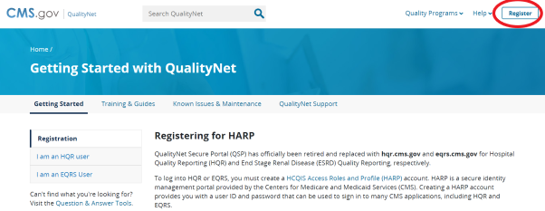
Step 1: Create HARP accounts for all new Security Administrators at https://harp.cms.gov/register/profile-info

Step 2: Register Security Administrator with QualityNet
If a hospital has another Security Administrator (SA) active in QualityNet, they may add anyone with a HARP ID into this facility’s QualityNet account. The SA logs in, selects Administration and then Access Management. Select Add User and then enter the HARP ID of the new SA.

If a hospital does not have another Security Administrator active in QualityNet, the new SA will call HQR program support at 866-288-8912.

Step 3: Enroll in the Hospital Quality Reporting System located within the QualityNet Secure Portal
Training Materials: A set of instructional support videos are now available to help you navigate through HQR. You may access these videos from the HQR playlist at: https://www.youtube.com/playlist?list=PLaV7m2-zFKpjctAKzszs_jNbXmhvADgcy.
Step 4: Complete Inpatient Notice of Participation (NoP)
For a hospital to have their data publicly reported, a Notice of Participation (NoP) must be completed. A NoP must be completed for inpatient and outpatient reporting. NoPs are required for participation in the Medicare Beneficiary Quality Improvement Program (MBQIP) to verify if your hospital has completed a NoP, or needs to complete a NoP for the first time:
- Log into the QualityNet Secure Portal.
- From the dashboard, under Administration, select Notice of Participation.
- Next, you will see the available programs to confirm for NoP selection.
- Select the program to review the pledge on file or follow the confirmation steps, if needed.

Hospitals are required to maintain an active QualityNet Security Administrator. To maintain an active account, it is recommended that QualityNet SAs log into their account at least once per month. If an account is not logged into for 120 days, it will be disabled. Once an account is disabled, the user will need to contact the QualityNet Help Desk to have their account reset.
.
Step 5: Install CART on your computer or contract with an approved measures reporting vendor
CART is free CMS Abstraction & Reporting Tool software for the inpatient and outpatient reporting programs and can be downloaded from QualityNet: https://qualitynet.cms.gov/outpatient/data-management/cart.
- Follow the instructions on the page to install or update CART as needed.
- CMS releases new versions of CART when changes are made in the Core Measures – you will not be able to report if you are not using the correct version of CART.
- Follow the same steps to install or update CART – Outpatient.
Important: CART – Inpatient and CART – Outpatient are two separate software packages and need to be installed individually. The login for each of the accounts will also be individual.
Training videos for CART set-up and initial login: View the following training videos (also posted on QualityNet) to understand the basics and as well as the patient set up and abstraction:
- CART Basics (32-minute video)
- CART Patient Set-up/Abstraction and Import/Export (28-minute video)
.

Contact QualityNet Help Desk at 866-288-8912 for any questions about CART or QualityNet.
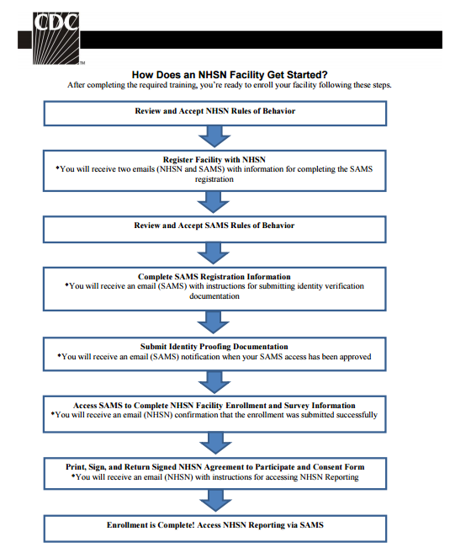
Step 6: Enroll in Centers for Disease Control (CDC)/National Healthcare Safety Network (NHSN) to report Health Care Acquired Infections (HAI)
Copied from NHSN Facility Administrator Enrollment Guide
- To enroll your facility with CDC to report HAI visit: http://www.cdc.gov/nhsn/enrollment/index.html
- Choose your facility type to enroll in the program and follow the steps on the webpage.
- Once all the steps in the picture to the right are complete, you will need to wait to receive a SAMS grid card credential in the mail from CDC. This can take up to a few weeks.
- Using the SAMS grid credential, login to NHSN at: http://www.cdc.gov/nhsn/enrollment/index.html.
- After logging into SAMS using the SAMS grid card, click NHSN Enrollment. Then click Access and print required enrollment forms.
- Print the required forms listed under the component you are enrolling in, which will be submitted electronically in the next step. CAHs should enroll under the Healthcare Personnel Safety component.
- After accessing, printing and completing required enrollment forms, select Enroll facility.
- Complete the enrollment.
- You will immediately receive an “NHSN Facility Enrollment Submitted” email with a link to your consent form.
- Consent forms are facility specific – print the forms within 30 days of receiving the email.
- Forms must be signed by:
  - A contact person for each component being followed; and
  - The leadership/administrator.
Signature pages must be faxed to 404-929-0131 (do not mail)
- Within 3 -5 business days you will receive an email notification from NHSN notifying you of facility activation.

Contact the NHSN Help desk at nhsn@cdc.gov if you have any questions.
MT Flex offers data sharing via a NHSN User Group. Instructions to join the User Group can be accessed here: https://mtpin.org/wp-content/uploads/2020/01/5.-NHSN.docx

Step 7: HCAHPS Survey administration and reporting
Determine the process for the HCAHPS survey implementation. The survey can be implemented by either the hospital or a vendor contracted by the hospital. It should be noted that the requirements for implementing the survey are stringent so most hospitals choose to have their survey process completed by a vendor. As with any service provided by a vendor it is recommended that CAHs work closely with their chosen vendor to ensure that their survey data is submitted and will contribute to their HCAHPS measure score. For quarters with either zero patients eligible for a survey or zero responses were returned, the hospital vendor can submit this “zero” when data they submit quarterly to CMS.
An updated list of approved vendors can be found at on the HCAHPS Online website https://hcahpsonline.org/en/approved-vendor-list/.
For more information about approved vendors, including those that work specifically with small rural hospitals, see the HCAHPS Vendor Directory at https://www.ruralcenter.org/tasc/resources/hospital-consumer-assessment-healthcare-providers-and-systems-overview-vendor from the National Rural Health Resource Center.
Training materials for hospitals that plan to self-administer the survey can be found at: https://hcahpsonline.org/en/training-materials/.

Step 8: Use the online tool available on the Stratis Health website to record data on the Emergency Department Transfer Communication (EDTC)
- The data specifications manual can be found at http://www.stratishealth.org/documents/ED-Transfer-Data-Specifications-Manual.pdf.
- Download and save the Excel data collection tool (“ED_Transfer_Tool_Data_Collection_Tool.xls”) by clicking https://stratishealth.org/toolkit/emergency-department-transfer-communication/.
- Instructions on using the EDTC Data Collection Tool and abstraction of data can be found at: https://stratishealth.org/wp-content/uploads/2020/07/EDTC-Data-Collection-Tool-Manual-v4.1.pdf.
Training Video: The EDTC Data Collection training video is a 25-minute video that serves as a step-by-step guide on how to download the Excel-based data collection tool, enter data, and run reports to calculate your measures.

Exporting Data from CART
Figure 1
- Open CART and choose inpatient or outpatient.

- Click on Abstraction Search (Figure 1).
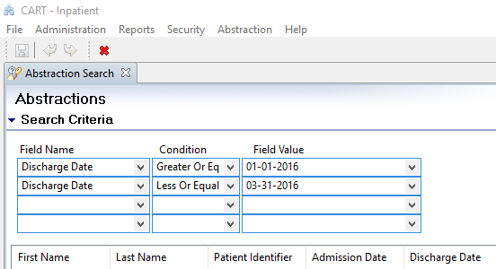
Figure 2
- Search by discharge date to reflect the quarter dates (Figure 2):
  - Make sure to use “-“as separators for the date.
  - Click Search on the page.

- Pull down all the records to one page by using the down arrow (Figure 3).

- Sort by abstraction status to check if there are any pending files or errors.
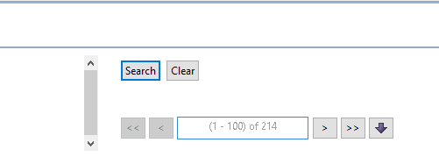
Figure 3
- Select all the files on the page once all the files show abstraction status of “complete.”

- Click on Export at the bottom of the page:
  - File type: Zip
  - Measure type and export type: CMS
  - Action type: Add
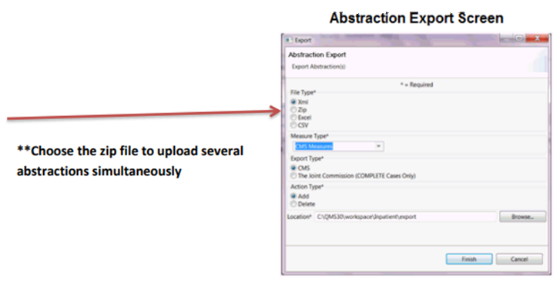
  - Location: Make sure to create a new folder and choose that folder as your location. XML files are individual files, so it is much easier to have all files in one zip file. Otherwise, if you have 250 files, you will have 250 individual files.
- Once the export is complete, confirm that the number of files exported is same as the number of files in CART.

Submitting Chart Abstracted Data Via QualityNet
Uploading IQR and OQR files
- Log in to Hospital Quality Reporting (HQR) at https://hqr.cms.gov/hqrng/login.
- Under the Dashboard, select Data Submissions,
- Choose Chart Abstracted from the tabs at the top of the screen.
- Make sure to select Production as the submission type.
- Click Select Files. A browsing window will open. Then navigate to the folder where you have saved your CART xml files.
- You can select all the xml files and click open or save the CART folder as a zip folder and choose to upload the files as a zip folder (zip folder uploading leads to less chance of upload failure as well as fewer confirmation emails).
- You will receive an email from qnetsupport@sdps.org if and when your files are processed. If you upload the files as a zip folder, you will receive one email with the information about number of files accepted vs. rejected.
To verify that cases have been accepted:
- Log in to Hospital Quality Reporting (HQR) at https://hqr.cms.gov/hqrng/login.
- Under the Dashboard, select Data Results.
- Select Chart Abstracted under Data Results.
- Select the relevant program from the drop-down menu, IQR or OQR.
- From the Report drop-down menu, select Case Status Summary.
- Select the appropriate Encounter Quarter from the drop-down menu.
- Select Export CSV.
- The report requested will pop up in an Excel spreadsheet. Open the spreadsheet to view the report.
Export cases from CART to QHi for population of Montana reports
NOTE: This needs to be repeated for each month for both OP-18 and OP-2 and 3.
- In CART, Create Measures Report.
- Select Reports > Measures > Measures Set AMI or ED
- Select Discharge date range. This MUST be one month. From - the first day of the month and to - last day of the month. Example: From: 04-01-2022 To: 04-30-2022. Choose OK
- In CART Report Viewer, Select the save icon and choose Export as CSV. Rename the file to the measure and month. Example: OPAMIApril.csv. Note the location of the CSV file that is created to easily find it.
- Log into QHI and navigate to Home > Data Submission
- Click on Import CART data link.
- Choose Browse and go to file location.
- Click import & Confirm Import.
- Repeat steps for each month in the submission quarter.

Web-Based/Structural Measures Reporting
For each of the below:
- Log in to Hospital Quality Reporting (HQR) at https://hqr.cms.gov/hqrng/login.
- Under the Dashboard, select Data Submissions.
- Choose Web-based Measures from the tabs at the top of the screen.
- Select the way you would like to submit your data – either with a file upload or via data form. The most common way to submit data for a CAH is via data form.

PC-01: Quarterly Reporting
- Select IQR Launch Data Form.
- Select the most recent year from drop-down of Payment Year.
- After selecting the quarter, click on “PC-01.”
- Select Start Measure to enter all the questions.
- Select Submit the Data when you are finished.

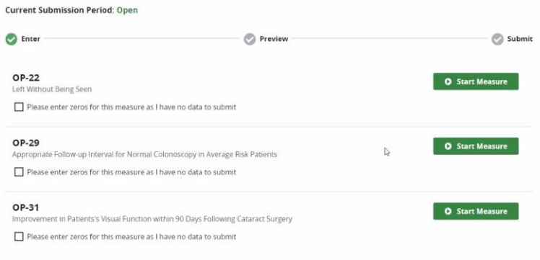
Outpatient Web-based Measures (OP-22, OP-29, OP-31): Annual Reporting

- Select OQR Launch Data Form.
- Select the most recent year from drop-down of Payment Year.
- Select Start Measure to complete all the data for each measure.
- If you are not submitting data (for OP-29 or OP-31), you must select, Please enter zeros for this measure as I have no data to submit.
- Once all three measures are complete, you may select, I am ready to submit.
- Enter data into QHi for December of encounter year.

Submitting Data to NHSN
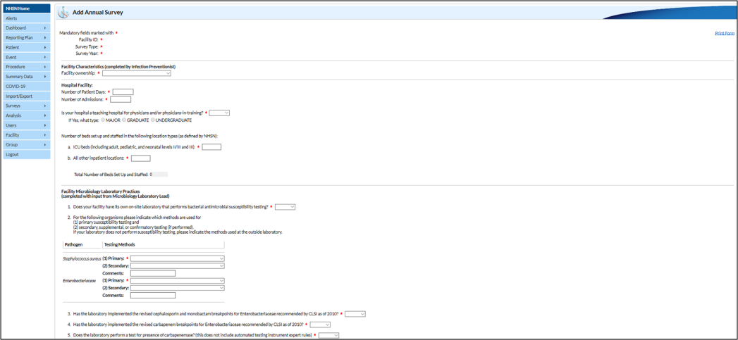
Completing Annual Patient Safety Survey
- Log in to the NHSN site at
https://www.cdc.gov/nhsn/index.html and select
NHSN Member Login, using SAMS grid card.
- Choose Patient Safety Component
- Navigate to Surveys > Add.
- Complete the required fields.

Completing Healthcare Personnel Influenza Vaccination
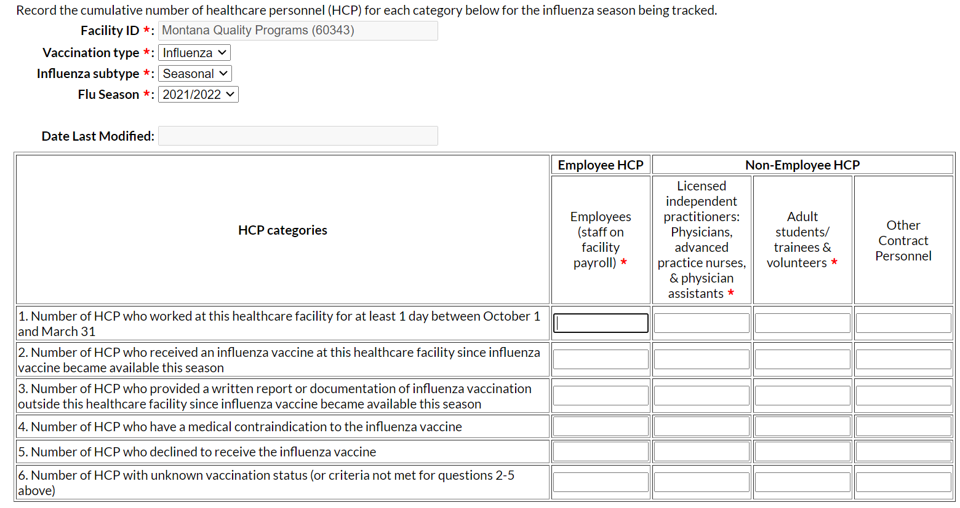
- Gather healthcare personnel influenza immunization data.
- Log in to the NHSN site at https://www.cdc.gov/nhsn/index.html and select NHSN Member Login, using SAMS grid card.
- Choose Healthcare Personnel Safety Component.
- Choose Reporting Plan > Add.
- Select Month: March, Year: Current Year. You may get a note that “No data available” Just click OK.
- Under Healthcare Personnel Vaccination Module; check Influenza Vaccination Summary .
- Select Save.
- Navigate to Vaccination Summary> Annual Vaccination Summary > Add.
- Select Flu Season from drop down.
- Complete the required fields and Save.
- MT Flex will input your data in QHi if the facility is in the MT User Group.

Submitting Data to NHSN
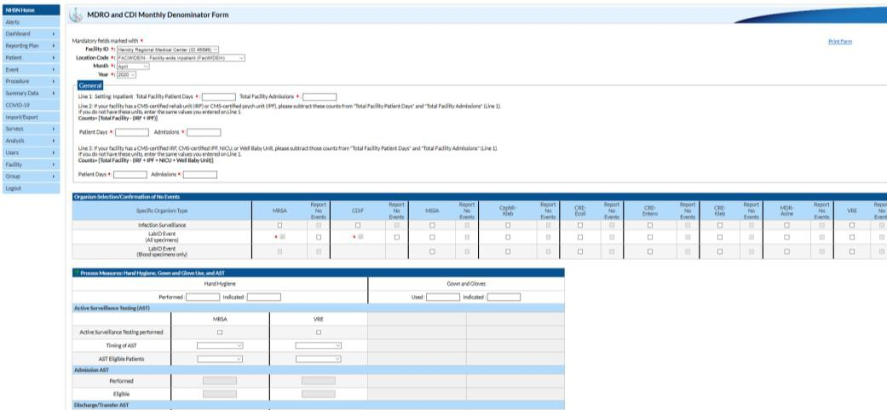
Completing Monthly HAI Reporting
- Log in to the NHSN site at
https://www.cdc.gov/nhsn/index.html and select
NHSN Member Login, using SAMS grid card.
- Navigate to Summary Data > Add.
- Select MDRO and CDI Monthly Denominator Form – All
Locations.
- Complete the required fields.
- If there have been any infections, then you will complete
a separate module.

Training Video: MDRO and CDI Monthly Denominator Training. This video is a step-by-step guide to completing the form.

Resources for Quality DIRECTORS AND STAFF

National Organizations:

National Rural Health Resource Center (https://www.ruralcenter.org/)
Provides technical assistance, information, tools and resources for the improvement of rural health care. It serves as a national rural health knowledge center to build state and local capacity. It supports various programs including:
- Small Rural Hospital Improvement Grant Program (SHIP)
- Health Education and Learning Program Webinars
- Performance Management Group (PMG) calls
- Technical Assistance and Services Center (TASC)
- Rural Health Performance Improvement (RHPI)
- Rural HIT Network Development (RHITND)
- Population Health Portal
- Key Health Alliance

Quality Reporting Center (http://www.qualityreportingcenter.com/ )
This website provides outreach and education support programs. Here you will find resources to assist hospitals, inpatient psychiatric facilities, PPS-exempt cancer hospitals, and ambulatory surgical centers with quality data reporting. Through these sites, you can access:
- Reference and training materials
- Educational presentations
- Timelines and calendars
- Data collection tools
- Contact information
- Helpful links to resources
- Question and answer tools

Quality Net (https://qualitynet.cms.gov/)
Established by the Centers for Medicare & Medicaid Services (CMS), QualityNet provides health care quality improvement news, resources and data reporting tools and applications used by health care providers and others. It supports information for CART, HIQR, HOQR, ASCs, ESRD facilities, and Inpatient Psychiatry facilities. QualityNet is the only CMS-approved website for secure communications and health care quality data exchange between: quality improvement organizations (QIOs), hospitals, physician offices, nursing homes, end stage renal disease (ESRD) networks and facilities, and data vendors.

Institute of Healthcare Improvement (http://www.ihi.org/Pages/default.aspx)
IHI is a not-for-profit organization, which is a leading innovator, partner and driver of the results in health and health care improvement worldwide. IHI provides various forms of education including virtual training, conferences, IHI open school and in-person training. IHI focus areas include:
- Improvement capability
- Person and family-centered care
- Patient safety
- Quality, cost and value
- Triple Aim for populations

Quality Payment Program (https://qpp.cms.gov/)
The Quality Payment Program makes Medicare better by helping you focus on care quality and the one thing that matters most – making patients healthier. The Quality Payment Program ends the sustainable growth rate formula and gives you new tools, models, and resources to help you give your patients the best possible care. You can choose how you want to take part based on your practice size, specialty, location, or patient population. The QPP website has step-by-step instructions to meet MACRA/MIPS requirement and is governed by CMS.

Stratis Health Quality Improvement Basics Course, Concepts and Tools (https://stratishealth.org/quality-improvement-basics/)
This QI Basics course is designed to equip professionals with the knowledge and tools to start quality improvement projects at their facilities. The course may be completed in sequence, or individual modules and tools may be used for stand-alone training and review.

Other National Quality Sites:
- National Association for Healthcare Quality (http://www.nahq.org/)
- Agency for Healthcare Research and Quality (http://www.ahrq.gov/)
- Centers for Medicare and Medicaid Services, Quality Initiatives (https://www.cms.gov/medicare/quality-initiatives-patient-assessment-instruments/qualityinitiativesgeninfo/index.html)

State Organizations:

Montana Rural Hospital Flexibility Grant & Performance Improvement Network (Flex/PIN) (http://www.mtpin.org)
The Montana Rural Hospital Flexibility (Flex) Program provides funding to spur quality and performance improvement activities, stabilize rural hospital finance and integrate population health and emergency medical services (EMS) into existing health care systems. The program encourages the development of cooperative systems of care in rural areas to increase efficiencies. Forty-nine of Montana’s critical access hospitals benefit from the program and participate in the Performance Improvement Network (PIN), which facilitates the sharing of resources related to meeting these goals.

The mission of the Montana Rural Healthcare Performance Improvement Network (PIN) is to develop and provide a collaborative support system which will enable small rural hospitals to have the ability to deliver quality care and achieve customer satisfaction.

Montana Hospital Association (http://www.mtha.org)
The Montana Hospital Association (MHA) is a nonprofit organization with more than eighty members that provide the full spectrum of healthcare services, including hospital inpatient and outpatient services, skilled nursing facilities, home health, hospice, physician services, assisted living, senior housing and insurance services.

Every acute care hospital in the state is a member. Members range from the smallest critical access hospitals, providing primary care services in Montana’s rural communities, to the largest tertiary care hospitals in the state.

Montana Office of Rural Health (MORH) (https://healthinfo.montana.edu/morh/index.html)
The Montana Office of Rural Health is dedicated to improving access to quality healthcare for rural Montana by providing collaborative leadership and resources to healthcare and community organizations. This is accomplished through services such as Rural Hospital and Clinic Programs, Area Health Education Centers (AHEC), Small Rural Hospital Improvement Grant Program (SHIP), and the Montana Rural Health Association (MRHA).

MORH works with federal, state and local partners to offer services and resources to rural healthcare providers, facilities and communities. The MORH is proud to collaborate with various organizations, health departments, hospitals, government and academia. MORH is committed to provide rural health leadership for the state’s diverse and inclusive statewide constituency of stakeholders.

Mountain-Pacific Quality Health (https://www.mpqhf.org/corporate/)
Mountain-Pacific Quality Health (MPQH) is a nonprofit health care improvement organization that partners within our communities to provide solutions for better health. We first opened our doors in Helena, Montana, in 1973; since then, we have broadened our reach to include Wyoming, Alaska, Hawaii and the U.S. Pacific Territories of Guam, American Samoa and the Commonwealth of the Northern Mariana Islands.

MQPH serves as Montana’s Medicare Quality Improvement Organization (QIO) and leads QI initiatives as a QIN-QIO subcontractor. MPQH partners with health care providers, practitioners, stakeholders, patients and families on a variety of quality improvement initiatives to achieve better care, better population health and lower health care costs. MPQH also offers technical assistance, guidance and information on best practices to support meaningful use of electronic health records through their Health Transformation Consulting Services (https://www.mpqhf.org/corporate/health-and-transformation-services/)

Montana Healthcare Associated Infection Prevention Initiative (MT HAI) (https://dphhs.mt.gov/publichealth/cdepi/haiprevention)
This program has provided support to healthcare facilities since 2012 through the Epidemiology and Laboratory Capacity Cooperative agreement with CDC. This funding supports the following Montana activities:
- Improve accurate reporting of HAIs to the NSHN database
- Coordinate and implement HAI prevention activities
- Improve infection prevention breadth and scope at healthcare facilities
- Facilitate the advisory group composed of physician, infection preventionists, pharmacists and leaders from Mountain Pacific Quality Health and Montana Hospital Association to create the HAI State Plan
- Detect and help mitigate outbreaks that occur in healthcare facilities
- Educate providers to prescribe antibiotics appropriately
- Assist hospitals and other healthcare facilities to have strong Antibiotic Stewardship Programs

IV. Analyzing and sharing data within the hospitaL
It is important for staff, managers, leadership and board members to regularly receive information about the hospital’s performance on quality metrics and patient safety measures and for the hospital to use this information to identify ways it can improve. Strong Quality Committee participation and engagement help to ensure compliance with CAH standards.

Sharing MBQIP and HCAHPS Data
The Montana Flex Program provides quarterly MBQIP reports to each CAH, which compares an individual hospital’s MBQIP and HCAHPS performance to the state average. These reports are good indicators of your hospital’s current performance in these measures.
MBQIP data is released with a lag time of about two quarters. The EDTC reporting tool, however, can help identify your facility’s performance for the current quarter. The figure below shows an example EDTC tool report that can be run once the data are entered in the EDTC Excel tool.
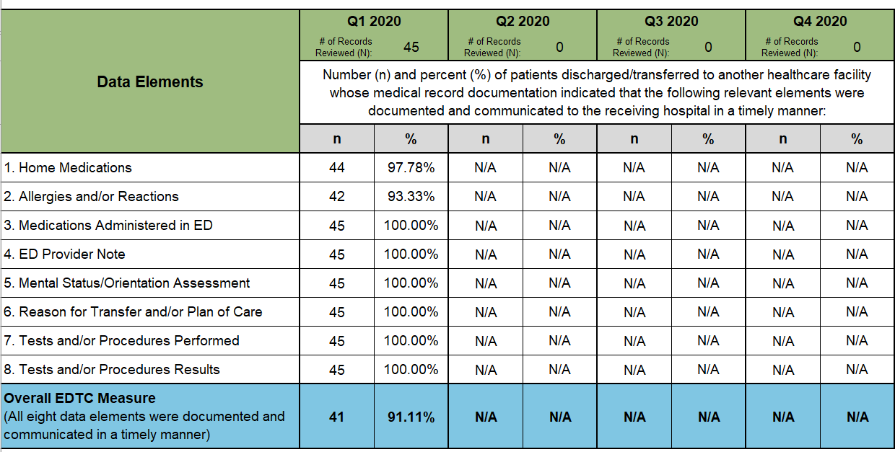
Additionally, if CAHs are using a vendor to conduct the HCAHPS survey, the vendor can provide a monthly report to share the hospital’s scores. Please contact your vendor for more information.

Sharing IQR and OQR Data
The CART “Measure Summary” and “Measure Failure” are two important reports that will help the hospitals measure their performance.
Measure Summary Report: This report shows the hospital’s performance rate for all the measures. The hospitals performance score shows the number of failed cases
- Choose Measure Summary” Provider – Your facility.
- Choose the Measure Set.
- Choose Discharge Date for the quarter or the month.
Measure Failure Report: This report will help identify individual cases that failed the measure. Follow-up on these patient charts can help identify the reason for failure.
- Choose the provider, measure set and discharge date for the report.

Other Examples of How to Share Data
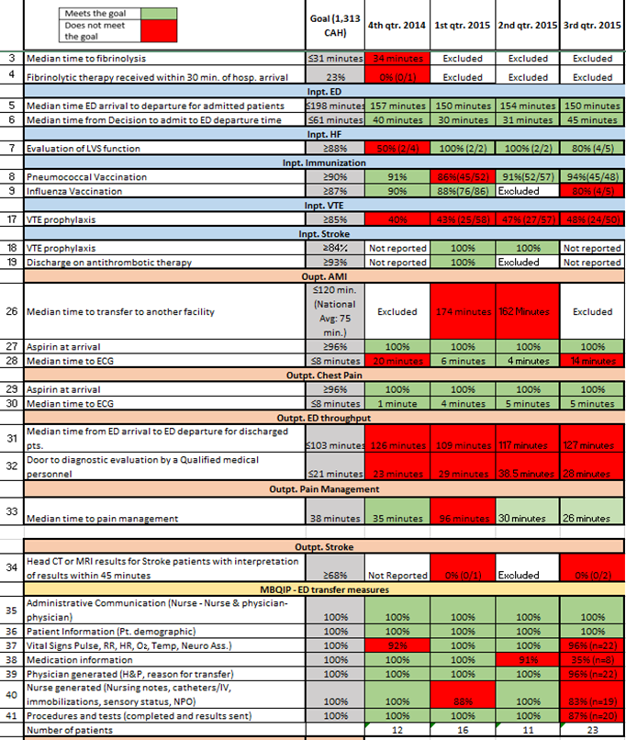
One way to share data is to create and share a stop light report outlining quality measures and your hospital’s progress.
Visual indicators that provide a snapshot of information are often meaningful ways of promoting a culture of providing high quality of care with frontline staff.
A quality and patient safety bulletin board can showcase information about patient safety measures; Patient Falls, Adverse Drug Events, CLABSI, CAUTI, SSI, and Immunization measures in addition to other quality measures.
Note that it is important to be sure that this information is shared and located in a highly visible location for staff. If the whole board is too much to concentrate on at one time, highlight certain key measures to work on and show what is being done to address those measures. This is ideally done in the same location to better communicate process and outcome results.

Appendix A: Additional MBQIP Improvement Measures
Short Name | Measure | Source

Patient Safety/Inpatient
CLABSI | Central Line-Associated Bloodstream Infection | National Healthcare Safety Network (NHSN)
CAUTI | Cather Associated Urinary Tract Infection
CDI | Clostridium Difficile Infection
MRSA | Methicillin Resistance Staphylococcus Aureus
SSIs | Surgical Site Infections Colon or Hysterectomy
Perinatal Care | PC-01: Elective Delivery | Internal Tracking  QualityNet
Falls | Potential measurement around Falls with Injury, Patient Fall Rate, Screening for Future Fall Risk | Internal Tracking
Adverse Drug Events (ADE) | Potential measurement around Opioids, Glycemic Control, Anticoagulant Therapy | Internal Tracking  MT HQIC Data Reporting
Patient Safety Culture | Patient Safety Culture Survey | AHRQ Surveys on Patient Safety Culture (SOPS)
Influenza Vaccination | Inpatient Influenza Vaccination (formerly IMM-2) | Internal Tracking

Patient Engagement
ED Patient Experience | Emergency Department Patient Experience Survey | Internal Tracking

Care Transitions
Discharge Planning | Potential measurement | Internal Tracking
Medication Reconciliation | Potential measurement | Internal Tracking
Swing Bed Care | Potential measurement | Internal Tracking
Claims-Based Measures | These measures are automatically calculated for hospitals using Medicare Administrative Claims Data including:  - Reducing Readmissions  - Complications  - Hospital Return Days | Medicare Administrative Claims Data Reports (PPS hospitals only)

Outpatient
Chest Pain/AMI | Potential measurement around Aspirin at Arrival (formerly OP-4) and Median Time to ECG (formerly OP-5) | Internal Tracking
ED Throughput | Potential measurement of Door to Diagnostic Evaluation by a Qualified Medical Professional (formerly OP-20) | Internal Tracking

Appendix B: Tools Used for Reporting
Program | Tool
Adverse Drug Events, Readmissions,  Sepsis Mortality, Pressure Ulcer Rate (HQIC) | QHi
CAUTI | NHSN/QHi
CLABSI | NHSN/QHi
C. diff | NHSN/QHi
HAI | NHSN
HCAHPS | QualityNet through registered vendor or self-administered
HQIC | QHI & NHSN
IQR | QualityNet via CART or data vendor
OQR | QualityNet via CART or data vendor
MIPS | Registry or EHR
MBQIP | QHi/MT Flex, QualityNet & NHSN

Appendix C: Quality Crosswalk for CAHs
Measure | Measure  Name | MBQIP | IQR | eCQM | OQR | HQIC | PIP
OP-2 | Fibrinolytic therapy received within 30 minutes | ✓ |  |  | ✓
OP-3 | Median time to transfer to another facility for acute coronary intervention | ✓ |  |  | ✓
OP-8 | MRI lumbar spine for low back pain |  |  |  | ✓
OP-10 | Abdomen CT use of contrast material |  |  |  | ✓
OP-13 | Cardiac imaging for preoperative risk assessment for non-cardiac low-risk surgery |  |  |  | ✓
OP-18 | Median time from ED arrival to ED departure for discharged ED patients | ✓ |  |  | ✓
OP-22 | Patient left without being seen | ✓ |  |  | ✓
OP-23 | ED head CT or MRI scan results for acute ischemic stroke or hemorrhagic stroke who received head CT or MRI scan interpretation within 45 minutes of arrival | ✓ |  |  | ✓
HCP/IMM-3 | Influenza vaccination coverage among health care personnel (formerly OP-27) | ✓ |  |  | ✓
OP-29 | Endoscopy/polyp surveillance: appropriate follow-up interval for normal colonoscopy in average risk patients |  |  |  | ✓
OP-31 | Cataracts – Improvement in Patient’s Visual Function within 90 Days Following Cataract Surgery |  |  |  | ✓
EDTC | Emergency department transfer communication | ✓
ED-2 | Admit decision time to ED departure time for admitted patients |  | ✓ | ✓ |  |  | ✓
Sepsis | Severe sepsis and septic shock: Management bundle (Composite Measure) |  | ✓
STK-2 | Ischemic stroke patients discharged on antithrombotic therapy |  | ✓ | ✓ |  |  | ✓
STK-3 | Anticoagulation therapy for arterial fibrillation/flutter |  | ✓ | ✓ |  |  | ✓
STK-5 | Antithrombotic therapy by the end of hospital day two |  | ✓ | ✓ |  |  | ✓
STK-6 | Discharged on statin medication |  | ✓ | ✓ |  |  | ✓
STK-8 | Stroke education |  | ✓
STK-10 | Assessed for rehabilitation services |  | ✓
VTE-1 | Venous thromboembolism prophylaxis |  | ✓ |  |  |  | ✓
VTE-2 | Intensive care unit venous thromboembolism prophylaxis |  | ✓ |  |  |  | ✓
PC-01 | Elective delivery prior to 39 completed weeks of gestation | ✓ | ✓ |  |  |  | ✓
PC-05 | Exclusive breast milk feeding |  | ✓ | ✓ |  |  | ✓
CLABSI | Central line-associated bloodstream infection, expand to include some non-ICU wards | ✓ |  |  |  | ✓
SSI | Surgical site infection | ✓ |  |  |  | ✓
CAUTI | Catheter-associated urinary tract infection, expand to include some non- ICU wards | ✓ |  |  |  | ✓
MRSA | MRSA bacteremia | ✓
CDIFF | Clostridium difficile (C. Diff) | ✓ |  |  |  | ✓

Appendix D: Quality Data Reporting Channels

Appendix E: Quality Health Indicators (QHi)
The Quality Health Indicators (QHi) platform is a service of the Kansas Hospital Education and Research Foundation. It is a comprehensive online platform that allows for submission of a variety of data AND provides users with the ability to run your own reports. Access to the program is provided by MT Flex and HQIC.
QHi Data Entry Layout
QHi’s elements and measures are divided into 4 categories. MT measures have been placed within these.
  - Clinical Quality- Monthly
  - Clinical Quality - Annual
  - Workforce
  - Finance/Operational

Data in entered in QHi by element; elements are then used to calculate reported out measures. This calculation will display in real time as you enter data. Once an element is entered, it will populate for future occurrences of that element. On the information document we have noted what measures are calculated and what calculation an element informs.

The order of the elements within each group cannot currently be changed, however hospitals may filter by measure set.
Any staff may enter data specific to them. Once added as a user, the user can choose their elements as Favorites and these will appear at the top.

QHi Core Measures List
QHi has a set of eight long-standing core measures. These will show up by default in each user’s profile and cannot be removed. Some measures are also PIN Benchmarking and/or HQIC measures. For those that do not overlap, feel free to skip. Overlapping measures in the list of QHi Core Measures in italics below.
- Healthcare Associated Infections per 100 Inpatient Days - BCBSKS CAH *Core Measure*
- Unassisted Patient Falls per 100 Inpatient Days *Core Measure*
- Readmission within 30 days (All Cause) Rate (same hospital) - KHC Compass (Req.), BCBSKS CAH & BCBSKS PPS *Core Measure*
- Percentage of Return ER Visits within 72 hours with same/similar diagnosis *Core Measure*
- Benefits as a Percentage of Salary *Core Measure*
- Staff Turnover *Core Measure*
- Days Cash on Hand *Core Measure*
- Gross Days in AR *Core Measure*

QHi Data Entry Frequency
Data is entered into QHi by month. Reports for MBQIP and PIN Benchmarking will use this data to calculate and display quarterly values. Regardless of the choice of data entry timing, data still must be in by the requested due date of the program you are entering data for.

- MBQIP and PIN Benchmarking data can be each month or quarterly for all three months (separate value for each month) by the data deadline.
- Enter data one month at a time: Select month from the drop down entitled Select month for entry.
- Enter a complete quarter at once: Select the last month of the quarter you are entering data for and click toggle for Multi-Month Entry

QHi Data Efficiency Opportunities
Please note the following opportunities in data efficiencies.

NHSN
If you submit the following measures to NHSN and have conferred rights to the MHA User Group; data will be pulled from the MT team and entered into QHi for you.
- MBQIP: Healthcare Worker Immunization This MUST be entered into NHSN to receive credit for reporting to the MBQIP program.
- HQIC: Clostridioides difficile Rate, Central Line Associated Bloodstream Infection (CLABSI) Rate, Central Line Utilization Ratio, Urinary Catheter Device Utilization Ratio, CAUTI Rate

DATABANK
The existing data sharing process within MHA for measures submitted to DataBank will continue. Measures are noted on PIN Benchmarking resource materials. MT Flex will send an email asking if you’d like us to use Databank values. Just respond Yes or No. DataBank metrics only apply to the PIN Benchmarking Project.

If you respond yes: Please ensure that whoever submits to DataBank from your facility completes the quarter by the PIN Benchmarking deadline.
If you respond no: enter the data into QHi prior to the deadline.

MBQIP
MBQIP measures must be submitted to the required reporting platform to ‘count’ as participation in the MBQIP data program and MT Flex Grant.
For measures submitted to QualityNet, follow the instructions in the measure sets to upload your data to QHi once it has been submitted to QualityNet. Entering data in QHi DOES NOT REPLACE REPORTING TO QNET.

QHi Support & Resources
QHi hosts monthly review calls and MT staff will send these notices out to QIC/DON emailing lists and the PIN List Serv. You can find information about these calls on your QHi dashboard page under Training and Education.

QHi Platform Support:
Stuart Moore | smoore@kha-net.org | 785-276-3104
Sally Othmer | sothmer@kha-net.org | 785-276-3118

References
- MBQIP Quality Reporting Guide 2020. Downloaded at following address: https://www.ruralcenter.org/resource-library/mbqip- quality-reporting-guide
- EDTC Reporting Tool manual gives detailed instructions on how to download and use the tool. It can be viewed at: https://stratishealth.org/wp-content/uploads/2020/07/EDTC-Data-Collection-Tool-Manual-v4.1.pdf
- National Rural Health Resource Center MBQIP Measures: https://www.ruralcenter.org/tasc/resources/mbqip-measures
- Quality Improvement Implementation Guide and Toolkit for Critical Access Hospitals: https://www.ruralcenter.org/tasc
/resources/quality-improvement-implementation-guide-and-toolkit-critical-access-hospitals
- Rural Emergency Department Transfer Communication Resources (Stratis Health): ::http://www.stratishealth.org/providers/ED_Transfer_Resources.html
- Quality Payment Program: https://qpp.cms.gov/
- Payment Adjustment Cycle information and graphic: https://nrdrsupport.acr.org/support/solutions/articles/11000028996-merit-based-incentive-payment-system-mips-
- Hospital Inpatient Quality Reporting (IQR) Program Measures: https://www.qualitynet.org/inpatient/iqr/measures
- Hospital Outpatient Quality Reporting (OQR) Program Measures: https://qualitynet.cms.gov/outpatient/oqr/measures
- Hospital Consumer Assessment of Healthcare Providers and Systems: https://www.cms.gov/Medicare/Quality-Initiatives-Patient- Assessment-Instruments/HospitalQualityInits/HospitalHCAHPS.html

