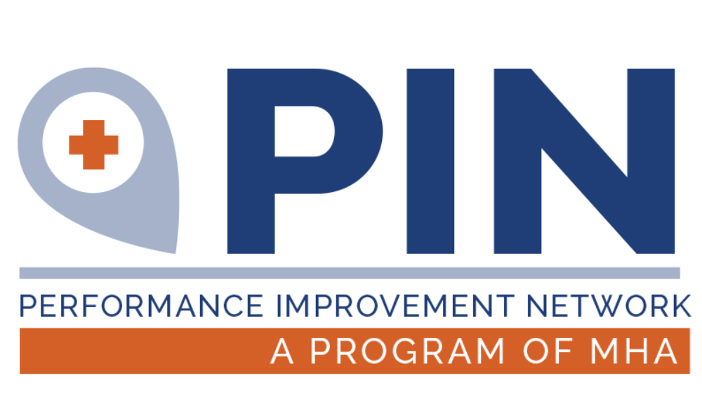

2023-2024 Program Year
MHREF Quality Programs Activity and Resource Catalog
Activities September 1, 2023 – August 31, 2024

Dated: 08/29/2023

This project is supported by the Health Resources and Services Administration (HRSA) of the U.S. Department of Health and Human Services (HHS) as part of an award totaling $928,510 with 0% financed with non-governmental sources. The contents are those of the author(s) and do not necessarily represent the official views of, nor an endorsement, by MT DPHHS, Montana Health Research & Education Foundation (MHREF), HSA, HHS, or the U.S. Government.

MHREF Quality Programs Activity Overview
All program activities listed below can be found in a specific area of the Montana Health Research and Education Foundation (MHREF) Quality Programs work plan. Activities provide education, training, improvement projects or participant support for onsite conferences. Most activities are at little to no cost to Montana Critical Assess Hospitals and Rural Health Clinics. Services funded solely by the Montana Flex Program are only available Critical Access Hospitals. Related Quality Program Area and/or audience is indicated.

Meetings and Network Opportunities
- Montana Healthcare Conference
- CAH CEO Meetings
- DON/QIC CAH Regional Meetings
- Rural Health Clinic Regional Meetings
- MHA Health Summit
- HFMA/MHIMA Annual Meeting

Distance Education
- Regular Connections
- MBQIP Mini Series
- Conditions of Participation Webinar Series
- Billing and Coding Webinar Series

Improvement Projects
- Cultivating the Roots of Quality Improvement
- Antibiotic Days of Therapy Tracking Tool
- Lean Internship Program with Montana State University
- Practice Operations National Database (POND) for Rural Health Clinics
- Strategic Planning Model for a Montana CAH Centered Balanced Scorecard

Consulting Training
- Annual Certification Program: Certified Professional in Healthcare Risk Management (CPHRM)
- Swing Bed Certification
- QI Champions
- Mock Survey
- Survey Self-Assessment Tools
- Community Health Needs Assessment (CHNA) Implementation Plans (IP)

Data Monitoring
- Medicare Beneficiary Quality Improvement Program
- Quality Health Indicators (QHI)
- PIN Benchmarking

MEETINGS & NETWORKING OPPORTUNITIES

Montana Healthcare Conference | Financial & Operational
September 19–22, 2023 – Billings, MT
The Montana Healthcare Conference is Montana’s largest gathering of healthcare professionals. A partnership between Montana Hospital Association and the Montana Primary Care Association attracts attendees from nearly every hospital and community in Montana. This event takes place in Billings every Fall. MHREF Quality Programs provides reimbursement of participant support costs (registration and limited lodging) for MT CAH CEOs, as well as Quality & Nurse Leadership staff to attend (some limitations do apply for due to funding stream requirements). For more information about the Montana Healthcare Conference: https://mtha.org/education-events/annual-events/

CAH CEO Meetings | Financial & Operational
September 20, 2023 - Billings, MT
The MHREF Quality Program convenes CAH CEOs on a regular basis. The CEOs are brought together annually (during Montana Healthcare Conference) and bi-annually in odd years in Helena for educational content that includes updates on Quality Programs, input for future programs and activities, and education from subject matter experts. The 2023 CAH CEO meeting will be held September 20 in Billings as a kickoff event to the Healthcare Conference. The next CAH CEO Winter meeting will be in Helena, January of 2025.

DON/QIC Regional Meetings |Quality
October 2023 – Dates and Locations vary by Region
MHREF Quality Program staff hit the road every October to meet with Directors of Nursing and Quality Coordinators in each MHA Region. The regional meetings are no cost to participants and designed so CAH staff can travel to and from in one day. They are hosted by regional critical access hospitals as available. Content includes program updates, information, input for future Flex projects, quality improvement training, and time reserved for “QI Showcases” where peers share what they are doing in their hospitals.

MHA Health Summit |Quality
April 10-12, 2024 – Butte, MT
The MHA Health Summit is the premier educational opportunity to jump-start member learning for a new season. This event offers a wide range of topics which include emerging health equity trends; population health and quality improvement best practices, advances in telehealth; rural health transformation; leadership; and much more! MHREF Quality Programs hosts a CAH QIC/DON event and provides reimbursement of participant support costs (registration and limited lodging) for MT CAH staff to attend. For more information about the MHA Health Summit: https://mtha.org/education-events/

HFMA/MHIMA Annual Meeting | Financial & Operational
April 2024 – Official dates and location to be determined.
MHREF Quality Programs provide participant support reimbursement (registration and limited lodging) for up to 10 CAH staff to attend the annual meeting for MT Chapter of Healthcare Financial Management Association (HFMA) and MT Health Information Management Association (MHIMA). The Annual Meetings are held jointly each year in the spring. Learn more at:
Healthcare Financial Management Association (HFMA)
MT Health Information Management Association (MHIMA)

DISTANCE EDUCATION

Monthly Meet Up | Quality
MHREF Quality Programs host a monthly meet up, the first Thursday of every month. This meeting serves as an “office hours” format where MHREF provides a quick update on anything hospital staff need to know, and the remaining time is for participants to bring forward any questions or concerns. Registration for series: https://us02web.zoom.us/meeting/register/tZUufu-uqzgoH9294QI8LfQ-ja_qe55MK6cV

Conditions of Participation Webinar Series |Finance & Operations
MHREF Quality Programs will host two multi-part education series to provide education and support for Critical Access Hospital and Rural Health Clinic staff to prepare for and meet conditions of participation for each.

Coding & Billing Webinar- Critical Access Hospital | Finance & Operations
Appropriate coding and billing is essential to a hospital’s financial health MHREF Quality Programs provides webinar opportunities and continuing education credits at no cost for CAH staff responsible for coding in the facility to ensure the continual education so that CAHs can have the best impact to their financial health.

Coding & Billing Webinar- Rural Health Clinic | Finance & Operations
Appropriate coding and billing is essential to a hospital’s financial health. MHREF Quality Programs provides webinar opportunities and continuing education credits at no cost for RHC staff responsible for coding in the facility to ensure the continual education so that RHCs can have the best impact to their financial health.

IMPROVEMENT PROJECTS

Cultivating the Roots of Quality Improvement (QI Roots) | Quality
MHREF Quality Programs MHREF Quality Programs provide an annual quality improvement workgroup (QI Roots) with a subject matter expert to orient CAH QICs and other staff to healthcare quality improvement basics, project management tools, and team leadership. This program will teach fundamental skills while participants work on a specific project. Participants will choose a project topic in alignment with measures in data programs and then have opportunities to work together in topic cohorts as available. Education sessions and coaching hours are virtual.

Lean Internship Program with Montana State University (MSU) | Finance & Operations
Montana State University Industrial & Management Systems Engineering (IMSE) program in collaboration with the MT Flex Grant selects two students to participate in a summer internship performing Lean Rapid Improvement Events in 8 Critical Access Hospitals across rural Montana. Over each two-week event, students work in conjunction with hospital staff to apply their knowledge of Lean principles and tools towards a pre-determined improvement project within each facility. Applications go out in February of each year.

RHC Support and Network Development | Finance & Operations
MT Flex Program and MT Office of Rural Health are expanding their efforts in support of Montana’s Rural Health Clinics and the potential development of a Montana Rural Health Network. MT Flex and MORH have engaged with LillyPad, LLC and their data platform, POND (Practice Operations National Database) as well as EideBailly and Wintergreen as RHC consultants to further improve RHC performance through shared best practices, peer group evaluation, shared education and financial improvement. These efforts will support the eventual application to a Rural Health Network Development grant for Montana’s RHC’s.

Financial & Operational Improvement Project (FOIP) | Finance & Operations
Using quality improvement and lean tenets, cohort participants will work through project identification, scope, team facilitation and improvement tools to further financial health and viability metrics. MT Flex will engage a consulting subject matter expert that will provide education and coaching to participating CAH finance and revenue cycle staff.

Strategic Planning Model for a Montana CAH-Centered Balanced Scorecard | Finance & Operations
Data is essential to identifying areas to improve and areas to celebrate. MHREF Quality Programs is collaborating with the Montana Health Network to develop a MT CAH Balanced Scorecard (BSC) with incumbent measure for strategic planning. The intended audience for the strategic planning BSC model is the CAH leadership team and trustees and for use to compare performance and improvement for the largest to the smallest of Montana’s CAHs. The data provided will come from past Financial & Operational Indicators Improvement projects, data from the Flex Monitoring Team, and national benchmarks.

CONSULTING & TRAINING

Annual Certification Program: Certified Professional in Healthcare Risk Management (CPHRM) | Quality
MHREF Quality Programs will coordinate the development of a cohort of risk management staff to participate in a study group led by a subject matter expert to prepare staff to test for and obtain the Certified Professional in Healthcare Risk Management credential offered by the American Hospital Association. Study materials, meeting platform, subject matter expert, and test fee reimbursement for a passing score are all provided.

Mock Survey | Finance & Operations
The MHREF Quality Programs has entered into an agreement with HealthTech to provide Mock Survey services for up to 5 MT Critical Access Hospitals in which a consultant will come on site for approximately three days to perform a Mock Survey to assess readiness to comply with CMS Conditions of Participation. Hospitals can choose from one of four mock survey types: Critical Access Hospital, Rural Health Clinic, Environment of Care, and Swing Bed Program. This program is a on a cost-share basis with the hospital where the hospital is responsible for consultant travel costs and the MHREF Quality Programs will pay for consulting fees.

Survey Self-Assessment Tools | Finance & Operations
The MHREF Quality Programs will work with contracted subject matter experts to provide survey self-assessment tools and resources including, but not limited to, a full self-assessment of Appendix W of the CMS CoPs and a list of CMS CoP required policies. These resources will be updated regularly and made available to all Flex-eligible CAHs. Resources are available and can be found here; https://mtpin.org/education-meetings/education/cms-regulations/ on the PIN Website.

Community Health Needs Assessment (CHNA) Implementation Plans (IP) | Population Health
MHREF Quality Programs provides matching funds for 8 MT CAHs to support the Implementation Plan portion of the Community Health Needs Assessment (CHNA). CHNAs are an IRS Form-990 requirement of most CAHs and is a community health needs assessment process that helps CAHs engage members of their rural community, identify and measure the community’s health needs, recognize potential gaps in healthcare services, and develop specific strategies to prioritize and address the health needs that are identified during the CHSD process. MHREF Quality Programs collaborates with the Montana Office of Rural Health (MORH) at MSU to provide the CHNA implementation plans to the CAHs in need of the service and costs of the implementation plans are based on a 50/50 cost share between the CAH and the MT Flex Program. Applications open each year in September.

DATA MONITORING

Medicare Beneficiary Quality Improvement Program | Quality
The Medicare Beneficiary Quality Improvement Project (MBQIP) is a quality improvement activity under the Medicare Rural Hospital Flexibility (Flex) grant program. The goal of MBQIP is to continually improve the quality of care provided in small, rural and frontier Critical Access Hospitals (CAHs). MBQIP is a required activity of the MT Flex Grant. Additional MBQIP measures are not required, but the MT Flex Program will monitor and provide assistance with these measures in collaboration with other national quality programs (ie. HQIC). Participants in the HQIC are currently reporting on most of these measures.

Domain | Required | Additional
Care Transitions | Emergency Department Transfer Communications | Discharge Planning  Swing Bed Care  Medication Reconciliation  Reducing Readmissions
Outpatient | ED Throughput | ED Door to Diagnostic Evaluation
Patient Engagement | HCAHPS | ED Patient Experience Survey
Patient Safety | Healthcare Worker Influenza Immunization  Antibiotic Stewardship | Healthcare Associated Infections (HAI)  Falls  Adverse Drug Events (ADE)

Quality Health Indicators (QHi) Data Platform
The QHi platform will support data reporting to the PIN Benchmarking Project, Swing Bed Quality Improvement, allow for upload of MBQIP data, and is inclusive of Montana HQIC program data. Hospitals will then have access to pre-developed reports as well as the ability to develop their own reports as they see beneficial to their individual facility. This platform will allow for efficiencies and increased meaningfulness among both the facility and the MHREF Quality Programs.

ACTIVITIES FROM MT DPHHS

The following topics and projects are managed by staff at MT DPHHS with funding from the MT Rural Hospital Flexibility Grant.

Worksite Wellness | Population Health
The Worksite Wellness program has 8 CAHs participating to utilize CDC evidence-based programs of Live Life Well and Walk with Ease. For more information, contact Jessica Kechely, Health Education Specialist at Jessica.kechely@mt.gov or 406-444-6873.
Prenatal and Postpartum Breastfeeding Support Training | Population Health
Prenatal and Postpartum Breastfeeding Support Training opportunities provide free to low-cost options for training for CAH staff. These include a Rural Train-the-Breastfeeding Trainer Program (4 hours) on-site at no cost to the host facility and Critical Access Certified Lactation Scholarship Program (40 hours) with Flex providing 15 scholarships for staff certification. Limited funding will be made available for attendee scholarships to the March conference. Details can be found on DPHHS’ website at https://dphhs.mt.gov/publichealth/chronicdisease or you may contact Jessica Ackeret, Health Education Specialist at Jessica.kechely@mt.gov or 406-444-6873.

Time Sensitive Injury & Illness Training | EMS Improvement
EMS and hospital staff have significant impact on the recovery for persons suffering cardiac arrest, stroke, heart attack, brain injury, and severe trauma. This activity expands on the FY 22-23 Time Sensitive Injury and Illness trainings. Two joint CAH/EMS staff training opportunities will be offered.

Advanced Trauma Life Support (ATLS) Training | Finance & Operations
Trauma Systems will offer 5 Provider Courses this year offering a stipend to the instructors. Only students who receive “Instructor Potential” at an ATLS Provider course are eligible to be instructors. In the past, Instructor Course eligibility was limited to doctors, however, Montana requested and received permission to have Advanced Practice Clinicians eligible for Instructor Potential, too. From the pool of potential instructors that receive the training, an Advanced Trauma Life Support (ATLS) Instructor Course is scheduled in Year 5 to continue towards the goal of increasing the number of ATLS instructors in Montana. Please check the EMSTS website for Registration information for the 2022-2023 ATLS Provider Courses: https://dphhs.mt.gov/publichealth/emsts. Questions can be directed to Alyssa Johnson, Trauma Systems Manager at Alyssa.johnson@mt.gov or 406-444-0752

Advanced Burn Life Support (ABLS)| Finance & Operations
Advance Burn Life Support (ABLS) programs provide knowledge for immediate care of burn patients up to the first 24 hours post-injury. ABLS programs also support emergency and mass casualty preparedness focusing on triage, burn survivability, patient transportation, and patient treatment. Flex will supplement classes offered by MHA and Billings Clinic by offering an ABLS NOW joint CAH/EMS staff virtual class for 35-60 participants (physicians and non-physicians). Questions can be directed to Alyssa Johnson, Trauma Systems Manager at Alyssa.johnson@mt.gov or 406-444-0752
Please contact Leslie Howe at LHowe@mt.gov or 406.444.9519 for more details.
CONNECT WITH US!

MHREF Quality Programs
2625 Winne Ave.
Helena, MT 59601

P. 406-442-1911
WWW.MTPIN.ORG

Jennifer.wagner@mtha.org Jennifer Wagner, Director of Quality Programs
Jack.king@mtha.org Jack King, Finance & Operations Program Specialist
Lindsay.Konen@mtha.org Lindsay Konen, Quality Programs Specialist

