Daily Management Learning Tool for Frontline Leaders Leader(s): ______________ Team(s): ________________ Date: ___________
To Use: Assessment should be completed with a visit(s) to the area of interest. Observations and Inquiry are key contributors to accuracy. Avoid completing this tool based on assumptions of current practices.
Daily Management Principle | Core Questions/Evidence | Not yet started | Yes but not consistent | Consistent and reliable | Comments
1  Visual Management | Is demand and capacity captured and made visible to your team? | ☐ | ☐ | ☐
 | Are abnormals captured and made visible to you? (including but not limited to barriers, PSAs, customer feedback) | ☐ | ☐ | ☐
 | Is action taken in response to abnormals - including demand being more/less than capacity? | ☐ | ☐ | ☐
 | Are demand vs capacity and abnormal tracked? | ☐ | ☐ | ☐
 | Do you trend demand and capacity over time? Do you trend any abnormals? | ☐ | ☐ | ☐
 | Do demand vs capacity and abnormal trends lead to improvement efforts? (PDSAs or formal Kaizen activity) | ☐ | ☐ | ☐
2  Daily Accountability | Do you regularly communicate with your team to review demand, capacity, and abnormals? | ☐ | ☐ | ☐
 | Is there a standard agenda for huddles that focuses on the status/health of the work? | ☐ | ☐ | ☐
 | Are countermeasures to abnormal trends and barriers identified and put into action? (mistake-proofing) | ☐ | ☐ | ☐
3  Leader Standard Work | Do you use leader standard work to meet core leader responsibilities? | ☐ | ☐ | ☐
 | Is the leader’s standard work visible to your team? | ☐ | ☐ | ☐
 | Is genba time/rounding built in your leader standard work? | ☐ | ☐ | ☐
 | Is the leader standard work available and understood by others for temporary coverage and/or to facilitate transitions? | ☐ | ☐ | ☐
 | Is the standard work aligned between leaders in the work area? (Super/ANM/Manager/D/AD) | ☐ | ☐ | ☐
4  Root-Cause Analysis | Do you use formal/structured tools to conduct RCA and make it visible to the team? | ☐ | ☐ | ☐
 | Do you gather and use data to validate issues and evaluate ways to minimize/resolve problems? | ☐ | ☐ | ☐
 | Are problem data trends and countermeasure actions visible to the team? | ☐ | ☐ | ☐
5  Reliability | Do you intentionally go to the genba to physically observe standard work compliance? | ☐ | ☐ | ☐
 | Do you go the genba to teach and coach on standard work? | ☐ | ☐ | ☐
 | Is data related to standard work compliance used to make decisions and identify training or improvement opportunities? | ☐ | ☐ | ☐
6  Daily Kaizen | Are processes in place to capture staff-identified problems? (idea board, etc.) | ☐ | ☐ | ☐
 | Is there a process to support regular review and celebration of staff ideas? (idea huddle, etc.) | ☐ | ☐ | ☐
 | Do you coach staff through their ideas and engage them in improvement efforts? | ☐ | ☐ | ☐
 | Are all team members engaged in improvement efforts? | ☐ | ☐ | ☐
Daily Management Status and Action Plan for Leaders

Department(s): __________________ Date: ________
Instructions:
For each element of daily management add up the number of checks present in the “consistent and reliable” column.

Use this number from each element and fill in the number of corresponding cells in the hexagon visual.

For example, if you said “consistent and reliable” for four of the six questions for visual controls, you will shade in, starting from the inside and working your way out, four cells.
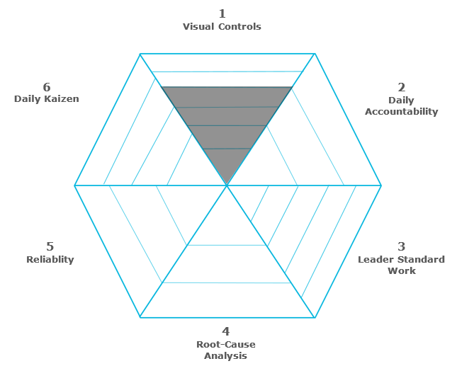

Do this for all six elements. Afterwards, you’re left with a complete visual showing what opportunities exist for your daily management.
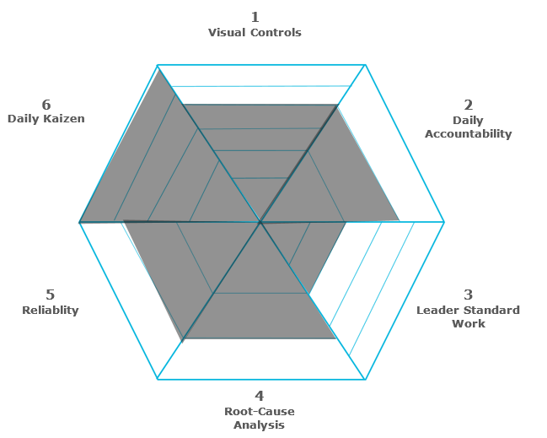
1
Visual Management
2
Daily Accountability
3
Leader Standard Work
4
Root-Cause Analysis
5
Reliablity

6
Daily Kaizen

Steps to be taken before next assessment:

