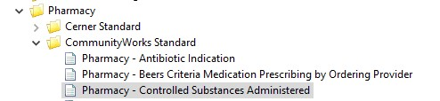

Additional Filters (see EOM for exclusions):
- non-opioid medications like benzodiazepines
- Covert doses to MMEs using CDC Guidelines

