1 Log in: https://www.qualityhealthindicators.org/account/login
- Email and password – Montana#1 if you are new to QHi
2 Click on Data Submissions and choose “Submit Data”
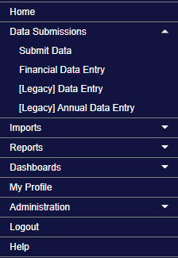
3. Select the month you would like to enter (April – July has been entered for you).
4. By default you will see all the measures selected by your hospital. To access the SWB measure set click on the “Show All Measures” drop down. This will list measures sets selected by the hospitals. Click on CAH Swing Bed Measure Set. This will display only these measures.
5. Enter the monthly values (see Data Calculations Tab in the excel tool) in the box and click Activate then Save. DONE!

