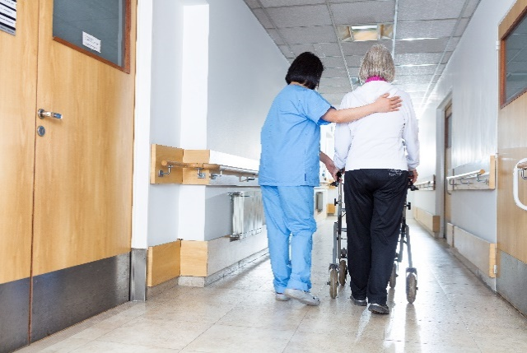
Where are you sending patients after their hospital stay?
of patients recommend our swing bed program to their friends and family
Patient quote: “It’s a network and community I know and feel comfortable with.”
100%
Research suggests simply having a friend nearby can help patient recover quicker. The social contact of a friend or family helps boost morale, provide comfort, and reduce stress, which allows the body to heal more quickly. Where are you sending patients after their hospital stay? We are here to help your patients heal and get back to their home as soon as possible.
Our goal is to help patients return home safely.
If your patients need extra skilled care before returning home, NAME OF HOSPITAL is here to help.
YOUR LOGO HERE
15% readmission rate
90% of patients return home
7 day
average stay
PROGRAM
NUMBERS

Patient quote: “Being close to my home support system helped me immensely in my recovery.”
Name of Hospital
Address
City, State, Zip
Contact
Phone
Email
What is a swing bed?
Swing bed services are a step between hospitals and home where patients get the continued care they need while recovering from an illness, injury or surgery. Our skilled staff provides on-site care 24 hours a day, to help patients prepare to return home safely. The length of stay varies, but the quality of care is consistent. After meeting therapy goals, patients can return home stronger and with more confidence.

Why do patients need swing bed care?
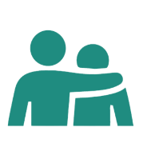
Our goal is to help patients return home safely. Swing bed services can help patients who need:
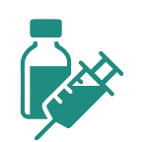
Long-term IV antibiotics
Wound care
Rehabilitation after surgery
Therapy after a stroke, accident or injury
Rehab or skilled care after a recent hospitalization

What you can expect from NAME OF HOSPITAL’S swing bed program:
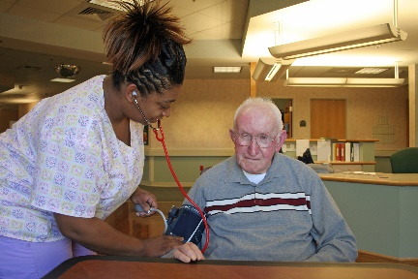
Nursing
Provides recovery care, pain management and education.

Physical Therapy
Provides injury rehabilitation and helps patients build strength to prevent falls and gain movement, balance and flexibility to resume activities like walking or exercising.

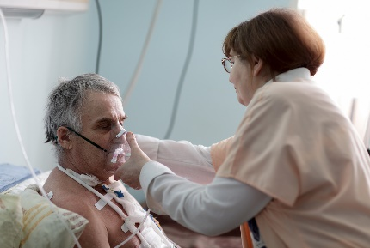
Occupational Therapy
Focuses on daily living skills that may include dressing and bathing.

Respiratory Therapy
Provides respiratory care and education about oxygen use.

Nutrition Services
Offers nutritional education and support.

Speech Therapy
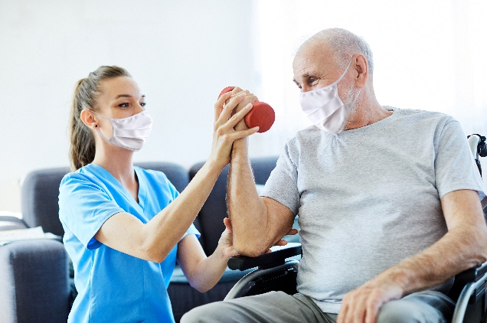
Helps with communication skills, reading and safe swallowing.

Pharmacy
Works with medical team to meet medication needs.

Social Work
Helps patients and families find additional services and resources for further education. Can also coordinate advance healthcare directives for patients.
To learn more about NAME OF HOSPITAL, please visit our website at WEBSITE ADDRESS.

