ASSISTANCE
While MT Flex and HQIC staff have been working diligently in QHi and attending trainings, it is new to us too. We appreciate your communication and patience! Below is individual contact information:
PIN Benchmarking & MBQIP Metric Questions
Lindsay Konen Lindsay.konen@mtha.org
Jennifer Wagner Jennifer.wagner@mtha.org
HQIC Metric Questions
Brayden Fine Brayden.fine@mtha.org
General QHi (functionality, adding users)
ANY of us at the address above!
QHI: Stu Moore smoore@kha-net.org or Sally Othmer sothmer@kha-net.org
QHi hosts monthly review calls and MT staff will send these notices out to QIC/DON emailing lists and the PIN List Serv.
You can find information about these calls on your QHi dashboard page under Training and Education
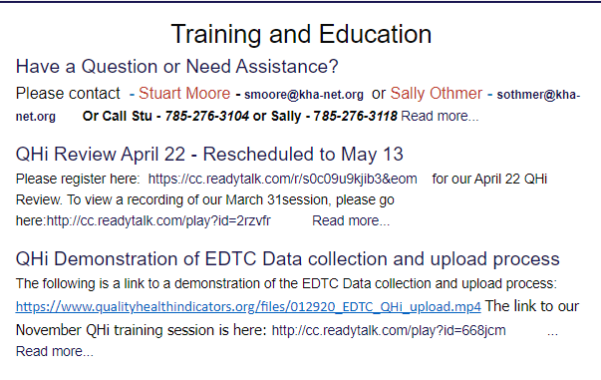
QHi DATA ENTRY LAYOUT
QHi is elements and measures are divided into 4 categories. MT measures have been placed within these.
- Hospital Characteristics
- Clinical Quality- Monthly
- Workforce
- Finance/Operational
The order of the elements within each group cannot currently be changed, however we are working with QHi for the possibility of being able to filter by Measure Set (example – Select MT HQIC and only HQIC measures appear for data entry). This is down the road a bit though.
Tips:
- To enter a set of similar data elements use the filter in the upper right. For instance enter “Sepsis” for all sepsis elements and measures.
- Allow other staff at the hospital to enter data specific to them. They then can choose their elements as “Favorites” and will appear at the top. Notify Jen, Lindsay, or Brayden for assistance in setting up new users!
DATA ENTRY FREQUENCY
Data is entered into QHi by month. Reports for MBQIP and PIN Benchmarking will use this data to calculate and display quarterly values. HQIC reports will continue to be monthly.
Regardless of your choice of data entry timing, data still must be in by the requested due date of the program you are entering data for.
MBQIP and PIN Benchmarking data can be entered on a month to month basis, or all three months (separate value for each month) can be entered at once by the data deadline.
In the QHI platform, data can be entered in a single month (only the selected month will be open to enter values) or multi-month. Follow the following instructions in the Submit Data portion of Data Submission.
Enter data one month at a time: Select month from the drop down entitled Select month for entry. Ensure you choose the correct year! In the screen shot below, I chose October. You can see how the data field for October is open but the other months are grayed out.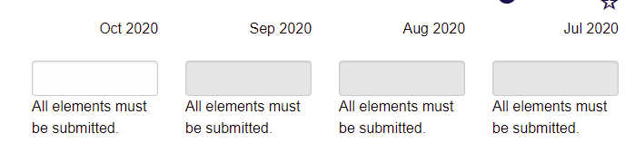

Enter a complete quarter at once: Select the last month of the quarter you are entering data for. For Quarter 4 2020, that would be December. Then click the toggle for Multi-month Entry. You will see in the screen shot below that all months (4 are visible at a time) are open for data entry.
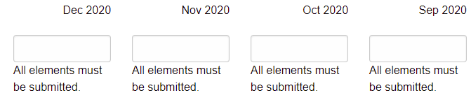

DATA EFFICIENCIES
Please note the following opportunities in data efficiencies.
NHSN
If you submit the following measures to NHSN, these will be pulled from the MT team and entered into QHi for you. For HQIC measures, if your facility does not report these to NHSN, please enter into QHi.
- MBQIP: Healthcare Worker Immunization This MUST be entered into NHSN to receive credit for reporting to the MBQIP program
- HQIC: Clostridioides difficile Rate, Central Line Associated Bloodstream Infection (CLABSI) Rate, Central Line Utilization Ratio, Urinary Catheter Device Utilization Ratio, Catheter-Associated Urinary Tract Infection (CAUTI) Rate
DATABANK
The existing data sharing process within MHA for measures submitted to DataBank will continue. Measures will be noted on the info document. MT Flex will send an email asking if you’d like us to use Databank values. Just respond Yes or No. DataBank metrics only apply to the PIN Benchmarking Project.
If you respond yes: Please ensure that whoever submits to DataBank from your facility completes the quarter by the PIN Benchmarking deadline.
If you respond no: enter the data into QHi prior to the deadline.
MBQIP
MBQIP measures must be submitted to the required reporting platform to ‘count’ as participation in the MBQIP data program and MT Flex Grant. However, to build more timely reports, this data will be entered into QHi as well. Since MBQIP is a national data program, QHi has efficiencies built in to upload data.
EDTC: Complete the Stratis EDTC Tool each quarter. Upload this information to QHi by going into Imports > New Stratis EDTC Import (see snip below).
Video and written instructions are found here: https://www.qualityhealthindicators.org/stratis_imports/new. You can also download the Stratis EDTC tool on this page or on the PIN Website.
If you do not use the Stratis Tool (most of you do!!), enter the raw data into QHi.
There is no sending this data to MT Flex once it is saved and activated in QHi. We are able to export this data to send to the Federal Office as long as it is ready by the EDTC deadline.
Outpatient AMI and ED Throughput Measures – OP-2, OP-3, OP-18: These measures must be entered into CART then uploaded into CMS’s Hospital Quality Reporting (HQR) under the HARP login to count for program participation. QHi does not replace data submission to HQR. The data to populate in QHi is uploaded from CART.
Upload this information into QHi by going to Imports>New CART Import (see snip below). Video tutorial is found here: https://www.qualityhealthindicators.org/imports/new
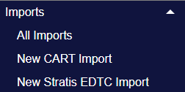

ELEMENTS AND MEASURES
Data in entered in QHi by element; elements are then used to calculate reported out measures. This calculation will display in real time as you enter data. Once an element is entered, it will populate for future occurrences of that element. On the information document we have noted what measures are calculated and what calculation an element informs.
Some previous measures have been broken out into the data elements. This will mostly be seen in the PIN Benchmarking workforce, productivity and financial and operational metrics. See Data Changes below for details
QHi CORE MEASURES LIST
QHi has a set of eight long-standing core measures. These will show up by default in your profile and cannot be removed. A couple of these metrics are also PIN Benchmarking and/or HQIC measures. For those that do not overlap, feel free to skip. I have noted overlapping measures in the list of QHi Core Measures in bold font below.
- Healthcare Associated Infections per 100 Inpatient Days - BCBSKS CAH *Core Measure*
- Unassisted Patient Falls per 100 Inpatient Days *Core Measure*
- Readmission within 30 days (All Cause) Rate (same hospital) - KHC Compass (Req.), BCBSKS CAH & BCBSKS PPS *Core Measure*
- Percentage of Return ER Visits within 72 hours with same/similar diagnosis *Core Measure*
- Benefits as a Percentage of Salary *Core Measure*
- Staff Turnover *Core Measure*
- Days Cash on Hand *Core Measure*
- Gross Days in AR *Core Measure*
DATA CHANGES
The attached excel sheet is a summary of data elements and measures (calculations from the data elements) in approximately the order they are seen when you log into QHI. Screens may look different if you have selected favorites or are a part of various programs, but we have come as close as possible. This document is a reader friendly guide to the elements entered into QHI and any changes. Changes are highlighted here. Since QHi is a multi-state benchmarking program, we have approved some slight changes in definitions or names to align with industry standards to allow for a great breadth of comparison.
These are specific to PIN Benchmarking and MBQIP.
Current | What changed?
Acute Inpatient Days | 1. Name. Previously Total number of CAH Acute Care patient days  2. Definition changed to AHA definition.
Average of length of stay (LOS) in days for swing bed. | 1. Process – report elements and QHi will perform the calculation.
Total inpatient discharges (excluding discharges due to death) | 1. New measure to calculate readmission rate that is redefined for alignment with HQIC, PIN Benchmarking and QHi Core Measures
Inpatients returning as an acute care inpatient to the same hospital within 30 days of date of an inpatient discharge, with the exception of certain planned admissions | 1. New measure to calculate readmission rate that is redefined for alignment with HQIC, PIN Benchmarking and QHi Core Measures
Skin and Fall risk assessments within 24 hours for acute and swing patients. | Removed per large consensus of MT CAHs. You may still track internally if it is useful for process improvement and quality assurance.
Patient Left w/o Being Seen - Yearly | 1. There is an option to submit Patient Left without Being seen (MBQIP OP-22) to QHi monthly.  2. If you submit monthly, you must enter the final yearly value into CMS’s Hospital Quality Reporting via the HARP log in by the yearly deadline.  3. If you choose to not enter it monthly, please enter your early value into December of the reporting year.
All Turnover Metrics | 1. Process – report elements and QHi will perform the calculation.
Staff Turnover: Total Facility | 1. Name change to Staff Turnover *Core Measure*
Days Cash on Hand | 1. Process – report elements and QHi will perform the calculation.
Days in AR | 1. Process – report elements and QHi will perform the calculation.  2. Name change to Gross Days in AR
Percent Occupancy | 1. Divided into two existing metrics in QHi –Acute and Swing Occupancy.  2. No additional data collected.
Bad Debt as a % of Gross Patient Revenue | 1. Process – report elements and QHi will perform the calculation.
Charity Care as a % of Gross Patient Revenue | 1. Process – report elements and QHi will perform the calculation.
Salaries as a % of Net Patient Revenue | 1. Process – report elements and QHi will perform the calculation.  2. Name change to Labor Costs as a % of Net Patient Revenue
Operational Costs per Adjusted Patient Day | 1. Name change to “Costs per adjusted patient days”. Operating Expense = Operational Costs
Adjusted Patient Day | 1. Definition – aligns with AHA definition.
Nursing hours per patient day | 1. Process – report elements and QHi will perform the calculation.  2. May see definition changes

Emergency Department Transfer Communication Upload into QHi
Use current year EDTC tool. 2021 Tool can be downloaded at this link. It is best to use the .XLSM version as the file will need to be .XLSM to be uploaded. https://stratishealth.org/wp-content/uploads/2020/09/EDTC-Data-Collection-Tool-v4.1-xlsm.xlsm

Step 1: Complete the Stratis EDTC tool at the link above. Instructions and specifications can be found here: https://stratishealth.org/toolkit/emergency-department-transfer-communication/ and MT Flex staff is always on hand for assistance.
The Stratis tool is very much the recommended process. However, if your EMR has a data report that pulls the same data, you can calculate the pass/fail for the measures and directly enter numerator and denominator into QHi. Please let us know if we can assist with this layout. Regardless, the data must be abstracted per individual record.
Step 2: When data entry is complete, the tool will bring you back to the record list screen that looks like the below image. Click on “Run a Monthly Report”.
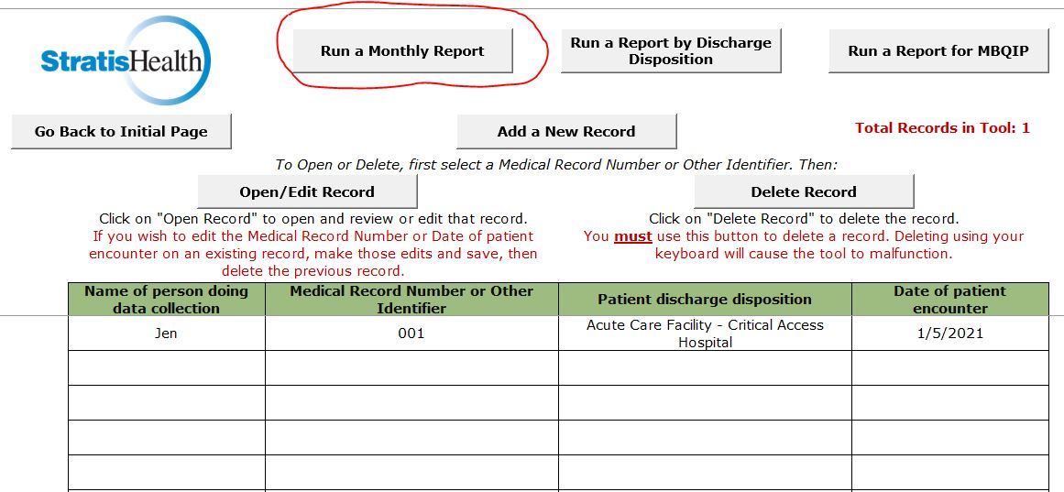

Step 3: The tool will direct you to this screen. If “Year of Report” does not say 2021, type in 2021 to populate the current year’s data.
Step 4: When it is complete, Choose File > Save As. From the “Save as type:” drop down, select “Excel Macro-Enabled Workbook” if not already selected. Choose the file path where you would like to save the file and then click “Save”. Close the file.
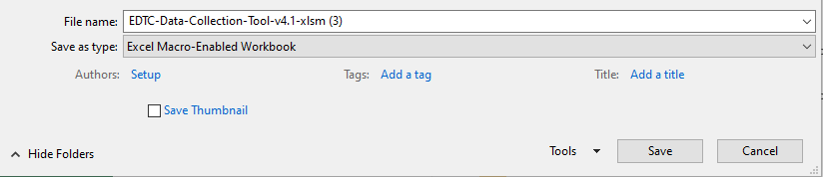

Step 5: Log into QHi and from the left drop down menu click on “Imports” then “New Stratis EDTC Import”.
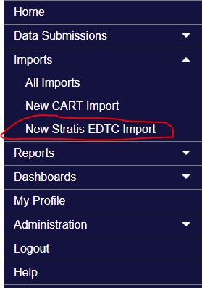

Step 6: Click on “Choose File” under Import and upload the file you just saved. Click “Import”.
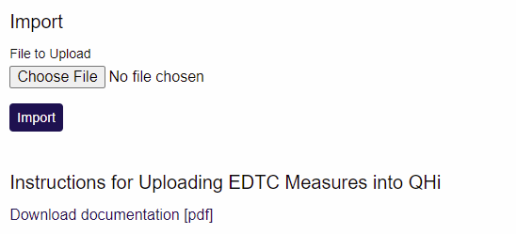
Step 6: If the data is uploaded successfully the following message with appear with the values listed for each element for each month. Review the data and if it looks correct click “Approve Import”. Import status will then say “Updating Submissions” and when its complete will say “Complete”. At that point, you are good to go!!!
