Submit CMS Outpatient Web-Based Measures (Yearly, May)
ED Throughput measure OP-22 is collected using administrative data to determine the measures’ denominator population; there is no individual chart abstraction. Data is collected on a yearly basis. Data is submitted the year following the encounter period, via the HARP sign in portal for Hospital Quality Reporting (HQR). HQR was formerly QualityNet Secure Portal.

For further information on how to collect this data, reference the Hospital Outpatient Quality Reporting Specifications Manual.

- Go to the HARP Sign In (https://hqr.cms.gov/hqrng/login), enter your credentials and click on Login.
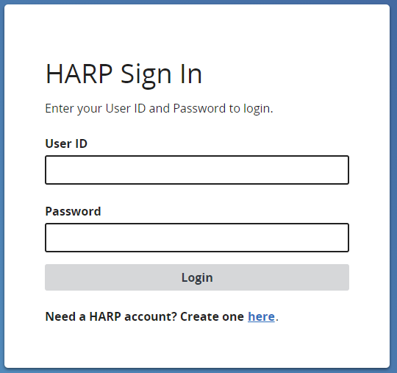

- Verify 2-factor authentication
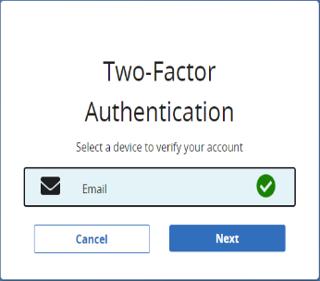
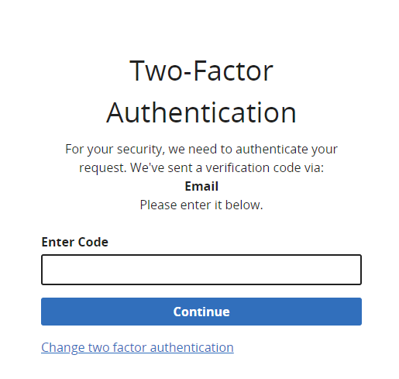

- Scroll to the bottom of Terms and Conditions and click Accept.
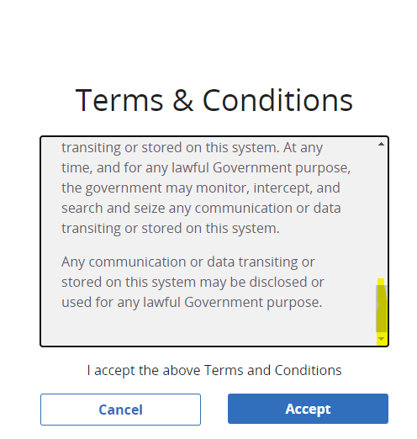
- Click on in the left side navigation panel for Data Submission.

- Choose Web-based Measures from the top tabbed menu.

6. Choose Data Form.
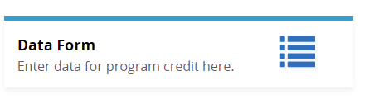

7. Select OQR Data Form.

8. Click Start Measure for OP-22.

9. Enter Numerator and Denominator. Click Save and Return.

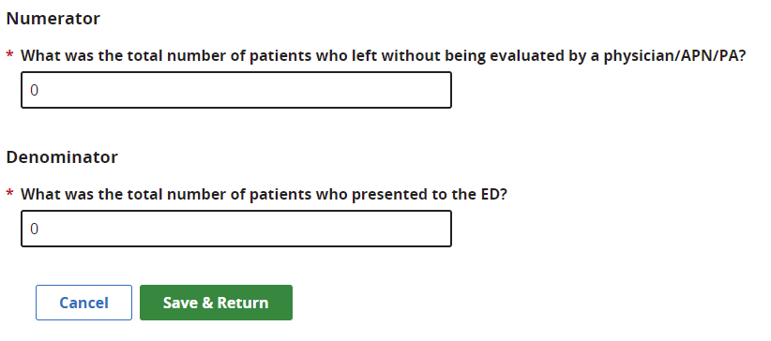
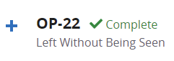
10. Measure will show as Complete.

