Getting Started in QualityNet

As of Summer, 2020 users can access file upload in QualityNet through the HARP sign in; previously the QualityNet Secure Portal.

- Create HARP Sign In
- HCQIS Access Roles and Profile page at https://harp.qualitynet.org/.
- Log into HARP Sign In at https://hqr.cms.gov/hqrng/login with your HARP user name and password.
- Set up at least one QualityNet Security Administrator (SA). It is highly recommended that hospitals designate at least two QualityNet SAs – one to serve as the primary QualityNet SA and the other to serve as backup.
- Go to My Profile (Under your User Name in the upper right).
- From this page, you can Request access, and View Current Access.
- Select Basic User or Security Administrator/Official when prompted to select a user type.
- Select your required permissions and click submit an access request.
- You will be notified by email when your request has been approved.

- Access the HARP Sign In (formerly QualityNet Secure Portal)
For access to the complete the Enrollment Process. As part of the process, you’ll be asked to change your password and answer a set of security questions
- Maintain an Active QualityNet Security Administrator (SA)
Hospitals are required to maintain an active QualityNet SA. To maintain an active account it is recommended that QualityNet SAs log into their account at least once per month. If an account is not logged into for 120 days it will be disabled. Once an account is disabled, the user will need to contact the QualityNet Help Desk to have their account reset.
- Complete a Notice of Participation (NoP)
In order for a hospital to have their inpatient data publicly reported, a NoP must be completed. The inpatient NoP is not required for participation in the Medicare Beneficiary Quality Improvement Project (MBQIP), but must be completed for data submitted to QualityNet to appear on Hospital Compare. To verify if your hospital has completed a NoP, or needs to complete a NoP for the first time:
- Log into the HARP Sign In
- On the left navigaction pane select Administration, then Notice of Participation
- From here, you can view the NOP Status for your programs, choose to participate, not participate, or request withdrawal. You can also change the contact information for your facility NOP. Once your hospital’s NoP is accepted, it remains active unless your hospital changes its pledge status.
Note – A NoP is no longer required for outpatient data. Such data will automatically be made publicly available unless it meets data suppression requirements set forth by Hospital Compare.

Submitting Data to QualityNet (aka the CMS Warehouse)
- Submit Data to the CMS Warehouse (QualityNet)
Clinical data submission is accomplished in one of two ways: uploading from Outpatient CART or by a third party vendor. Third party vendors must be able to meet the Measurement Specifications for data transmission via the HARP Sign In (formerly QualityNet Secure Portal) to the CMS Clinical Warehouse. Data Submissions must be timely. Refer to each domain/measure for timeframes.

- Go to the HARP Sign In (https://hqr.cms.gov/hqrng/login), enter your credentials and click on Login.
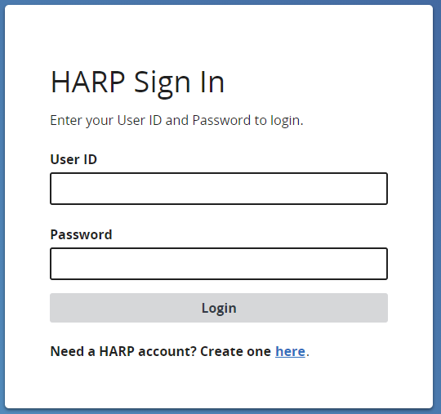

- Verify 2-factor authentication
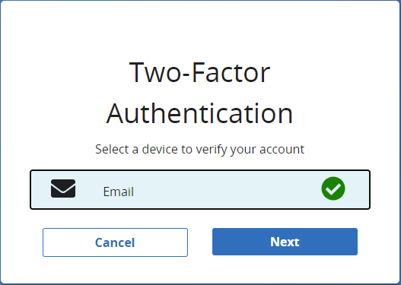
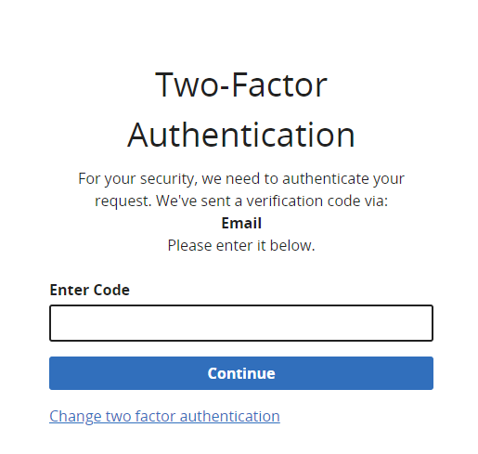

- Scroll to the bottom of Terms and Conditions and click Accept.
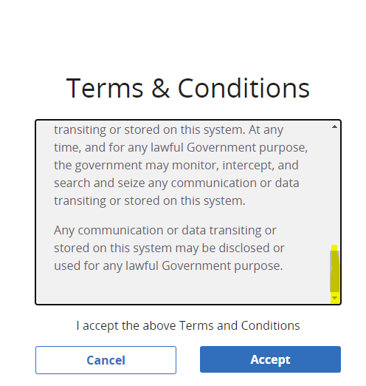

- Click on in the left side navigation panel for Data Submission.

- Choose Chart Abstracted from the top tabbed menu. (the program defaults to eCQM)
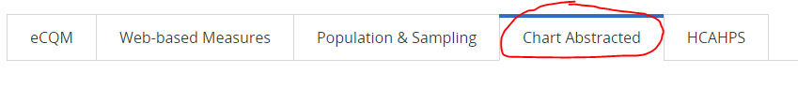\

- Change “Submission” from Test to Production in the drop down and click Change Selection to save this submission type.
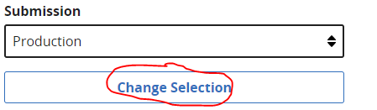

- Click on and follow the prompts to upload files.

- When the upload process is complete, you will get an email that indicates Accepted/Rejected status and the status in the portal will show as .

- Population & Sampling Submission (aka Zero Cases)
  - Reporting population data for measure sets with no cases is important to the story of rural relevant measures AND to meeting MBQIP participation requirements.

  - While in the HARP Sign In, choose Population & Sampling from the top tabbed menu.

  - Click on Data Form, then Launch Data Form for OQR.
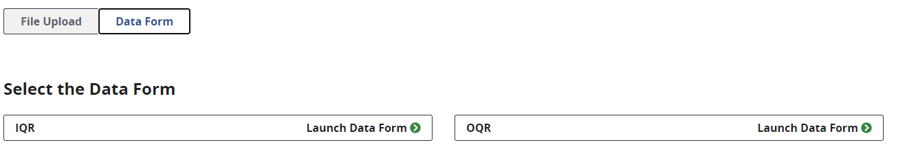
  - Select the appropriate Reporting Period from the drop down in the upper right.

  - Click on to the right of the measure set you are reporting on. Specifically for MBQIP we are only looking at reporting if there are zero encounters for the metric. CAHs are not required to submit all population data. We would expect that OQR-AMI would be the only set that this information will be submitted for. All CAHs should have ED populations for OQR-ED Throughput, and OQR-Stroke is voluntary and not part of the measure set.

  - Under Sampling Option, choose Not Sampled or N/A submission not required.
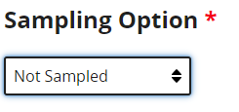

  - Put 0 in all Population and Sampling Fields
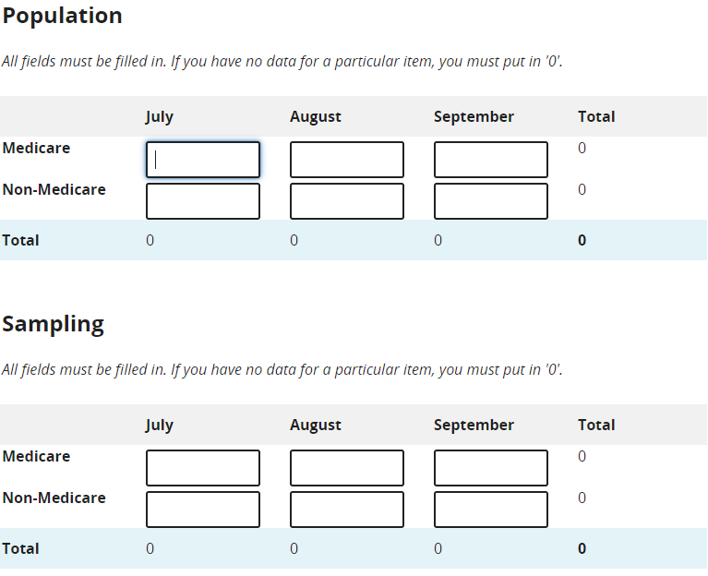

  - Click . If successful it will show as 