Reporting Zero Cases for Population & Sampling

As of Summer, 2020 users can access file upload in QualityNet through the HARP sign in; previously the QualityNet Secure Portal.
Reporting population data for measure sets with no cases is important to the story of rural relevant measures AND to meeting MBQIP participation requirements.
- Go to the HARP Sign In (https://hqr.cms.gov/hqrng/login), enter your credentials and click on Login.
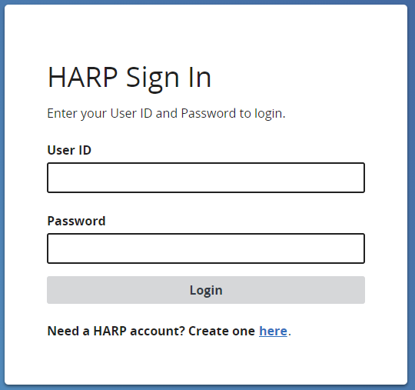

- Verify 2-factor authentication
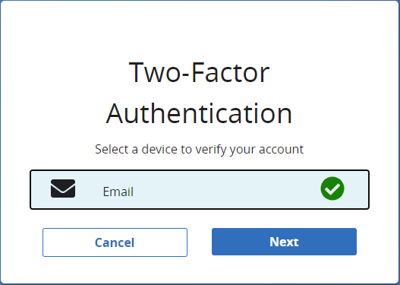
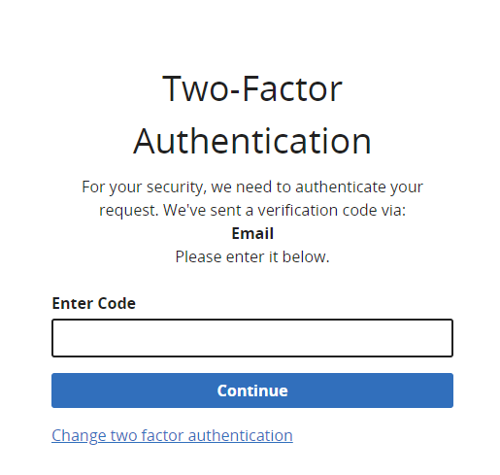

- Scroll to the bottom of Terms and Conditions and click Accept.
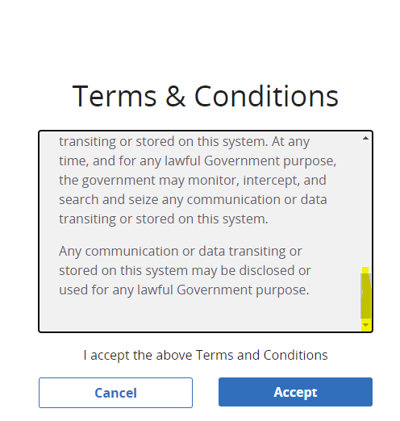
- Click on in the left side navigation panel for Data Submission.

- Choose Population & Sampling from the top tabbed menu.

- Click on Data Form, then Launch Data Form for OQR.
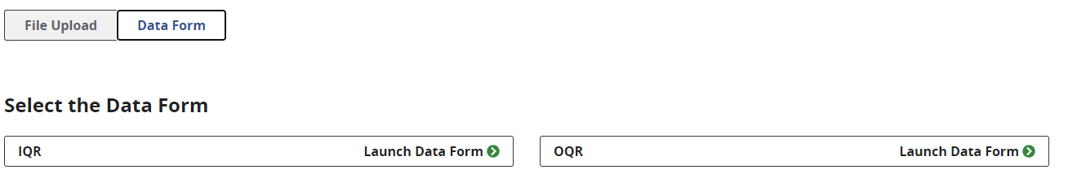

- Select the appropriate Reporting Period from the drop down in the upper right.

- Click on to the right of the measure set you are reporting on. Specifically for MBQIP we are only looking at reporting if there are zero encounters for the metric. CAHs are not required to submit all population data. We would expect that OQR-AMI would be the only set that this information will be submitted for. All CAHs should have ED populations for OQR-ED Throughput, and OQR-Stroke is voluntary and not part of the measure set.

- Under Sampling Option, choose Not Sampled or N/A submission not required.
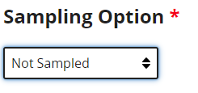
- Put 0 in all Population and Sampling Fields
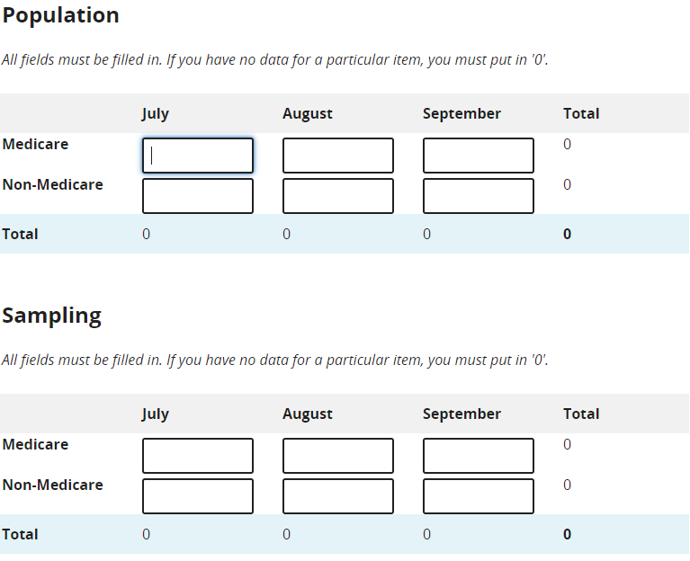

- Click . If successful it will show as 