The transition period is now through June 15, 2020. Please follow these steps to begin to transition your account.

Webinar Training: https://www.qualityreportingcenter.com/en/events-on-demand/vbp/SettingupHARP/

HARP User Guide: https://www.qualitynet.org/training-guides%23tab2#tab2

Go to the https://qualitynet.org

Click Log in to Secure Portal in the upper right-hand corner

Choose Hospital Quality Reporting from the drop-down and Click Let’s Go
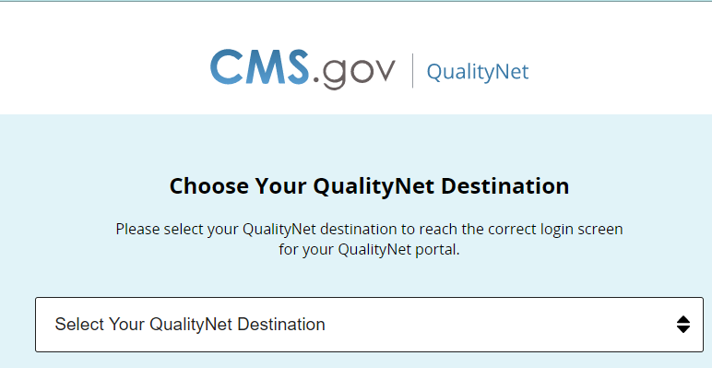

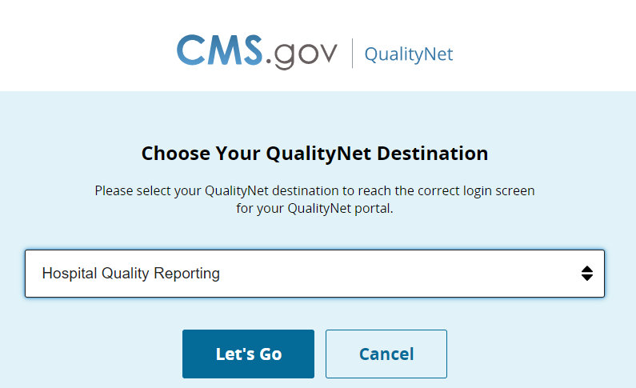

Enter your QualityNet login credentials and click Submit
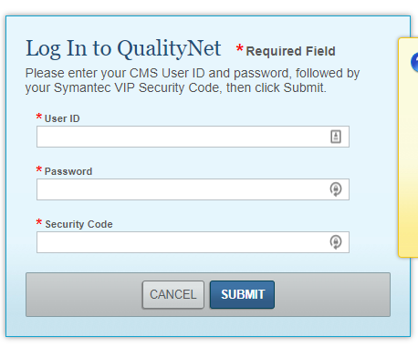

Once you log in, a pop-up window will appear in front of the My Tasks page alerting you to create a new HARP Login. Click Enable HARP Account, and follow the prompts
(If you accidentally close the pop-up, the My Tasks page will appear with a blue alert at the top of the page. Click Enable HARP Account there.)
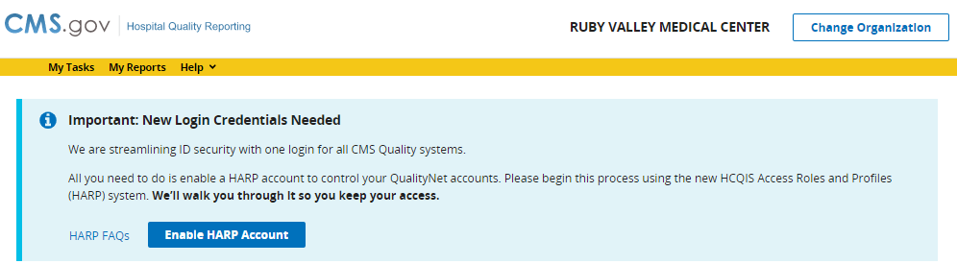
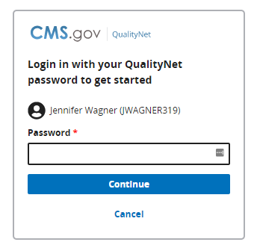
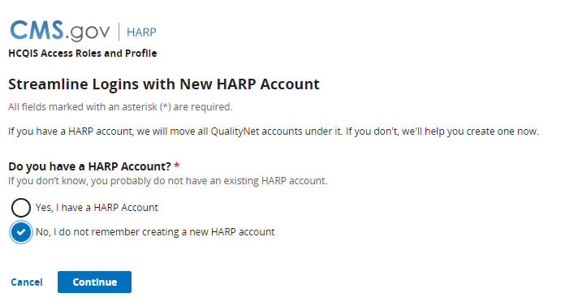
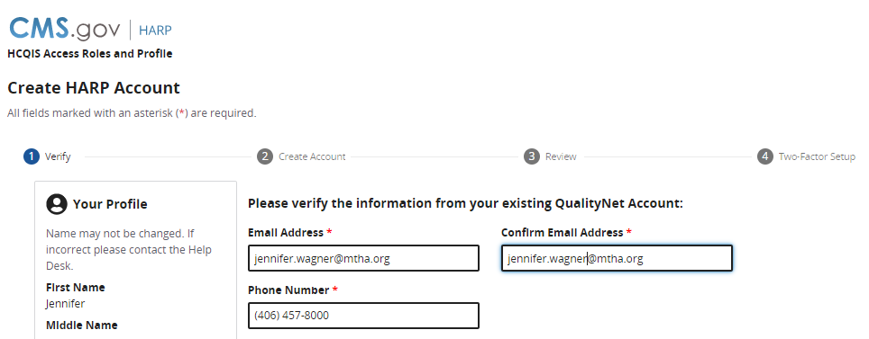
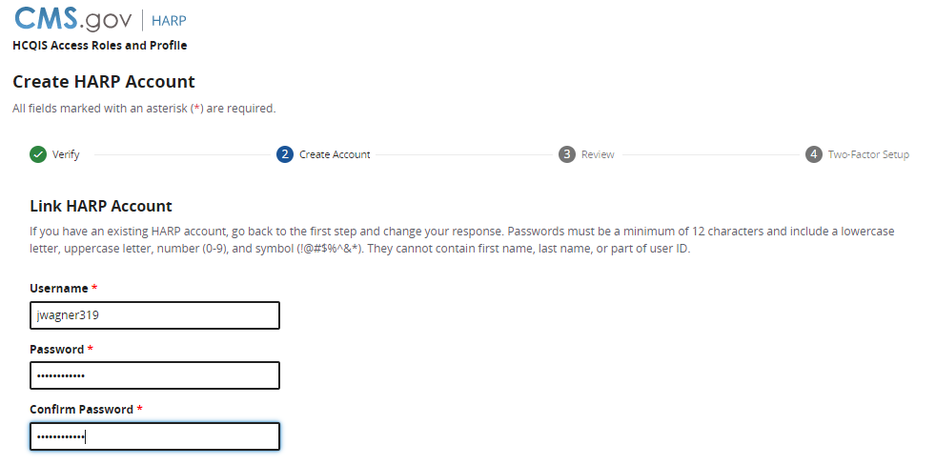
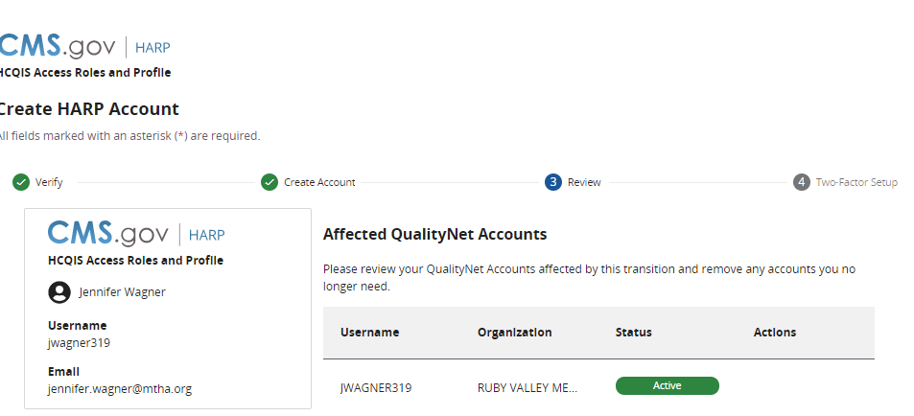
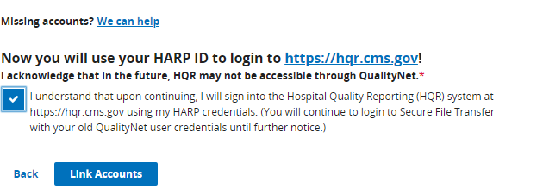
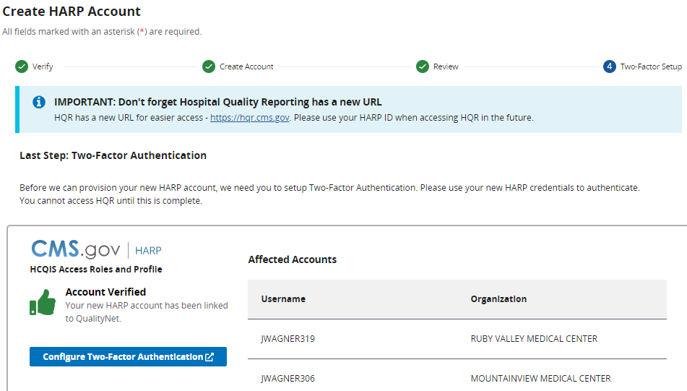

After two-factor authentication is complete, the program will bring you to your profile page and you are done.
NEW LOGIN:
