## CMS Abstraction & Reporting Tool (CART)

## *[September 2020]*

**Summary**:

CART is a software application, installed on the user’s hard drive or server, for the collection and analysis of quality improvement data. Data entered into CART is extracted and uploaded into [QualityNet](http://www.qualitynet.org) for Outpatient Quality Reporting (OQR) and Inpatient Quality Reporting (IQR) measures. The [Medicare Beneficiary Quality Improvement Program](http://www.mtpin.org/mbqip-reporting/) (MBQIP) uses CART for reporting of certain OQR and IQR measures.

Initial installation of CART requires the installation and setup of Quality Management System (QMS) as the foundation for the CART software. CART has separate inpatient and outpatient modules. These are downloaded separately and will have separate updates. This guide will refer to each module as IP CART (Inpatient CART) and OP CART (Outpatient CART).

**Contents:**

Quality Management System (QMS) Installation

CART Modules Installation – Initial

CART Modules Installation – Update and Patches

Initial Log In to CART and Provider (CAH) & User Set Up

Access Maintenance

Entering data into CART

Accessing Patient & Abstraction Data

Upload files to QualityNet

Other Resources

**Note:**

Screen shots may appear visually different due to varying computer operating systems and web browsers, but will contain the same information.

**QUALITY MANAGEMENT SYSTEM (QMS) INSTALLATION**

*Download links say* ***Initial CART Installation****, but the download of QMS as the foundational program is included in this download package.*

1. Go to www.qualitynet.org. On the right of the screen, go to the **Downloads** box. Click on **Hospitals – Outpatient.**

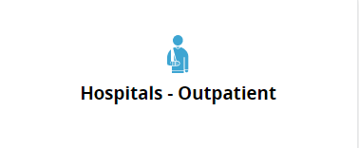

1. On the menu bar at the top of the screen, click on Data Management.



1. Click *Learn More* under CMS Abstraction & Reporting Tool (CART).

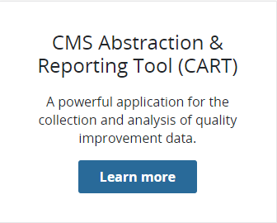

1. Click on *View all versions of CART.* This will allow you to confirm you are downloading the accurate version for the quarter of data being abstracted.

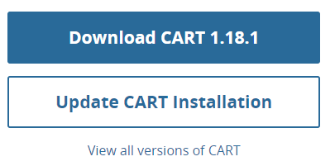

.

1. New installation – Choose Initial Installation of CART

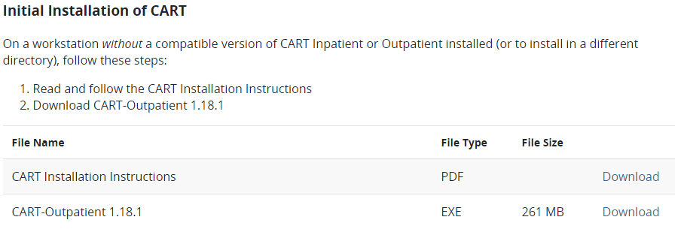

1. A security warning window will appear. Click **Save** to continue the installation process. If an additional security widow appears with the choice to **Run** or Don’t Runclick **Run** to continue the installation process.
2. The WinZip Self-Extractor box will appear with a **Browse** option to select the download location of your choice, then click **Unzip**. A progress bar will appear and when complete an additional window will appear advising the files were unzipped successfully. Choose **OK** and close the WinZip Self Extractor box.  
   *Write down the download location of this file to access later.*

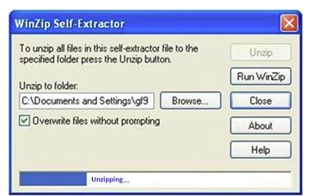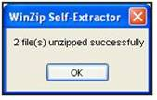

1. Go to the computer download location of the file. Double click on **QMSInstall** file (This will be an .exe file extension). A setup loading window will appear.

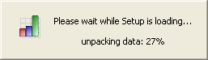

1. After the Setup is loaded, the *Welcome to QMS30 Set Up Wizard* window appears. Click **Next**.

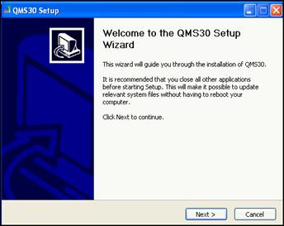

1. Select the installation type (Standalone, Client or Server) that you will be using, then click **Next**. Standalone is the default selection and that means that it will be on your computer’s hard drive and only accessed on your computer.   
   *Discuss with your IT department your individual needs and get their recommendation on what installation type to use.*

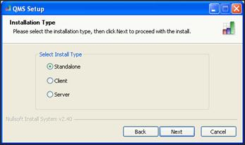

**Standalone**: Select **Standalone** then click **Next**.

**Client**: Select **Client** then click **Next**. *If client is chosen there are specialty instructions for the initial login to CART.*

**Server**: Select **Server** and click **Next**. Enter your Server Port number. The recommended port number is **3311**. Click **Next**.

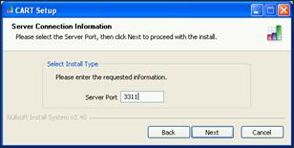

1. The Installation Directory window will appear. By default, the destination folder contains C:\QMS30.   
   *You must change the destination folder from C:\QMS30 to one of your choosing (ex: C:\OUTPTQMS30)*. If you do not have rights to install to C:\OUTPTQMS30, choose a different location that you have access to or contact your IT support.

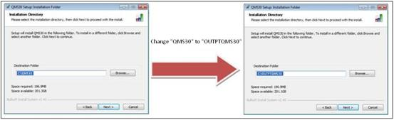

1. Click **Next**. If you choose a directory that already has an existing QMS installation you will receive an error message. Click **OK** and choose a different directory. Once a correct directory is chosen, a License Agreement Window appears. Choose **Yes** and click **Next**.

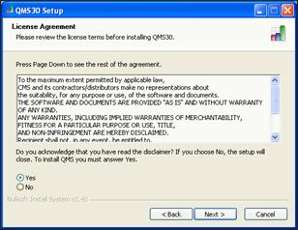

1. Click **Install**. Leave the folder to the default QMS30. An Installation window will show the progress of the installation.

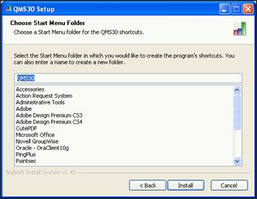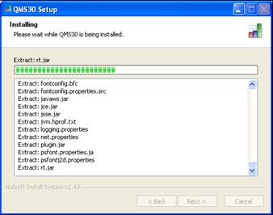

1. When the installation is complete. Click **Next** to close the window.

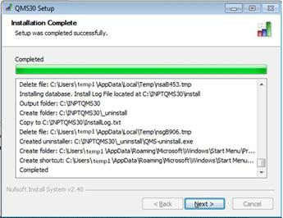

1. Click **Finish** to close the QMS30 Setup Wizard window.

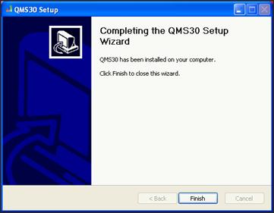

**CART MODULES INSTALLATION - INITIAL**

1. Navigate to the drive and directory where the installation file(s) were unzipped and saved earlier (ex: C:\OUTPTQMS30).
2. Double-click the CART installation filename to begin setup. It will be in one of the following formats depending on the installation type:  **CART[…].exe** or **OPPS[…].exe**. A status window will appear.

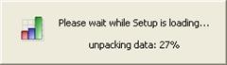

1. *Welcome to the CART Setup* window appears. Click **Next**.

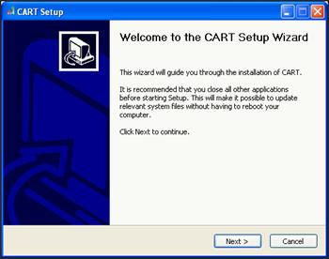

1. A *License Agreement* window appears. Choose **Yes** and click **Next**.

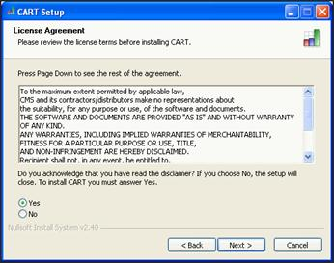

1. For Initial Installation and Upgrade Installations, a *Server Type* window appears. For patch installations, skip this step; otherwise, select **MYSQL** and click **Next**.

***Upgrades & Patch Installations:*** *This is where keeping record of what version of CART you’ve downloaded most recently is helpful. For example, if you have version 1.15.1, you will want the patch to get to version 1.15.2. If you have version 1.14 you will want to upgrade to 1.15. Communication from MT Flex Grant will indicate if CART is an upgrade or a patch. Most often it will be an* ***upgrade****.*

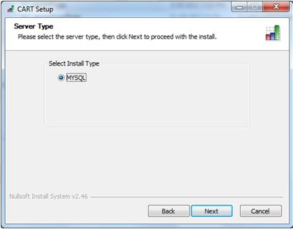

1. An *Installation Directory* window appears. Existing QMS installation locations are listed. Select a QMS30 location from the list or click **Browse** to search. Click **Install** to continue. QMS must be installed prior to installing CART.

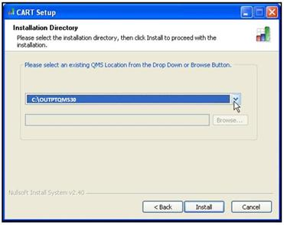

1. For initial installation and upgrade installations, if you choose a directory that already has the current CART installation, you will receive the following message. Click **OK** and choose a different location. An installation progress window will appear. For patch installations, if you choose a directory that does not have the CART installation being patched, you will receive a warning message and the installation will end.

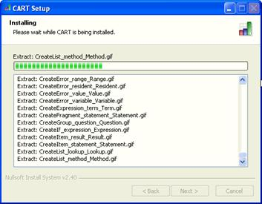

1. Click **Next** to close the *Installation Complete* window.

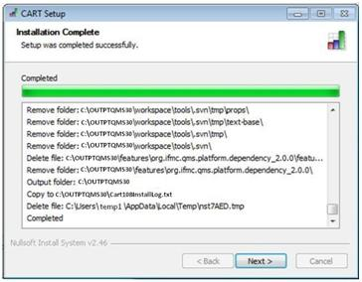

1. Click **Finish** to close the *CART Setup Wizard* window. Typically, a QMS30 icon is placed on the Desktop.

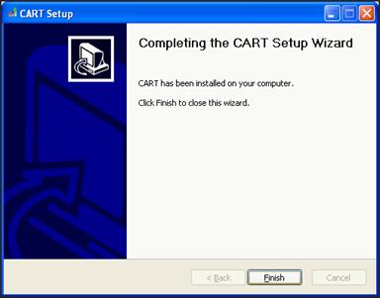

1. Verifying the CART Installation Version
   1. Open CART using the QMS30 shortcut icon.
   2. Click **About Quality Management System**, located on the CART Login screen.
   3. Verify that the version you just installed is displayed.
   4. Exit QMS.

**CLIENT-BASED INITIAL LOG-IN INSTRUCTIONS:** Refer to QMS Installation #8 on page 3.

1. Upon initial login to CART on a Client, you will be prompted to confirm the **Database Configuration**:
   1. Enter your **server’s IP address or name**.
   2. Enter the **port number** used with the server installation. The recommended port number is **3311**. This must only be entered once.
   3. Click **Confirm.**

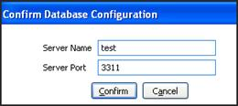

1. If the server has a QMS version prior to QMS 3.0.0 installed but does not have a QMS 3.0.0 Server Installation, an “Incompatible Database Found” message displays during the first attempt to login to the client workstation.
2. If you did not receive an error message, stop here. Otherwise, click **OK** to close the message window and continue.
3. Perform the [QMS 3.0.0 Client installation](https://www.qualitynet.org/WebHelp/CARTInstallInstructions/qms_3.0.0_installation_(initial_installation_only).htm) and perform a compatible [CART installation](https://www.qualitynet.org/WebHelp/CARTInstallInstructions/cart_installation.htm).
4. Enter the correct **IP Address and Port Number** and proceed to **Login**. An *Installing* window shows the progress of the installation. Click **Next** to close the *Installation Complete* window.

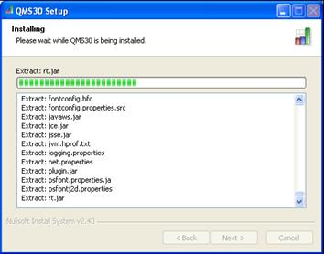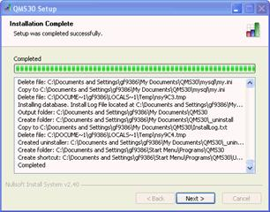

1. Click **Finish** to close the *QMS30 Setup Wizard* window:

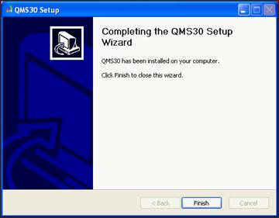

**CART MODULES INSTALLATION – UPDATES AND PATCHES**

CART will have updates depending on a change in calendar year, coding, etc. MT Flex will notify when an update or patch is pending and for what period of discharges. This will need to be repeated for both Inpatient and Outpatient. See CART Initial Installation #10 on page 8 for instructions to find your current CART Outpatient versions. *Pay attention to version numbers.*

*Download links say* ***Initial CART Installation****, but the download of QMS as the foundational program is included in this download package.*

1. Go to www.qualitynet.org. On the right of the screen, go to the **Downloads** box. Click on **Hospitals – Outpatient.**



1. On the menu bar at the top of the screen, click on Data Management.



1. Click *Learn More* under CMS Abstraction & Reporting Tool (CART).



1. Click on *View all versions of CART.* This will allow you to confirm you are downloading the accurate version for the quarter of data being abstracted.



.

1. Choose Patch or Upgrade installation

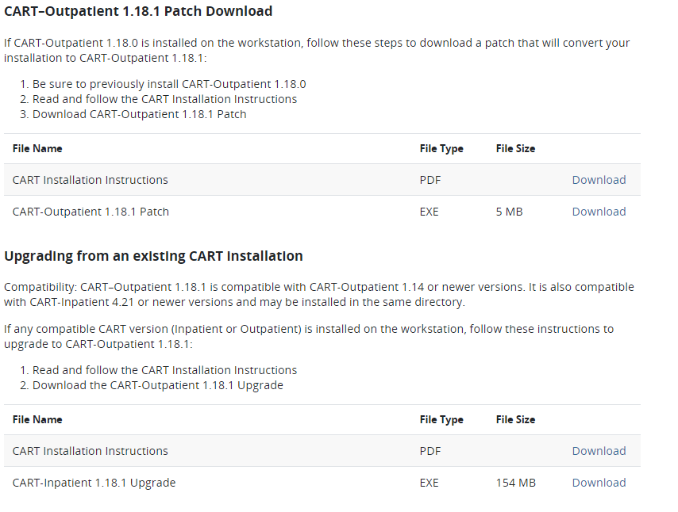

1. A *security warning window* will appear. Click **Save** to continue the installation process. Depending on web browser settings an additional security widow may appear with the choice to **Run** or Don’t Run. Click **Run** to continue the installation process.
2. A zip file extractor will appear with a **Browse** option to select the download location. Use previous QMS folders for simplicity. A progress bar will appear and when complete an additional window will appear advising the files were unzipped successfully. Choose **OK** and close the *WinZip Self Extractor* box.

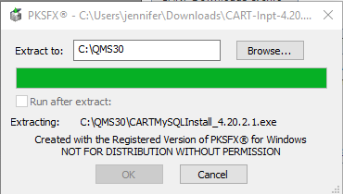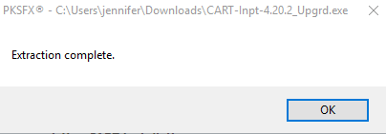

1. Go to the computer download location of the file. And click on **CARTMYSQLINSTALL*version*.**



1. The *CART Setup Wizard* will open. **Click Next.**



1. A *License Agreement* window appears. Choose **Yes** and click  **Next.**



1. A *Server Type* window will open. Choose **MYSQL** and click **Next.**



1. An Installation Directory window appears. Existing QMS installation locations are listed. Select a QMS30 location from the list or click **Browse** to search. Click **Install** to continue.

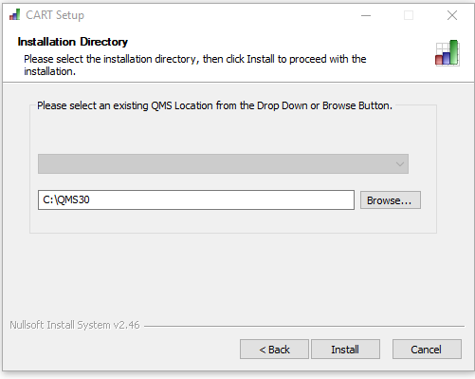

1. A progress bar will appear with a message when the download has been completed.



**INITIAL LOG IN TO CART & PROVIDER/USER SET UP**

1. Click on **QMS 30** on your desk top and choose the **CART- Outpatient** module.
2. At the CART-Inpatient login screen, type **opps** (all lower case) for the User ID.
3. In the Password field, type **p@ssw0rd** (that’s a zero) and click Login. You will be prompted to change your password to one of your choice and will need to enter it twice.

*Write this down! Most users will not go into CART frequently and it is easy to forget. Users will need to update their password every* ***three*** *months.*

**Password Rules**:  Must be 8-19 characters, at least one upper case, one numeric, and one special character such as: % # * + - , : = ?,. Passwords cannot contain dictionary words.

Passwords are case-sensitive. Do not use User ID, first Name, last Name or more than three consecutive like characters. Wait a minimum of six password changes to reuse a password. Do not change the password more than once in a 24 hour period.

1. After the password is set, you will be prompted provide answers to *Security Questions*. Answer any 6 of the 10 questions, then tab out of the last field.

*Take a screen shot or record your answers and save with your password before you click OK!*

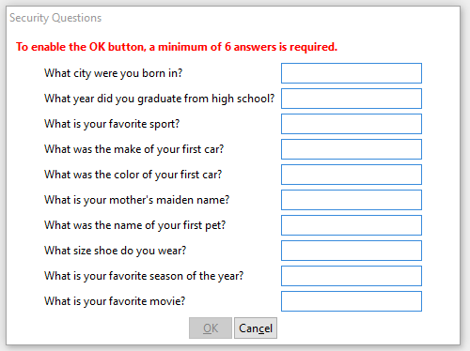

1. Next set up *Provider (Hospital) information*. This has to be done before completing your account. Go to the top of the page and click on **Administration > Provider**.
2. A *Provider Detail* box will appear on the right. Enter all the bolded fields, the time frame, and measure preferences. Choose other measures only if they are by your hospital or a requirement of another program.

Outpatient: AMI, ED Throughput

If you do not know your CMS Certification number, please contact the Flex Grant and we can provide that to you. It will be a 6 digit number starting with 2713_ _. Save this information by clicking on the **Save** icon in the upper left menu bar.

*The time period drop down is typically organized by module versions and updates. If you do an update to CART, you will need to select the new time period and choose measures for that. In the example screen shot below, if I still needed to enter 4Q 2017 cases, I would choose* ***Time Period 01/01/2017 – 12/31/2017 (1.19)*** *and check measure sets for that.. If you do not have measures selected for the time period you are entering, you will not be able to enter data.*

1. Next create the *User Account* by choosing **Administration > User** and complete the **User Detail** form on the right. Choose **“System Administrator**” as the User Type. When complete, **SAVE** and repeat the process for a backup account. (image 2)

*Set up 2 user accounts so you have a backup account in case you get locked out. Naming examples are below.*

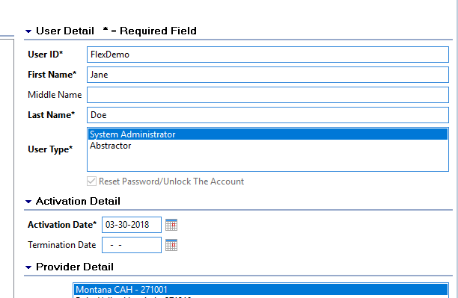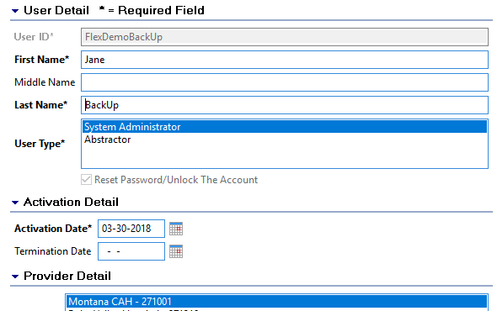

1. Exit out of CART then reopen and choose **CART-Outpatient**.
2. Enter User ID for main account and type in the CART default password of **p@ssw0rd** (that’s a zero). Click **Login**.
3. CART will prompt to change the password. Enter the password you created and answer your security questions again. When complete it will go to a blank screen. To make sure the User ID and password work logout and log back in using the User ID and Password you created.
4. Repeat steps 9 and 10 for the backup account. Use the backup account User ID and the same security questions as before.

**ACCESS MAINTENANCE**

*See the “cheat sheet” image below for an example to organize your access information. Save a document or print hard copy and put in a CART file folder. It doesn’t have to be fancy; mine is handwritten! Just remember to update when CART prompts your password to be updated (every three months).*

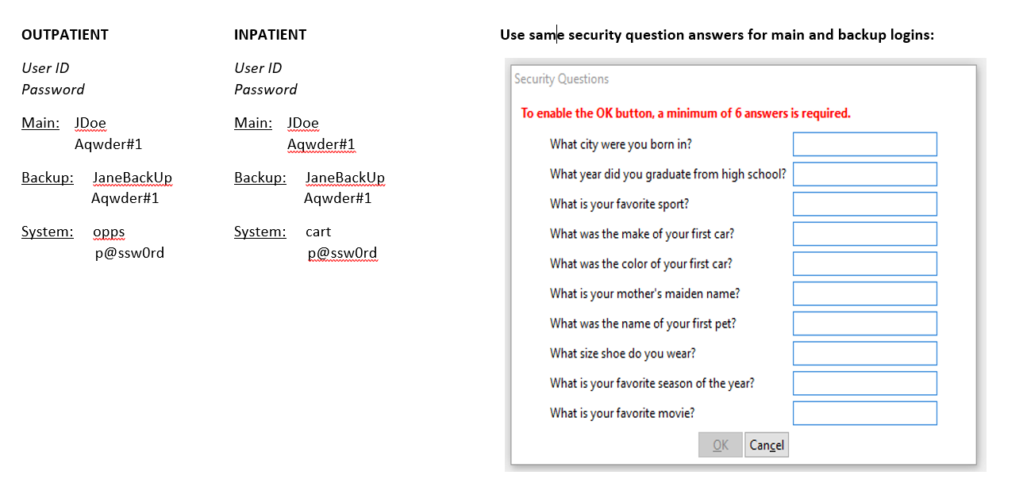

**LOCKED OUT OF CART?**

1. Select the CART login screen for the module you are locked out of (Inpatient or Outpatient)
2. Login with your back up account.
3. Go to **Administration > User** and select the User ID that is locked out. Under User Type, check the box that says **Reset Password/Unlock the Account** and **save**. Exit out of CART.

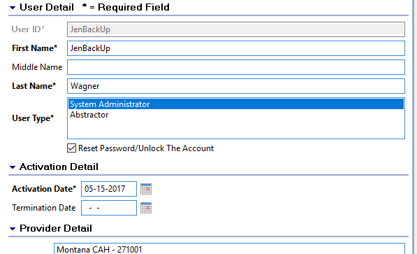

1. Log back into CART and enter the User ID that was locked out and **p@ssw0rd** for the password. The system will prompt for a new password. When a blank screen appears it is complete.
2. Log out and back in to test new password.

**ENTERING DATA INTO CART**

**HOW TO GET DATA –** *Actual abstraction of data will differ for each hospital.*

* Use two monitors and abstract directly from your EMR.
* Abstract and enter data on paper tools, then enter into CART. Paper tools can be found on the QualityNet website at the links below. Select the correct discharge period.

[Outpatient](https://www.qualitynet.org/dcs/ContentServer?c=Page&pagename=QnetPublic%2FPage%2FQnetTier3&cid=1205442056833)

* Depending on report capabilities of each EMR, hospitals may be able to directly import and export data to CART or QualityNet. However, due to the difference in EMRs those steps are not included in this guide and MT Flex is working on education modules to support this process.

1. Log in to the appropriate CART module. (Example uses Inpatient ED Throughput)
2. Click on **Administration** > **Patient**
3. Enter required patient data and click **Add Patient** and **Yes** on the pop up.

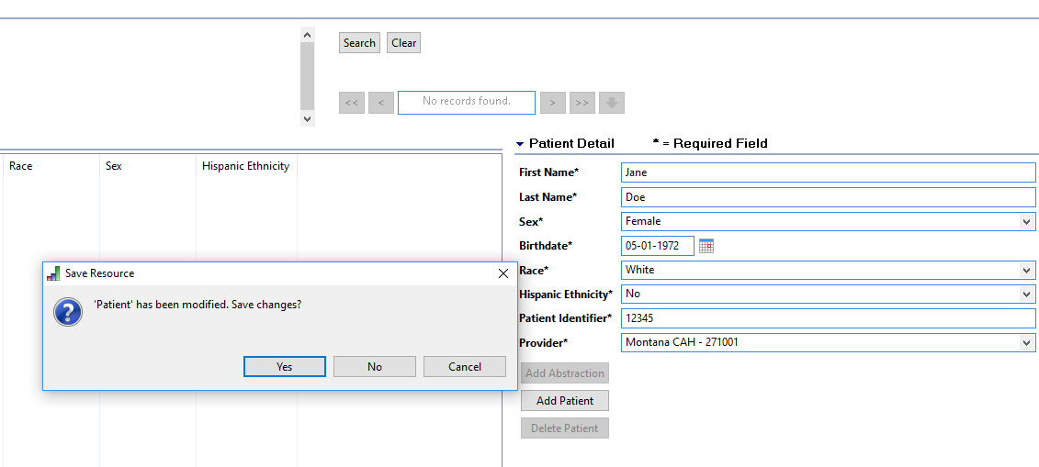

1. Double click on the Patient in the **Patient Summary** area on the left. Complete the pop up, tabbing through the fields and click **Finish**. Bolded fields are required.

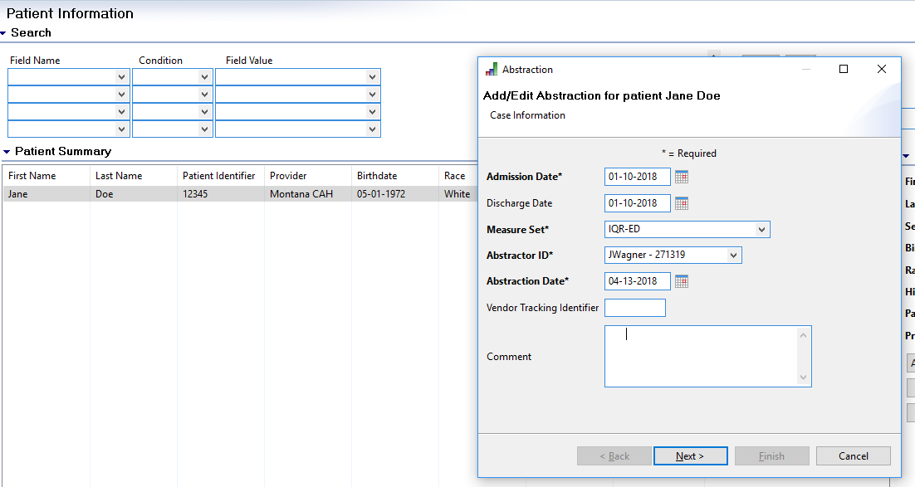

1. Enter information for **bolded** questions.

* Question 1: Always choose to “**Enable/disable questions appropriately”** so you don’t waste time entering unneeded data.
* ICD-10 Code: Start typing in the code and the list will begin to populate.
* Do not abstract or enter other diagnosis or procedures codes unless being used by the facility. They aren’t required and it takes a long time to abstract and then enter. *Note this on your paper tools!*
* Pay close attention to dates for arrival, admit, and discharge; especially if it’s over midnight as this could result in an outlier if entered wrong.
* Physician Identifiers are not required. Save time and effort and only enter if being used by the facility.

1. When all required data is entered, the bolded questions on the left will disappear. Click the **Save** icon in the upper left. A pop up will appear asking if you wish to duplicate. Choose **OK** if the patient falls into another measure set. Choose **Cancel** if you are done with the patient. Close*Abstraction*window**.**

*When entering Inpatient cases, start with ED measures, then choose to duplicate and enter IMM data..*

1. Repeat this process for each case.

**ACCESSING PATIENT AND ABSTRACTION DATA**

1. By just clicking **Search** at the top, all current abstractions will come up.
2. Click on the field heading in **Patient Summary** to sort abstractions.
3. You can also enter specific data to search for.
4. Double click on the patient/abstraction to edit.

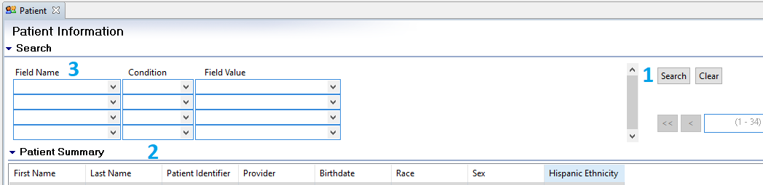

**EXPORT ABSTRACTIONS**

1. Click on **Abstraction** drop down, then **Search**. Then click on the **Search** button. All abstractions will appear.
2. Highlight abstractions to export. Click on column headers to sort if needed.
3. Click Export.

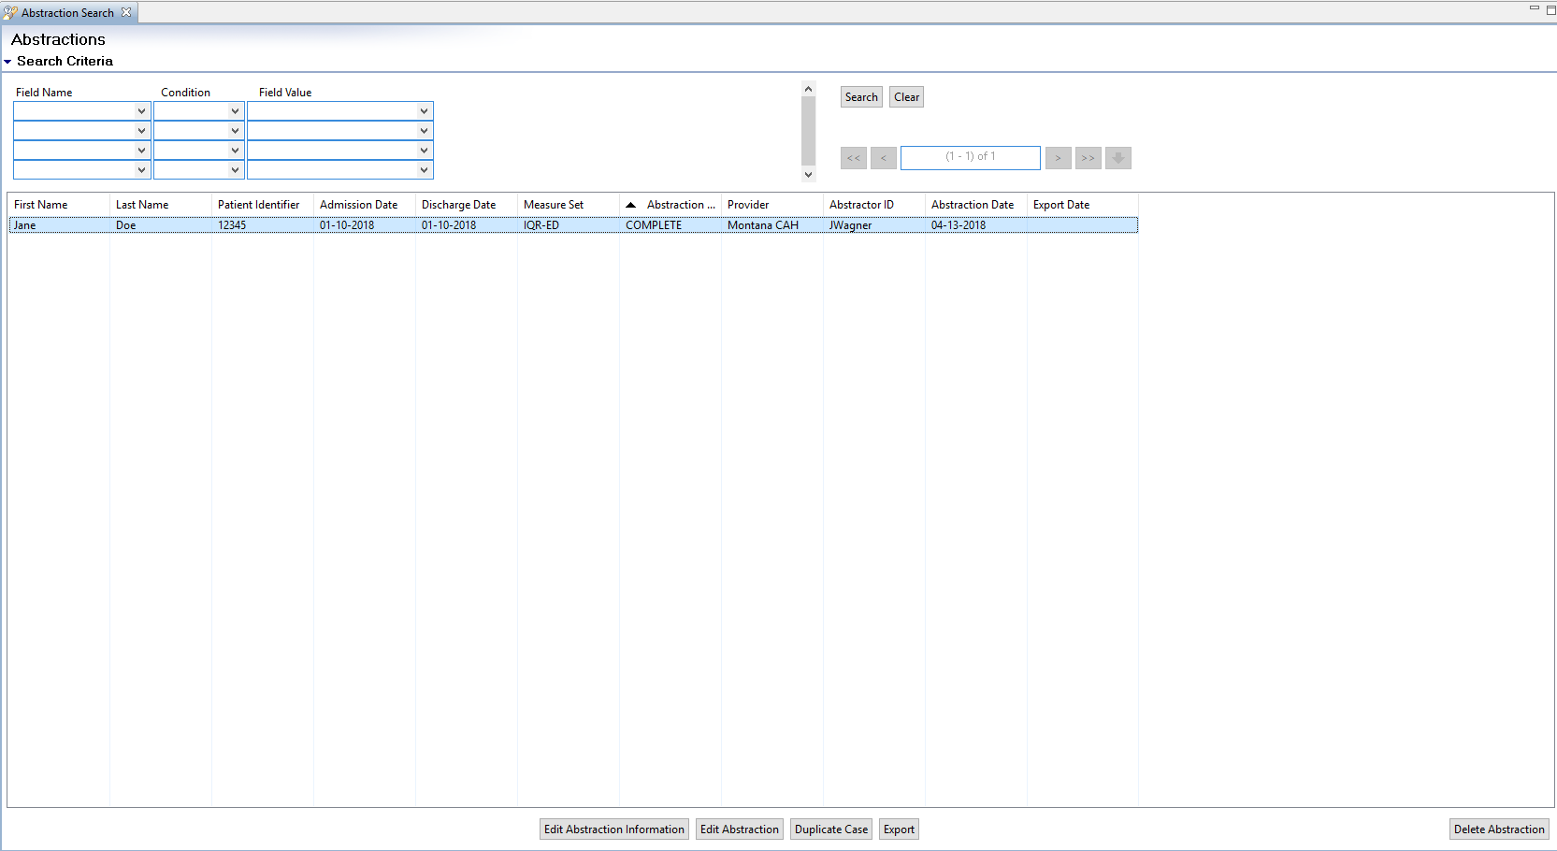

1. An *Export* pop up will appear. Choose **Zip** as file type and Browse to the appropriate location on your own computer system. Everything else will stay the same*.*

*Make note of the file path to access the export when you upload into QualityNet.*

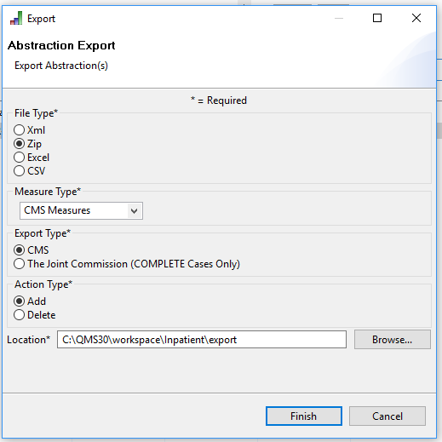

1. A pop up indicating “*The export process has completed”* will appear, click **close**. Some users may get an additional pop up asking if you would like files to be uploaded to the data warehouse now. You can choose yes or no; choosing **Yes** will open the [**QualityNet website**](https://www.qualitynet.org)**.**

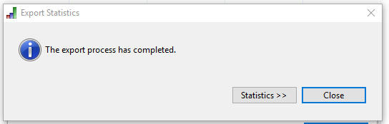

1. Once the files are uploaded and accepted into QualityNet you can remove patients and abstractions from CART.
   * + Click on **Abstraction** drop down, then **Search**. Then click on the **Search** button. All abstractions will appear.
     + Highlight abstractions to delete. Click on column headers to sort if needed.
     + Click **Delete Abstractions**.



**See HARP/HQR Guide to file upload directions**

[HARP Set Up with screen shots](https://files.constantcontact.com/f37a813f001/49c2db1e-9dc9-4251-98ef-5eb221e913d0.pdf)

[HARP training webinar](https://www.qualityreportingcenter.com/en/events-on-demand/vbp/SettingupHARP/)

[HARP User Guide](https://www.qualitynet.org/training-guides%23tab2#tab2)

[QualityNet Help Desk](mailto:qnetsupport@hcqis.org)