Appendix D
Diabetes Management Algorithm and Drug Prices
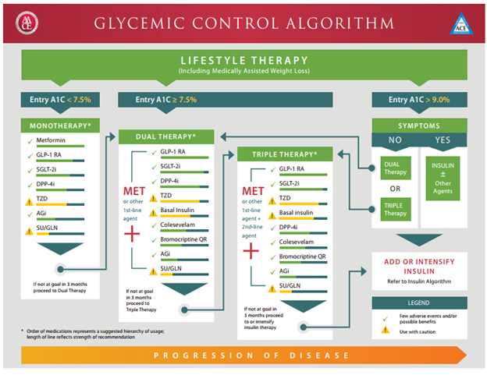
340B Drug Prices

Metformin: $10.00 for 100 tabs  Glyburide: $10.00 for 100 tabs  Glipizide: $10.00 for 100 tabs  Glimepiride: $15.00 for 100 tabs  Albiglutide: $107.32 for 4 syringes  Acarbose: $20.00 for 100 tabs | Canagliflozin: $150.00 for 30 (300mg) tabs  Empagliflozin: $73.71 for 10 (10mg) tabs  Lispro: $22.75 for box of 5 pens  Levemir: $22.75 for box of 5 pens  Humalog: $22.75 for one box  Aspart: $22.77 for one box
Drug pricing obtained via direct communication with Plentywood Rexall Drug Plentywood, MT
Glycemic Control Algorithm directly obtained from AACE/ACE Type 2 Diabetes Management Algorithm (2018)

