National Health Safety Network (NHSN)

- Enroll in NHSN

- Follow NHSN Components
- Log into: https://nhsn2.cdc.gov/nhsn. This will take you to the NHSN Landing Page
- Select any Component.
- On the left blue side bar choose Facility, then Add/Edit Component.
- Check Patient Safety and Healthcare Personnel Safety. You may be prompted to enter a contact for each component. You can enter an existing user or add a user by:
  - Click on Users on left blue side bar and then “Add”.
  - Complete User ID (created by the facility), First Name, Last Name, Email.
  - Save user and “Edit User Rights” screen will appear. Confer appropriate rights.

- Join MHA User Groups (Flex and HIIN Data)
These steps must be performed by a facility’s NHSN administrator. Contact nhsn@cdc.gov if you do not know your facility’s NHSN administrator or if you have technical issues with NHSN. You will need to complete the process for each the Healthcare Worker Immunization Component and Patient Safety Component

- Joining the MT Flex/HIIN Group in NHSN – Healthcare Personnel Safety Component
- Log into NHSN and select the Healthcare Personnel Safety (MT Flex/MBQIP)
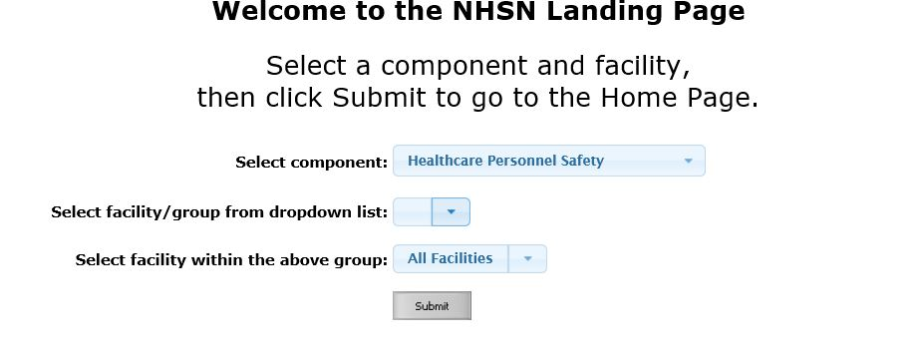

- In the left column, click on Group, then Join. This will take you to the Memberships screen. Enter the Group ID 44933 and Group Joining Password flexhen. Click Join Group. A pop-up warning message will appear. Click ok. You have now joined the group.
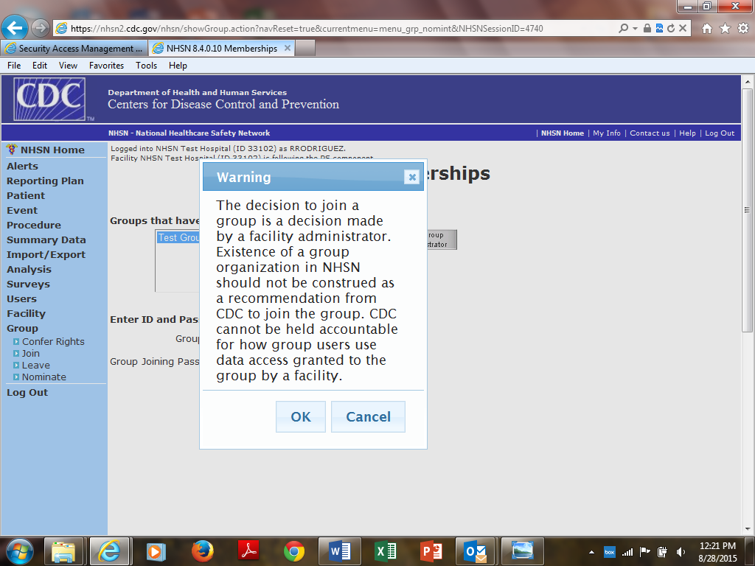

- MT Flex Group Data Template: On the next screen, (Confer Rights-Patient Safety), you will be able to review the data to which the MT Flex group will have access. Scroll down the screen to review the confer rights template.
- Under the section titled “General,” the template shows the MT Flex group will have access to: Patient data with NO identifiers, Healthcare Safety Monthly Surveillance Plan, Annual (HPSFACSURVEY), Seasonal Flu Survey, HPS Data Analysis, Facility Information
- To accept the reporting template and confer rights to your data to the MT HEN 2.0 group, please press “Accept” at the bottom of the page. You will receive a message saying your rights have successfully been conferred – the group name in your message with be “MHA_FLEX_H (44933)”

- Joining the MT Flex/HIIN Group in NHSN – Patient Safety Component
- Log into NHSN and select the Patient Safety Component (HIIN)

- In the left column, click on Group, then Join. This will take you to the Memberships screen. Enter the Group ID 44933 and Group Joining Password flexhen. Click Join Group. A pop-up warning message will appear. Click ok. You have now joined the group.
- Patient Safety Group Data Template
- On the next screen, (Confer Rights-Patient Safety), you will be able to review the data to which the MHA will have access. Scroll down the screen to review the confer rights template. Under the section titled “General,” the template shows the MHA will have access to: Patient data with NO identifiers, Monthly Reporting Plans, Rights to analyze your data, Facility Information, Hospital survey data
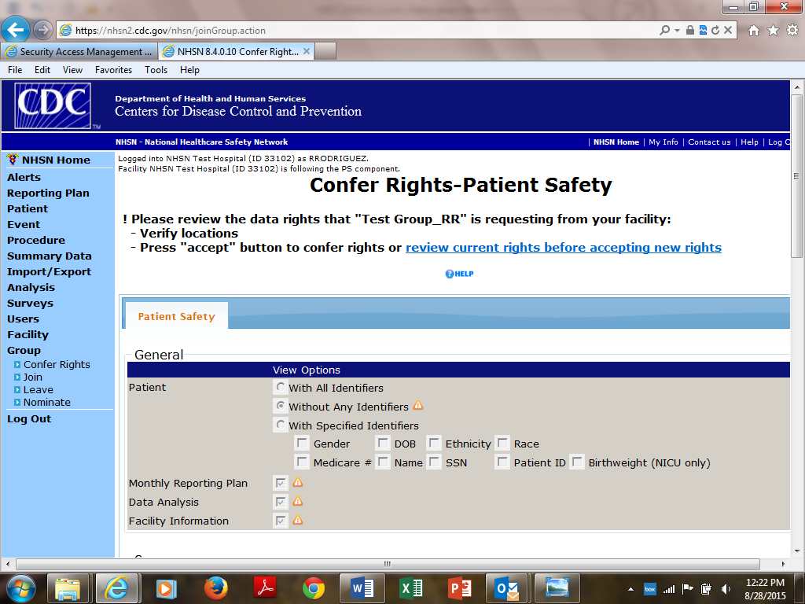

- 3) For “Infections and Other Events” the MHA will have access to:
Infection / Event | From where? | Time frame | Note
A. Central-line associated bloodstream infection (CLABSI) | All inpatient locations | 2010 through the end of HIIN
B. Surgical Site Infection (SSI) | All inpatient locations | 2010 through the end of HIIN | The MT HEN 2.0 group will have access to data on all inpatient procedures that you have entered into NHSN. At a minimum you must report data on colon surgeries (COLO), abdominal hysterectomies (HYST), total hip replacements (HPRO) and total knee replacements (KPRO).
C. Catheter-associated urinary tract infection (CAUTI) | All inpatient locations except NICUs | 2010 through the end of HIIN
D. Ventilator-associated event (VAE) | All inpatient locations | 2013 through the end of HIIN

  - MT HIIN expects data from all inpatient locations. For CAUTI, if you are a facility with NICUs, please exclude these locations from the CAUTI section (section c above).

  - To exclude locations, click the arrow in the “Your locations” box and de-select that location. In the example below, location NQIWJK3 – WJK NICU has been de-selected for CAUTI and the MT HIIN will not have access to CAUTI data from that location.

  - Under MDRO/CDI events MT HIIN is asking for C. difficile laboratory ID events for the FACWIDEIN location from 2013 until the end of the project. FACWIDEIN refers to all of the facility’s inpatient units. Note: if you get an error message under “Your Locations” that says “No locations meet criteria,” please ignore it.

  - Under MDRO/CDI Process & Outcome Measures, MT HIIN is asking for the Hand Hygiene process measure from all locations from 2010 until the end of the project.

- To accept the reporting template and confer rights to your data to the MHA, please press “Accept” at the bottom of the page. You will receive a message saying your rights have successfully been conferred – the group name in your message with be “MHA_FLEX_HEN (44933)”

