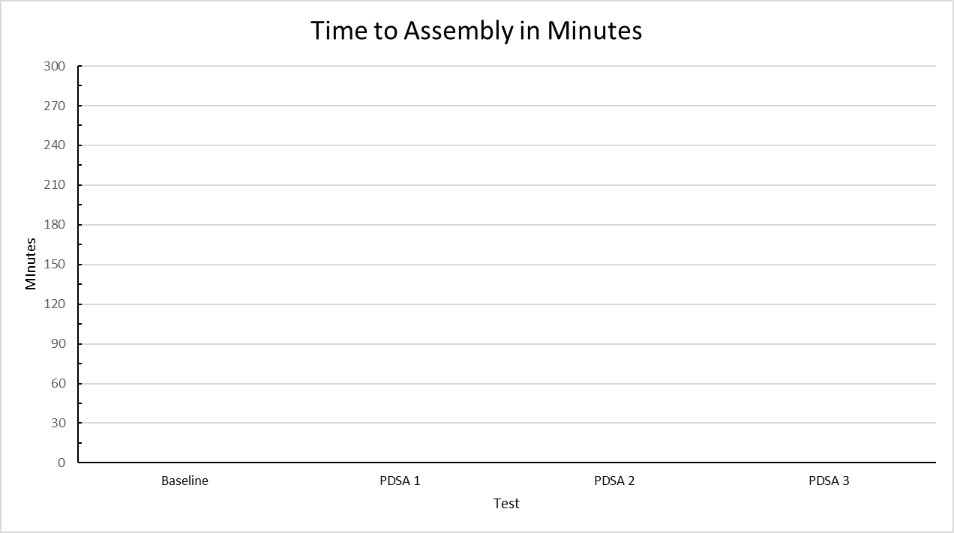

Minutes

5:00

4:30

4:00

3:30

3:00

2:30

2:00

1:30

1:00

0:30

0

Green = All pieces on and positioned correctly

Yellow = All pieces are on, but one or more is out of place

Red = One or more pieces are not on