Healthcare Teams Working to Improve Care of Multiple Bus Crash Victims

A bus filled with Potato Head family members has been in a terrible crash! At the scene of the accident, Emergency Medical Services arrives to find only scattered body parts. There were men, women and children on the bus.
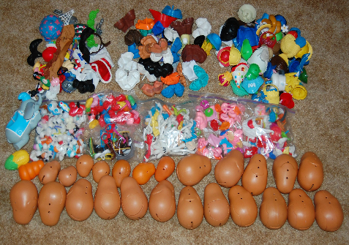
Luckily, one of the uninjured family members was carrying a photo album with a photo of each family member.

Your healthcare team is waiting in the emergency room to correctly assemble your 3 family members as quickly as possible.

To begin, on your health care team, one of the members is designated as an “Implantation Specialist” a.k.a. trauma surgeon. Only this specialist can “implant” the parts into the potato bodies. Other members of your team must include a timekeeper, a quality inspector, and a documentation specialist.

The number of correctly assembled Potato Heads and the number of errors will be tracked through each PDSA cycle. The first round will be for baseline only – no discussion or planning allowed (except for role designation)!

Your time will begin when any member of the team touches the bags.

After the first round, please stop for a group debrief and further instructions.

Round 1 – Establishing a Baseline

Each team will build their first Mr. Potato Heads and record their time and accuracy on the provide chart. This is an important benchmark for what will follow – assembling Mr. Potato Heads as quickly and accurately as possible.

Round 2 – First Test

Considering your baseline, your team will set out on your first PDSA. Your team will agree on a goal for time and accuracy and you will document your plan for improvement BEFORE testing. Record the outcomes in both time and accuracy. Discuss if your plan was confirmed or refuted.

Rounds 3 – Additional PDSA Cycle

In each round, your team should identify improvement opportunities that can be tested to improve on accuracy and/or time of the task. Results from each round should be recorded and plotted on your chart. Discuss if your goal has achieved, not achieved or exceeded.

Round 4 – Implementation
In this round, your team would decide how this system will be disseminated throughout different departments, how the improvement gains will be sustained, what are the budget implications and how will you monitor that your processes are still working. The PDSA cycle may need to be repeated several times before Implementation actually takes place.

