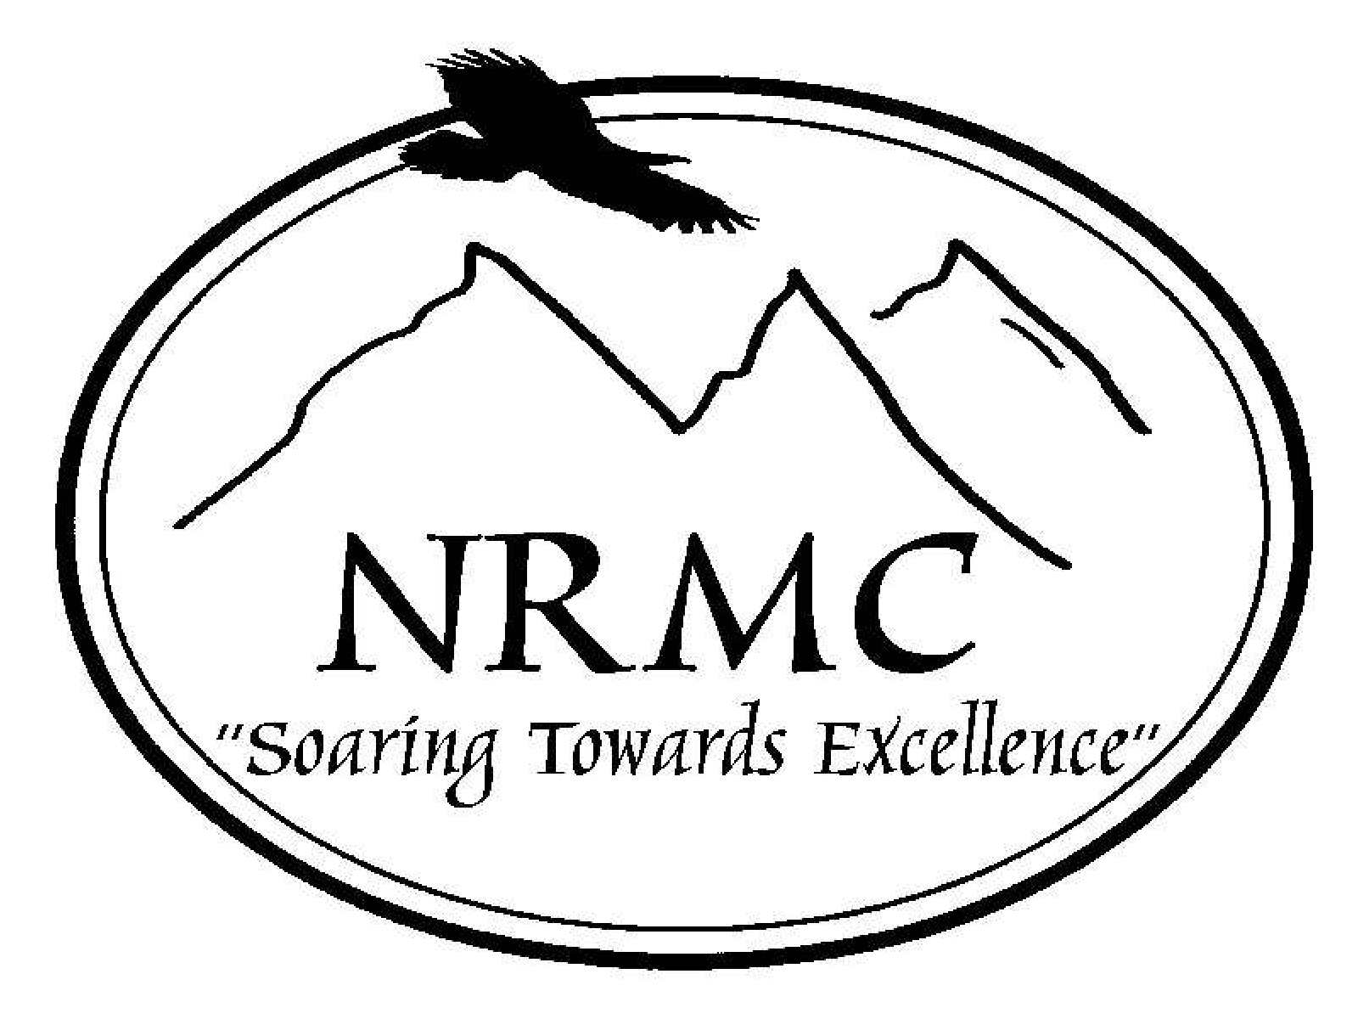 NORTHERN ROCKIES MEDICAL CENTER

802 2nd Street SE
Cut Bank, MT

Department: Facility Wide | Policy #: Admin.0026
Policy: Conflict of Interest | CNO:
 | Administration:
Effective Date: 11/2008 | Medical Staff:
Revised Date: | Mid-level:
 | Outside professional:

Policy:

As an employee of NRMC, you may not receive any financial kickbacks, bribes, or substantial gifts as a result of any business dealings involving NRMC.

Employees have an obligation to conduct business within guidelines that prohibit actual or potential conflicts of interest. This policy establishes only the framework within which NRMC wishes the business to operate. The purpose of these guidelines is to provide general direction so those employees can seek further clarification on issues related to the subject of acceptable standards of operation. Contact the Administrator for more information or questions about conflicts of interest.

An actual or potential conflict of interest occurs when an employee is in a position to influence a decision that may result in a personal gain for that employee or for a relative as a result of NRMC business dealings. For the purposes of this policy, a relative is any person who is related by blood or marriage, or whose relationship with the employee is similar to that of persons who are related by blood or marriage.

No “presumption of guilt” is created by the mere existence of a relationship with outside firms.
However, if employees have any influence on transactions involving purchases, contracts, or leases, it is imperative that they disclose to administration of NRMC as soon as possible the existence of any actual or potential conflict of interest so that safeguards can be established to protect all parties.
Personal gain may result not only in cases where an employee or relative has a significant ownership in a firm with which NRMC does business, but also when an employee or relative receives any kickback, bribe, substantial gift, or special consideration as a result of any transaction or business dealings involving NRMC.

Compliance with this policy of conflict of interest is the responsibility of every NRMC employee.

