|  |  |  |
| --- | --- | --- |
| **FMC Logo B&W** | **Acute Care**  **Guideline** | |
| **Subject: LUCAS Chest Compression Device** | | **PAGE 1 of 7** |
| **Reviewed:** | | **Effective date 9/15** |

## Purpose

This procedure describes the appropriate methods to apply, operate, and discontinue the LUCAS device in patients requiring mechanical chest compression related to cardiac arrest.

**Indications**

The Lucas may be used in patients who have suffered **non-traumatic** cardiac arrest, where manual CPR would otherwise be used.

**Contraindications**

* Patients suffering traumatic cardiac arrest or patients with obvious signs of traumatic injury.
* Patients who do not fit within the device (Sternum height of 6.7 inches to 11.9 inches, max chest width of 17.7 inches).
* Patients who are too large and with whom you cannot press the pressure pad down 2 inches.
* Patients who are too small and with whom you cannot pull the pressure pad down to touch the sternum

**Protocol for Placement**

* All therapies related to the management of cardiopulmonary arrest should be continued as currently defined.
* Early defibrillation should be considered and provided as indicated based on clinical presentation.
* Manual chest compressions should be initiated ***immediately*** while the LUCAS device is being placed on the patient.
* **Limit interruptions in chest compressions to 10 seconds or less.**
* **Do not delay manual CPR for the LUCAS. Continue manual CPR until the device can be placed.**
* While resuscitative measures are initiated, the LUCAS device should be placed on the patient in the following manner:

|  |  |
| --- | --- |
| **Subject: LUCAS Chest Compression Device** | **PAGE 2 of 7** |

1. **Position the Compressor**

* Turn the LUCAS Device on (the device will perform a 3 second self test).

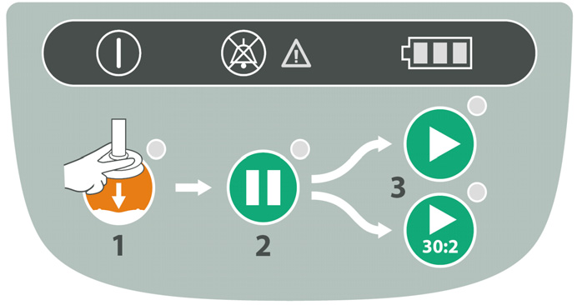

**ON/OFF Switch**

* Remove the LUCAS device from its carrying case using the handles provided on each side.
* With the index finger of each hand, pull the trigger to ensure the device is set to engage the backplate. Once this is complete, you may remove your index finger from the trigger loop.
* **Approach the patient** **from the side opposite the person performing manual chest compressions.**
* Attach the claw hook to the backplate on the side of the patient opposite that where compressions are being provided.
* Place the LUCAS device across the patient, between the staff member’s arms who is performing manual CPR.
* At this point the staff member performing manual CPR stops and assists attaching the claw hook to the backplate on their side. As long as the unit snaps into the backboard and the suction cup does not compress the patient’s chest in the start position, it will operate as intended.
* Pull up once to make sure that the parts are securely attached.

|  |  |
| --- | --- |
| **Subject: LUCAS Chest Compression Device** | **PAGE 3 of 7** |

1. **Backplate Placement**

* The backplate should be centered on the nipple line and the top of the backplate should be located just below the patient’s armpits.
* **Placement should occur during a scheduled discontinuation of compressions [e.g., after a complete cycles of 30:2 or two minutes of uninterrupted compressions]**

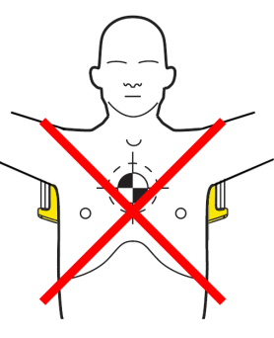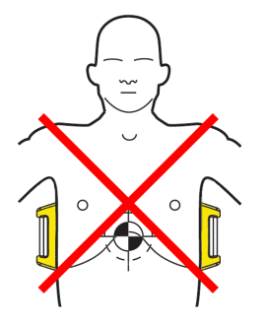

1. **Adjust the Height of the Compression Arm**

* Use two fingers (V pattern) to make sure that the lower edge of the Suction Cup is immediately above the end of the sternum. If necessary, move the device by pulling the support legs to adjust the position
* Press the Adjust Mode Button on the control pad labeled #1 (This will allow you to easily adjust the height of the compression arm).



**Adjust Mode Button**

**Pause (Lock) Button**

|  |  |
| --- | --- |
| **Subject: LUCAS Chest Compression Device** | **PAGE 4 of 7** |

* To adjust the start position of the compression arm, manually push down the SUCTION CUP with two fingers onto the chest (without compressing the patient’s chest)
* Once the position of the compression arm is satisfactory, push the green PAUSE button labeled #2 (This will lock the arm in this position), then remove your fingers from the SUCTION CUP. Mark the upper edge of the suction cup and visually verify correct placement frequently during resuscitation.
* If the position is incorrect, press the ADJUST MODE BUTTON and repeat the steps.

1. **Start Compressions**

* If the patient is not intubated or a king airway is in place and you will be providing compression to ventilation ratio of 30:2 push ACTIVE (30:2) button to start.
* If the patient is intubated or king airway in place and you will be providing continuous compressions push ACTIVE (continuous) button



**ACTIVE BUTTON**

**(continuous)**

**ACTIVE BUTTON**

**(30:2)**

* Place the neck roll behind the patient’s head and attach the straps to the LUCAS device.
* This will prevent the LUCAS from migrating toward the patient’s feet.
* Place the patients arms in the straps provided.

|  |  |
| --- | --- |
| **Subject: LUCAS Chest Compression Device** | **PAGE 5 of 7** |

**Using the LUCAS during the Resuscitation**

1. **Defibrillation**
   * Defibrillation can and should be performed with the LUCAS device in place and in operation. Defibrillation can be performed in manual or AED mode.
   * One may apply the defibrillation electrodes either before or after the LUCAS device has been put in position
   * The defibrillation pads and wires should not be underneath the suction cup
   * If the electrodes are already in an incorrect position when the LUCAS is placed, you must apply new electrodes.



* If the rhythm strip cannot be assessed during compressions, one may stop the compressions for analysis by pushing the PAUSE BUTTON (The duration of interruption of compressions should be kept as short as possible and should not be > 10 seconds. There is no need to interrupt chest compressions other than to analyze the rhythm).
* Once the rhythm is determined to require defibrillation, the appropriate ACTIVE BUTTON should be pushed to resume compressions while the defibrillator is charging and then the defibrillator should be discharged.

|  |  |
| --- | --- |
| **Subject: LUCAS Chest Compression Device** | **PAGE 6 of 7** |

**Pulse Checks/Return of Spontaneous Circulation (ROSC)**

* Pulse checks should occur intermittently while compressions are occurring
* If the patient moves or is obviously responsive, the LUCAS Device should be paused and the patient evaluated.
* If there is a change in rhythm, but no obvious indication of responsiveness or ROSC, a pulse check while compressions are occurring should be undertaken. If the palpated pulse is synchronized with the Lucas, one may consider pausing the LUCAS Device. If the pulse remains, reassess the patient. If the pulse disappears, one should immediately restart the LUCAS Device.

**Disruption or Malfunction of Lucas Device**

**If disruption or malfunction of the LUCAS device occurs, immediately revert to Manual CPR.**

**Device Management**

1. **Power Supply**
   * Battery Operation
     + When fully charged, the Lithium Polymer battery should allow 45 minutes of uninterrupted operation. Once the battery light turns orange, there is 10 minutes remaining on the battery.
     + When the orange Battery LED shows an intermittent light, one should replace the battery or connect to a wall outlet
     + There is an extra battery in the Lucas Device bag
     + The battery is automatically charged when the device is plugged into a wall outlet and not in operation. **(When detaching from the wall outlet, make sure that the cord is always with the LUCAS Device)**.
     + One may connect the LUCAS Device to wall power in all operational modes (One must always keep the battery installed in order for the LUCAS Device to remain operational).

|  |  |
| --- | --- |
| **Subject: LUCAS Chest Compression Device** | **PAGE 7 of 7** |

1. **Care of the LUCAS Device after use**



Power Supply Cord Slot

(for charging and AC operation)

* + Remove the Suction cup and the Stabilization Strap (if used, remove the Patient Straps).
  + Clean all surfaces and straps with a cloth and warm water with an appropriate cleaning agent.
  + Let the device and parts dry.
  + Replace the used Battery with a fully-charged Battery.
  + Remount (or replace) the Suction Cup and straps
  + Repack the device into the carrying bag
  + Make sure that the Charging Cord is stored with the LUCAS Device.
  + The LUCAS Device in the carrying bag should be stored fully charged and
  + Status of the battery checked and charged monthly or immediately after every use.

**After each use call 1-844-458-2272 or send email to** [**LUCAS@med.und.edu**](mailto:LUCAS@med.und.edu) **and let them know we have used the device.**