Annual Facility Assessment
Eastern Montana Veterans Home
2015
MJ Marx, RN, MSN, BC
Resident Care/Quality Coordinator

Physical Characteristics
Eastern Montana Veterans Home (EMVH) boasts 47,800 square feet; 39 semi-private resident rooms and 2 private resident rooms; 6 offices; 2 tub rooms; 2 conference rooms; 1 restorative therapy room; 1 beauty/barber shop; 1 kitchen; 1 dining room; 1 activity room; 1 chapel; 1 resident telephone room; 1 resident laundry; 3 medication rooms; a 16 bed (8 of the 39 semi-private rooms) locked therapeutic unit containing a combination kitchen/dining/activity area.
EMVH is located in Eastern Montana in Dawson county, city of Glendive. Glendive is located along Interstate-94, approximately 35 miles west of the North Dakota Border. It has a population of approximately 8500 people. EMVH is a free standing Montana Department of Health and Human Services owned Veterans Home. The Veterans Administration of Montana rents office space in the building as well.
Resident Population
EMVH is licensed for 80 residents. As a state owned Veterans Home, EMVH may admit, up to 25% of its licensed capacity, spouses of veterans. At the time this report was written there were 16 spouses and 44 veterans, a 75% capacity. The 16 bed special care unit is full and has a waiting list. The youngest resident is 56, and the oldest resident is 98. Table 1 shows how many residents are less than 60, then how many are in each year 10 year span up to age 100.

Table 1
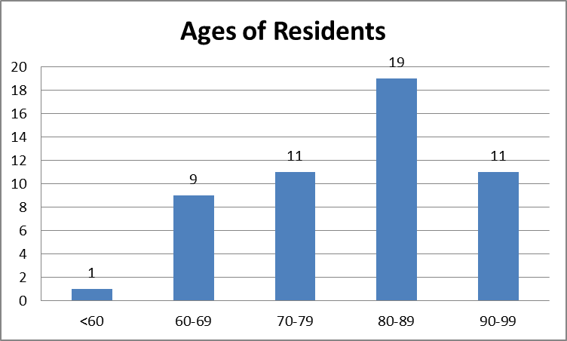
The types of care provided at EMVH includes: skilled, intermediate, hospice, behavioral health due to prevalence of mental illness in the Veteran population, and dementia care. EMVH is licensed as a Skilled Nursing Facility (SNF). This designation allows EMVH to care for Medicare Skilled residents on a short term basis (up to 100 days), Intermediate residents on a short or long term basis, and Hospice patients on a respite basis, short or long term basis.
The acuity of residents ranges from independent with ADL’s to completely dependent on staff, with numerous variances in dependence on staff.
The majority of residents are from Scandinavian countries, and Germany. There are opportunities within the community for ethnic dishes prepared, i.e. Lutefisk. Those ethnic community dinners are delivered to the residents who would like to enjoy their ethnic foods (activities staff assist with getting a list of residents who would like to receive a meal). Residents are from a wide variety of occupational backgrounds, rancher, farmer, teacher, housewife and numerous others.
Table 2 demonstrates how many residents have each of the diagnosis listed. Majority, if not all, residents have more than 1 of the diagnoses listed.
Table 2
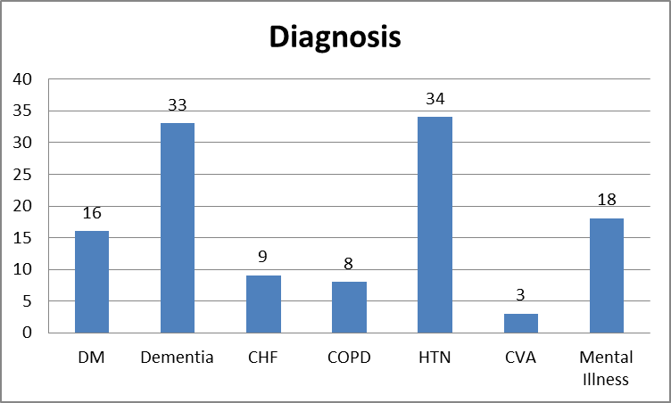
Resources Necessary to care for Resident Population
Medical equipment necessary to care for residents is: vital signs stands that include blood pressure cuff and thermometer; wheelchairs; stethoscopes; medication carts; beds; over-bed tables; enteral feeding pump; intravenous infusion pump; oximeters; mechanical lifts utilized to transfer residents; whirlpool tubs for bathing residents; bladder scanner; Omnicell drug dispensing system.
Non-medical equipment necessary for the care of the residents include-office equipment, i.e. chairs, desks, computers, printers, filing cabinets, chart racks, chart binders, fax machine. Other non-medical equipment necessary for the care of the residents include, recliners, loveseats, card tables, table chairs.
There is an Administrator (0.5 FTE); an Assistant Administrator (0.25 FTE) Director of Nursing (1.0 FTE); Assistant Director of Nursing/MDS Coordinator (1.0 FTE); a Resident Care Coordinator (1.0 FTE); Resident Care/Quality Coordinator (0.5 FTE); and 2 Social Workers (1.25 FTE), in leadership at EMVH.
There are 31 nursing, 2 engineering, 2 activities (=2.5 FTE), and 7 dietary department employees. This fall, dietary has a new general manager that will be hands on assisting at EMVH. There are 20 open FTE positions in nursing that are currently being filled by a combination of 64 traveler employees. The traveler employees are from local and national travel companies. EMVH utilizes 6-13 week contracts with travelers to increase consistent care for the resident. Staff competencies required to care for residents include: competent in IV management; mechanical lift transfers; abuse prevention; feeding tube management; dementia care; Skin Care prevention; Basic Life Support; medication administration; assessment of lung and bowel sounds; competent in communicating the resident’s condition to the provider and family.
There are 18 adult volunteers and 1 junior volunteer who help in the beauty shop; assist the residents with their activities; and provide intergenerational activity for the residents. Volunteer competencies required are: abuse prevention; suspected abuse reporting.
EMVH has on one bus, lift equipped, and one van, lift equipped, used for bus rides and resident appointments out of the facility.
Services Provided
Services provided through GMC are Physical Therapy, Occupational Therapy, and Pharmacy. Restorative Nursing is provided within EMVH. EMVH has an agreement with GMC Hospice for inpatient care.

Health Information Technology
EMVH utilizes Saunders software as its electronic medical record; RL solutions as its Risk Management software; Cerner as its Billing software, pharmacy software, laboratory and radiology software; Lawson as its materials management software. EMVH has some WI-FI capabilities but it is not reliable to be a strong signal throughout entire building. The process for communicating with physicians is through fax or phone.
Evaluation of Quality Assurance Performance Improvement Program
Quarter 2
On April 24, 2015, Eastern Montana Veterans Home (EMVH) experienced an Immediate Jeopardy Survey. An Abatement plan was accepted by the Montana State Department Health and Human Services (MTDPHHS), and we were placed back into compliance. We received 19 total deficiencies from that survey, 16 in Nursing, 1 in Dietary, and 2 in Administration. On June 9, 2015, upon resurvey by the MTDPHHS, we were in compliance. We have since had 2 resurveys by fax that has continued to show us in compliance.
Through our extensive audits since that time we have identified Performance Improvement Projects (PIP’s) to drill down into certain areas. Those areas that will be drilled into starting in September, 2015 are: Notifications (of provider and family); Catheter Care Documentation; and Orientation (of all employees, including travelers). We have identified, through my observations as Resident Care/Quality Coordinator, that there are other areas we would like to address through the PIP process. One of those areas is the coordination of physician services. We have a good process for this now, but it can be improved upon, specifically in the area of what we are able to get accomplished for the resident in that day. A second area that has been noted is the pre-admission process. There is a feeling that we could tighten this process, making it better, more efficient, and as smooth as possible for the resident and family. We expect to start these PIP’s in October.
September 9, EMVH received its yearly Veterans Administration survey. While we do not have the official results in hand yet, the surveyors shared 5 areas of concern. The first two areas involve the care plan process, with being revised timely and ensuring that what is written is being done. A third area is our infection control program. We have a new Infection Control nurse, and we need to shore up our processes. The fourth area discussed was in dietary and the use of outdates on dietary products. The last area of concern was in life/safety regarding the sensitivity testing of smoke detectors.
Our focus has been on the Nursing department as they received the largest number of deficiencies in the April survey. As time marches on, our goal at EMVH is that my role will expand to include all departments within the facility. The second department I will be focusing on is the Dietary department. The expectation is I will add this department to what I am currently working on in the next quarter.
Quarter 3
September 9-11, Eastern Montana Veterans Home (EMVH) received its yearly Veterans Administration (VA) survey. There was one deficiency received in the area of Life/Safety regarding checking of smoke detectors. All other standards were met. The surveyors did give some recommendations to the nursing department and dietary department.
The nursing department started an intensive audit and review of comprehensive care plans that will continue into the fourth quarter of 2015, based on those recommendations. The initial results of this audit and review show that there is a concern with accuracy. The dietary department is changing its food labeling in regards to dates based on those recommendations.
The Quality Assurance and Assessment team has been meeting routinely and is receiving education about its role. The Minimum Data Set (MDS) Quality Measures were reviewed for EMVH, using the reporting period of January 1, 2015 to June 30, 2015. Two areas flagged under short term residents, and seven areas flagged under long term residents. Infection Control has been working on the Infection Control Plan for the department.
The Performance Improvement Project teams for notifications, orientation, and catheter care documentation, have set their first meetings.
Needs Identified through Annual Facility Assessment
Needs identified through this annual facility assessment include:
  - Dementia care education;
  - Behavioral Health Nursing education;
  - Improved Information Systems i.e. improved wi-fi capabilities; software compatible with current software being used in clinic and hospital;
  - Expansion of SCU;
  - Increase in employed staff and decrease in traveler staff.

