Annual Facility Assessment
Glendive Medical Center Extended Care
2015
MJ Marx, RN, MSN, BC
Resident Care/Quality Coordinator

PHYSICAL CHARACTERISTICS
Glendive Medical Center’s (GMC’s) Extended Care (EC) is comprised of 27,663 square feet. It boasts 36 rooms with 1 private, dedicated Hospice room with its own waiting room; 35 semi-private rooms; 6 offices; 2 tub rooms; 1 beauty/barber shop; 1 conference room; 2 Nurses Station; 1 activity room; a split dining room; 1 medication room. Extended Care is attached to a Critical Access Hospital.
Glendive Medical Center Extended Care is located in eastern Montana, Dawson County, in the city of Glendive. Glendive is located along Interstate-94, approximately 35 miles west of the North Dakota Border. It has a population of approximately 8500 people.
RESIDENT POPULATION
Glendive Medical Center EC is licensed for 71, with 36 residents at the time of writing this report, resulting in EC being at 51% of capacity. The youngest resident is 35, and the oldest is 100.
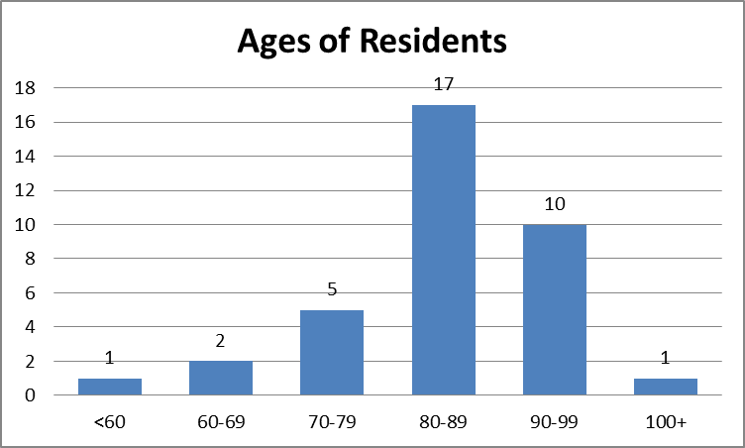
Extended Care is licensed as a Skilled Nursing Facility (SNF). This designation allows EC to care for Medicare Skilled residents on a short term basis (up to 100 days), Intermediate residents on a short or long term basis, and Hospice patients on a respite basis, short or long term basis.
The acuity of residents ranges from independent with ADL’s to completely dependent on staff, with numerous variances in dependence on staff.
The majority of residents are from Scandinavian countries, and Germany; there are opportunities within the community for ethnic dishes prepared, i.e. Lutefisk, those ethnic community dinners are delivered to the residents who would like to enjoy their ethnic foods (activities staff assist with getting a list of residents who would like to receive a meal). Residents are from a wide variety of occupational backgrounds, housewife, rancher, farmer, teacher, and numerous others.
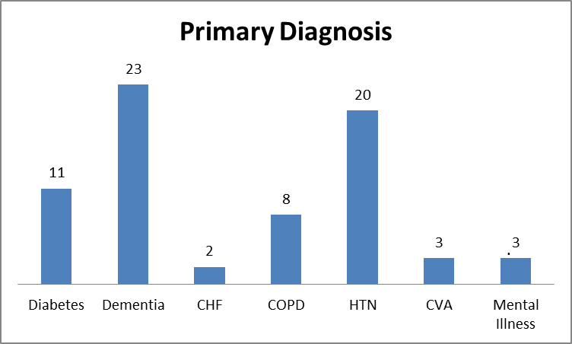
RESOURCES NECESSARY TO CARE FOR RESIDENT POPULATION
Medical equipment necessary to care for residents is: vital signs stands that include blood pressure cuff and thermometer; wheelchairs; stethoscopes; medication carts; beds; over-bed tables; enteral feeding pump; intravenous infusion pump; blanket warmer; oximeters; mechanical lifts utilized to transfer residents; whirlpool tubs for bathing residents.
Non-medical equipment necessary for the care of the residents include-office equipment, i.e. chairs, desks, computers, printers, filing cabinets, chart racks, chart binders, fax machine. Other non-medical equipment necessary for the care of the residents include, recliners, loveseats, card tables, table chairs.
Personnel
There is an Administrator (0.5 FTE); an Assistant Administrator (0.25 FTE) Director of Nursing (1.0 FTE); Assistant Director of Nursing/MDS Coordinator (1.0 FTE); a Resident Care/Quality Coordinator (0.5 FTE); and 2 Social Workers (0.5 FTE) in leadership at EC.
There are 36 GMC EC employees and 13 traveler employees. The traveler employees are from local and national travel companies. Extended Care utilizes 6-13 week contracts with travelers to increase consistent care for the resident. Staff competencies required to care for residents include: competent in IV management; mechanical lift transfers; abuse prevention; feeding tube management; dementia care; Skin Care prevention; medication administration, assessment of lung and bowel sounds; competent in communicating the resident’s condition to the provider and family.
There are 15 adult volunteers and 14 junior volunteers who help in the beauty shop; assist the residents with their activities; and provide intergenerational activity for the residents. Volunteer competencies required are: abuse prevention; suspected abuse reporting.
Extended Care has one bus, lift equipped, donated by the Glendive Medical Center Auxiliary, used for bus rides and resident appointments out of the facility.
SERVICES PROVIDED
Services provided through GMC are Physical Therapy, Occupational Therapy, and Pharmacy. Restorative Nursing is provided within EC. Extended Care has an agreement with GMC Hospice for respite and inpatient care.
HEALTH INFORMATION TECHNOLOGY
Extended Care utilizes Saunders software as its electronic medical record; RL solutions as its Risk Management software; Cerner as its Billing software, pharmacy software, laboratory and radiology software; Lawson as its materials management software. The process for communicating with physicians is through phone or fax.
EVALUATION OF QUALITY ASSURANCE PERFORMANCE IMPROVEMENT PROGRAM
- Quarter 2
Glendive Medical Center (GMC) Extended Care received its annual Montana Department of Public Health and Human Services (DPHHS) survey in March. Extended Care received Immediate Jeopardy in the areas of falls and elopements. An Abatement plan was accepted by the Montana State Department Health and Human Services (MTDPHHS), and we were placed back into compliance. We received 16 deficiencies total, 11 in nursing, 5 in administration. Three of the five in administration are being audited in conjunction with nursing audits. An on-site re-survey was conducted in May, and Extended Care was found to be in compliance. Two follow-up resurveys by fax, since May, have been conducted, with Extended Care continuing to be in compliance.
- Quarter 3
Extended Care has continued to work through the audit process following the spring survey. Extended Care’s Mood/Behavior team was restarted and is being monitored through a Performance Improvement Project. Extended Care’s Fall and Safe Transfer (FAST) team processes have been audited, and suggestions given as to where to improve interventions and documentation.
The Quality Assurance and Assessment (QAA) team has been meeting routinely and is receiving education about its role. Infection Control has been working on the Infection Control Plan for the department. Review of EC's Minimum Data Set (MDS) quality measures indicated eight quality measures as being measures to review for long term stay residents. Three of the top four measures were related to urinary concerns, catheters, incontinence, and infections. Based on this information, the QAA team approved a “urinary” performance improvement project” for EC to begin working on improving these areas. This team will begin its work in the fourth quarter of 2015.
NEEDS IDENTIFIED THROUGH ANNUAL FACILITY ASSESSMENT
Needs identified through this annual facility assessment include:
  - Dementia care education;
  - Improved Information Systems i.e. software compatible with current software being used in clinic and hospital;
  - Increase in employed staff and decrease in traveler staff.

