T.E.A.M. Safety Huddle 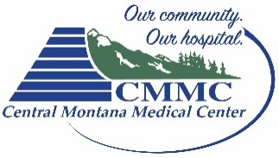

Team
Date: Shift:
Nurses: Students:
Ward Clerk: Orienting:
CNAs:

Environment
Census: Pending Admits:
Date of…  Last Fall:_______  Med Error:______  Foley Catheters  ______________  Labeled  Central Lines  ______________ | List room number for all that apply:  Lift Patients_______  Fall Risk________ Bed Alarm/Chair Alarm________  High Acuity_______ DNR______________  1:1 Feeders_______ Preferred Room__________  1:1 Sitters_______ Combative__________  Isolation  Contact_________ Droplet_________ Airborne_________

Advocate
Hospice___________ Readmissions____________
Patients/families in need of extra support/education_______________
Potential discharges____________________
Vaccine eForm completed_______________

Motivate
Safety Concerns or Events__________________________________________
__________________________________________
Crash Cart Check Completed

