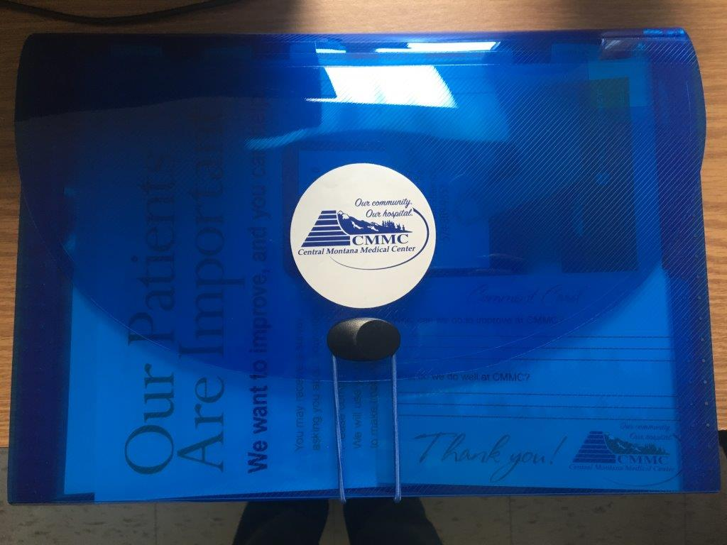
13-tab pocket folder. Below are tab titles and some examples of what is included in each. This is not an all-encompassing list, it is of course tailored to the patient.
- Discharge information checklist for the RN- this is not a tab itself, it is the first thing in the file folder ahead of the tabs
- Advance Directive/POLST
- What to Expect- Information regarding personal belongings & valuables, as well as bedside shift report
- Stay Summary- Labs, medications
- Discharge Instructions- Follow-up appointment(s)
- Education- Diagnoses, new medications, HCAHPS flyer, managing pain at home
- Comment Card (See photo below)
- Prescriptions
- Discharge Notices
- Patient Portal
- Medication Bag (Possibly in the near future)
